Student Financial Aid

FALN 113 – Returning Funds for Disbursed FFELP Loans

Date Issued/Rev: 02/07/07
General Description: This procedure explains how to return loan funds for a loan when we have received the funds, and it has disbursed.
Responsible Manager: Financial Aid Director
Related Procedures:
Related Forms: RPALDSB
RPAAWRD
ROAIMMP
ROIDISB

PROCEDURE
Procedure:
1. Make necessary adjustments on RPAAWRD.
2. Go to RPALDSB, perform next block function.
3. Go to the loan and term for which you want to make the adjustment, and click in any field. This will select the record. (The feed indicator will be set to ‘F’ for loans that have disbursed.)
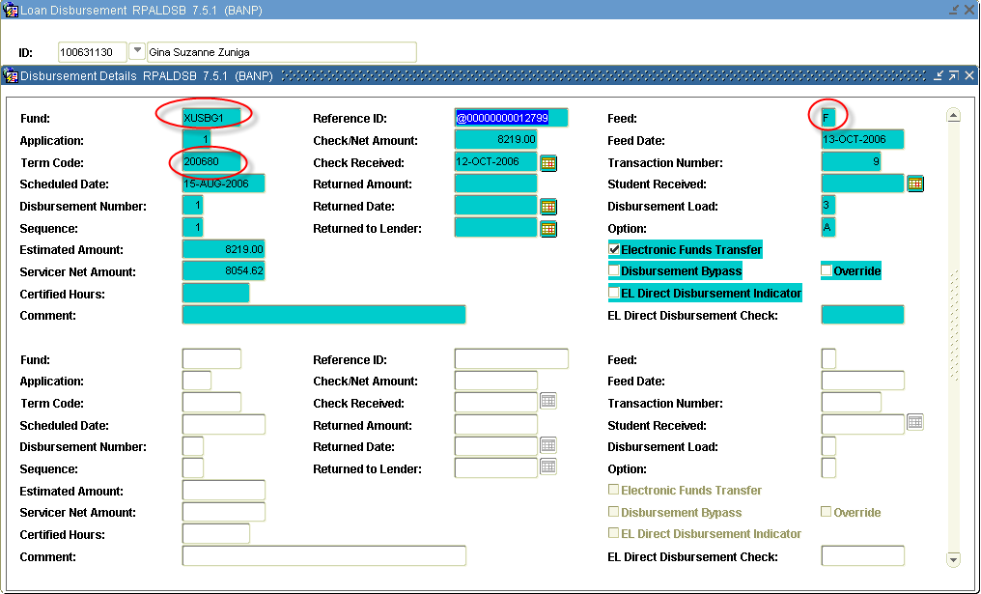

4. Insert record.
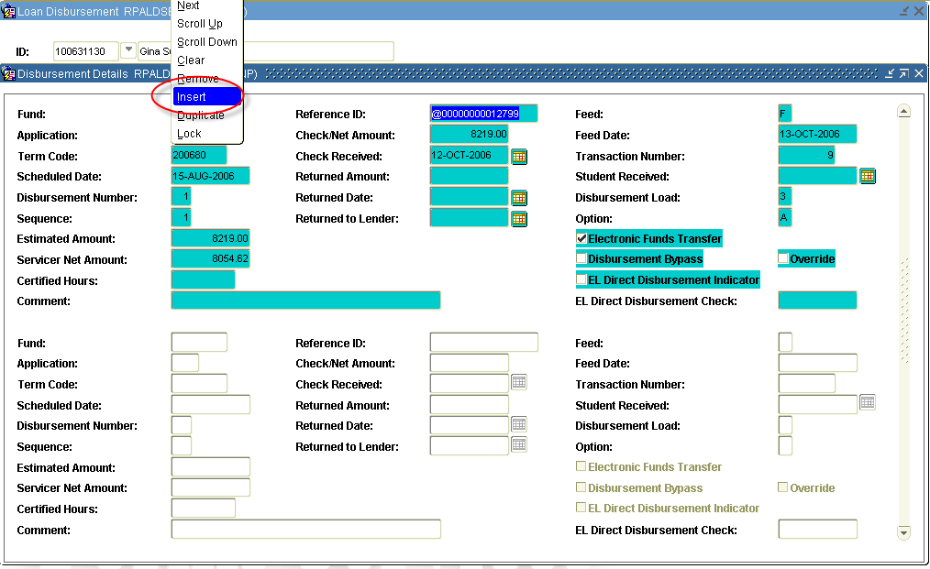
5. Copy the REFERENCE ID from the original record.
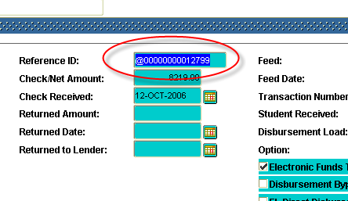

6. Paste this REFERENCE ID into the new record’s (1) REFERENCE ID field. (2) Enter the RETURNED AMOUNT, and (3) indicate the reason for the return in the comment field. The (4) date will autopopulate.
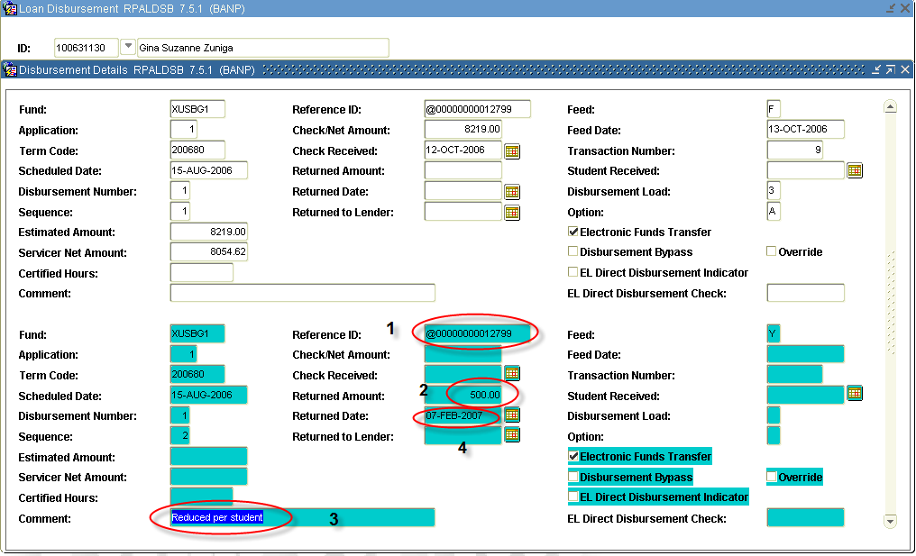
7. Save the record.
8. Go to ROAIMMP.
9. Run disbursement for the term you are adjusting.
10. Go to RPALDSB to verify the transaction has gone through. The feed indicator will be ‘F’, if the transaction processed.
11. If the transaction did not go through, go to ROIDISB, for the term in question, to determine the reason.

* * * E N D * * *

