Student Financial Aid

FALN – 118 Entrance Counseling

Date Issued/Rev: 04/29/08
General Description: This procedure explains how to update and store entrance counseling reports.
Responsible Manager: Financial Aid Director
Related Procedures: N/A
Related Forms: RRAAREQ

PROCEDURE
1. Go to the website http://mappingyourfuture.org/fap/ and log in.
2. Choose ‘Reports’ at the top of the screen.
3. Click on ‘Counseling Session Reports’
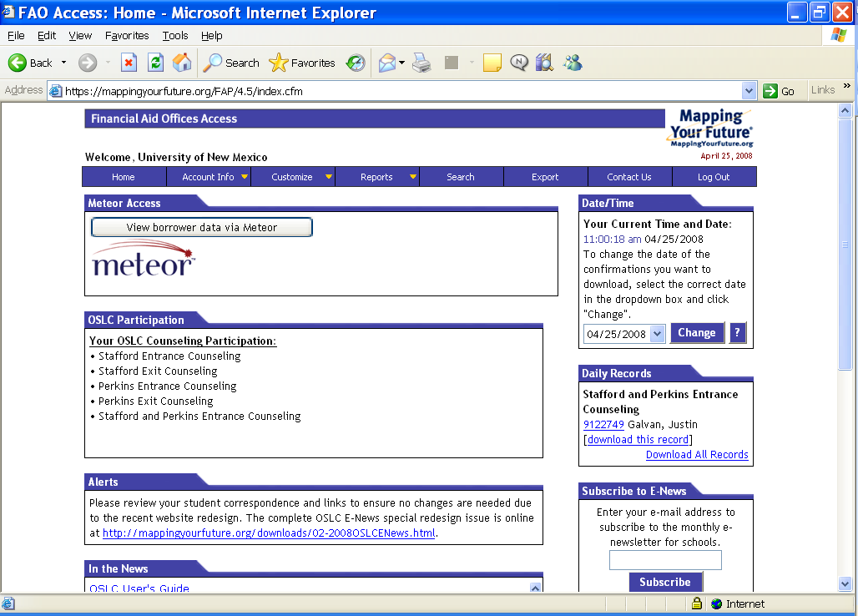

4. Click next to ‘Stafford Entrance’
5. For the ‘Date Range’, the first date is yesterday’s date and the second date (To:) is today’s date. If you are logging on a Monday the first date will be last Friday and the To: date will be Sunday.
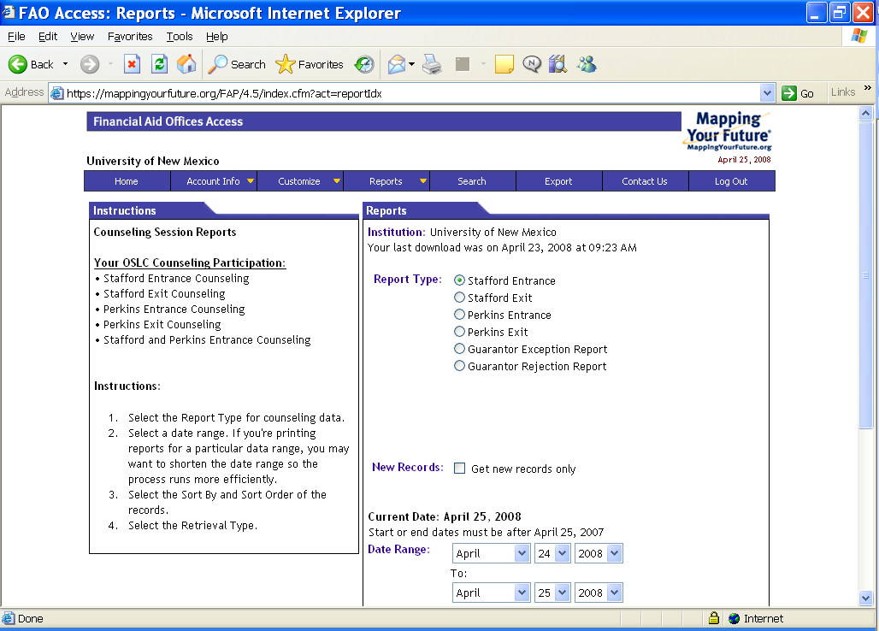

6. Select ‘Download Printable Confirmations’
7. Click the ‘Continue’ button
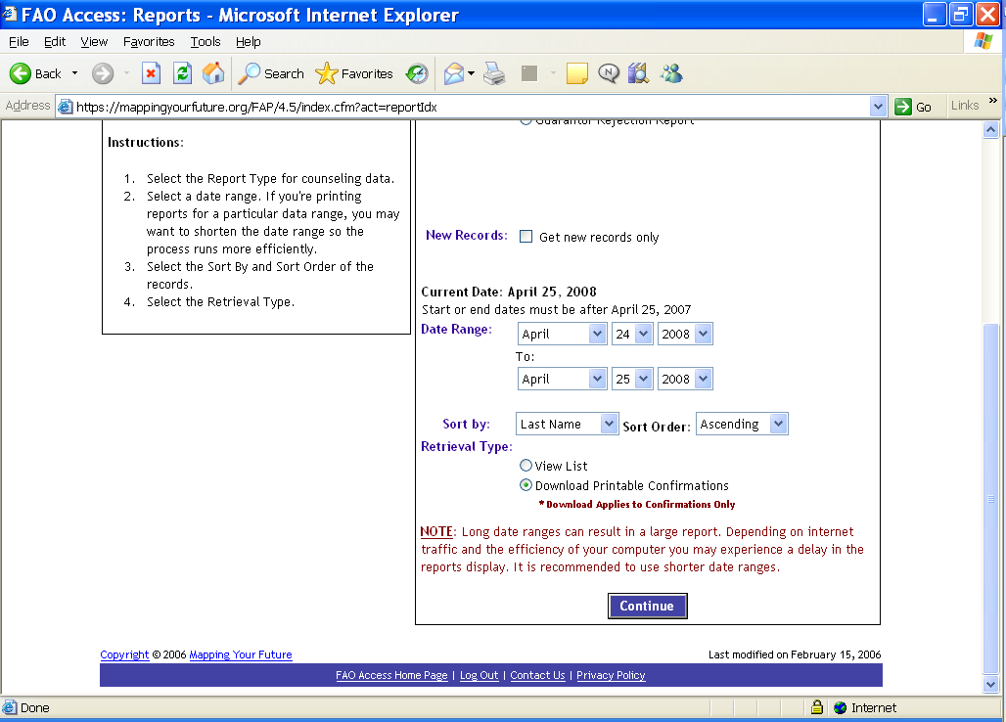

8. Click the ‘Save’ button
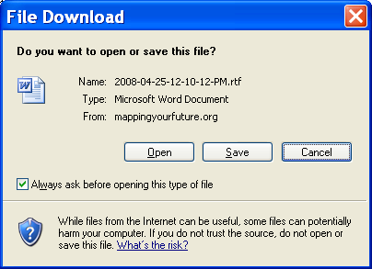
9. Save the confirmation as the first date in the date range or yesterday’s date in your documents folder.
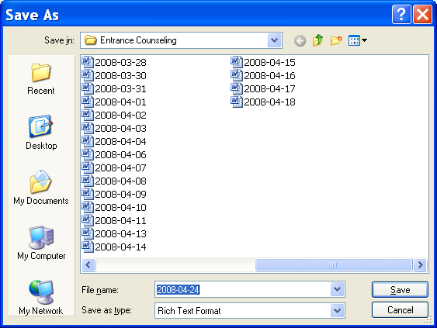

10. Click on ‘Open Folder’
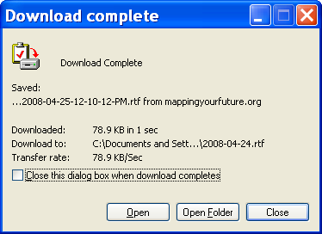
11. Click on ‘Folders’ at the top of the window
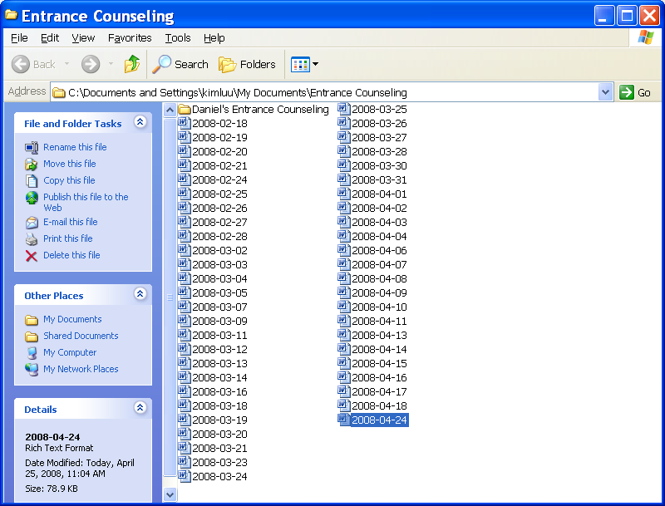
12. Click on the ‘+’ symbol to the left of the
a. (S:\) drive,
b. ‘forms’ folder
c. ‘Entrance Counseling’ folder
d. ‘Stafford’ folder
13. Drag the document icon into the folder appropriate to the month and year. This pastes the document into the shared drive.
14. If a folder for the current month and year do not exist, create a new folder for it.
15. Go back to Mapping Your Future and select ‘View List’ to begin logging.
16. Highlight the social security number and copy it (Ctrl + C)
17. Go to RRAAREQ in Banner
18. Enter the current aid year
19. Click on the arrow to the right of ‘ID:’
20. Click on ‘Alternate ID Search (GUIALTI)’
21. Paste the social security number into the ‘SSN/SIN/TIN’ field.
22. Delete the hyphens and spaces
23. Execute the query (F8)
24. Double click the student you wish to select
25. Perform Next Block
26. Locate the ‘PRELN’ requirement
27. Update the ‘Status’ field to “C”.
28. If ‘PRELN’ does not appear in the list of requirements, enter ‘PRELN’ as a requirement and update its status to “C”.
29. Rollback (Shift + F7) to repeat the process until the list is completed.
30. When the list is completed log out of Mapping Your Future.

* * * E N D * * *

