 | Student Financial Aid
 | FAPK-117 Request or Cancel an Award Letter | Date Issued: 7/30/2026
General Description:
This procedure explains how to request an award letter or cancel an award letter.
Responsible Manager: Director of Financial Aid
Related Procedures:
UNM-100 Search Three Times
Related Forms:
RPAAWRD Award Maintenance Form

PROCEDURE

Step 1 - Type RPAAWRD from the direct access field of the main menu.

Step 2 - Press ENTER.

NOTE: Do NOT click on the magnifying glass. (see screen sample on next page)

Step 3 - Type the student’s Banner identification number.

Step 4 – Verify the correct student found has been found.
- If yes, continue.
- If not, go to UNM-100 or search tools and locate the correct student.

Step 5 - Select “Options/Toggle Summary/Packaging Group Information” from the menu bar.

Step 6 - Choose action needed:
- If requesting an Award Letter, click the box to activate the letter. 
- If canceling an Award Letter, click the box to de-activate the letter. □

Note: When a change is made to the amount of an award, the Award Letter flag automatically displays. The next time award letters are printed, an award letter will then be generated.

Step 7 – Follow the prompts if you have more award letters to process.
- If yes, select “Save,” and return to step 2.
- If not, select “Save,” and select “Exit.”

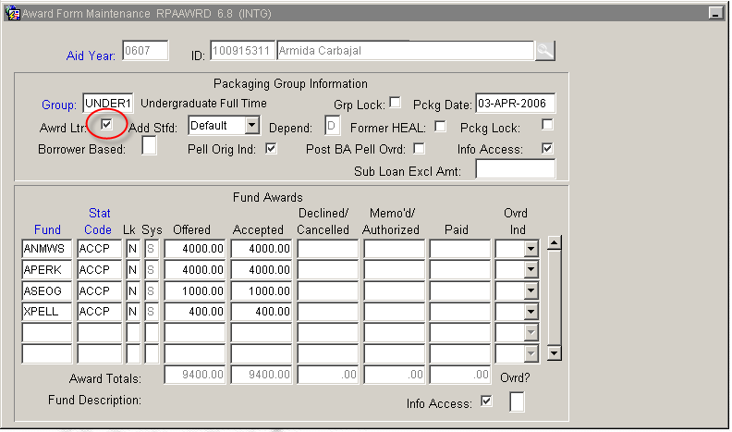

* * * E N D * * *

