 | Student Financial Aid
 | FAPK-118 Resolve an Over Award | Date Issued: 7/31/2026
General Description:
This procedure explains how to resolve an over award. Banner does not allow a fund to be packaged if an over award results. However, outside resources, 3rd Party Contracts, and Exemptions that are entered by other areas of the campus can result in an over award, if funds have been packaged prior to this information being entered.
Responsible Manager: Director of Financial Aid
Related Forms:
RPAAWRD Award Maintenance Form
Related Procedures:
UNM-100 Search Three Times

PROCEDURE

Step 1 - Type RPAAWRD from the direct access field of the main menu. Please refer to Figure 1.

Step 2 - Press ENTER.

Note: Do NOT click on the magnifying glass.

Step 3 - Type the student’s Banner identification number.

Step 4 – Verify the correct student has been found.
  - If yes, continue.
  - If not, go to UNM-100 or search tools and locate correct student.

Step 5 - Select “Next Block”

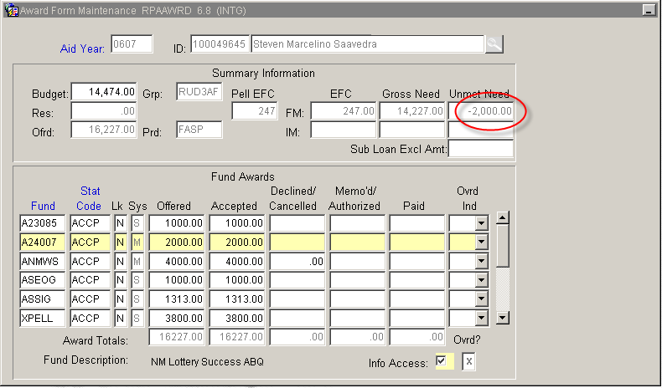
Figure 1 – RPAAWRD Form

Step 6 - Determine which funds to adjust to resolve the over award based upon Office policy (ie reduce awards in reverse order of packaging priority).

Step 6 - Choose next actions:
a. If award is to be reduced (or cancelled) equally across multiple terms refer to FAPK-109
b. If award is to be reduced (or cancelled) unequally across multiple terms refer to FAPK-112

Step 7 - Complete actions in step #6 according to those SOPs before continuing on to step 8.

Step 8 - Type ROAMESG from the direct access field.

Step 9 - Press ENTER.

Step 10 - Select “Next Block”

Step 11 - Choose action:
a. If the form is blank, continue.
b. If it displays other information, select “Insert Record”

Step 12 - Type “OVER” in the message code field. Please refer to Figure 2.

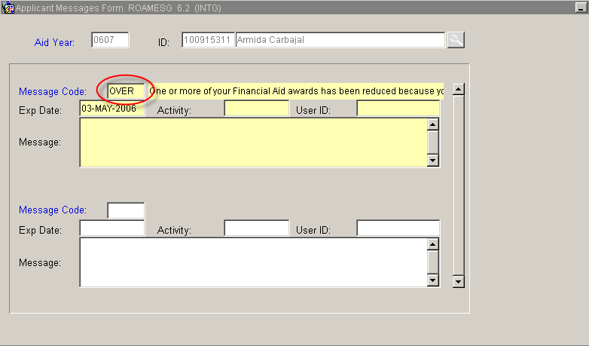
Figure 2 – Message Code Field

Step 13 - Select “Save”

Step 14 – Resolve more awards:
  - If yes, return to step 1.
  - If not, select “Exit”
* * * E N D * * *

