Student Financial Aid

FATRK-101 Active Duty

Date Issued/Rev: 02/15/2008
General Description: This procedure explains what steps are needed to complete a request for Active Duty documentation.
Responsible Manager: Financial Aid Director
Related References:
Related Procedures:
Related Forms: RNANAxx
RRAAREQ
RHACOMM

***************** NOTE: THERE IS NO REQUIRED FORM FOR THIS ******************
HOWEVER, A COPY OF DOCUMENTATION CONFIRMING ACTIVE DUTY IS NEEDED

Acceptable documents are:

Copy of Military Orders with dates confirming active duty
Copy of Military ID Stating Active duty

PROCEDURE
Procedure:
1. Receive document confirming Active Duty and verify documentation is complete.
2. Access RNANAxx for the school year the document is requested
- Confirm student indicated Active Military Status.
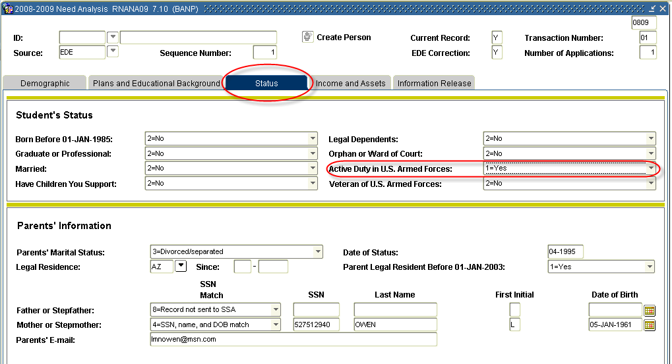
3. Access RRAAREQ
- Identify ACTIVE tracking requirement code and update status to ‘C’
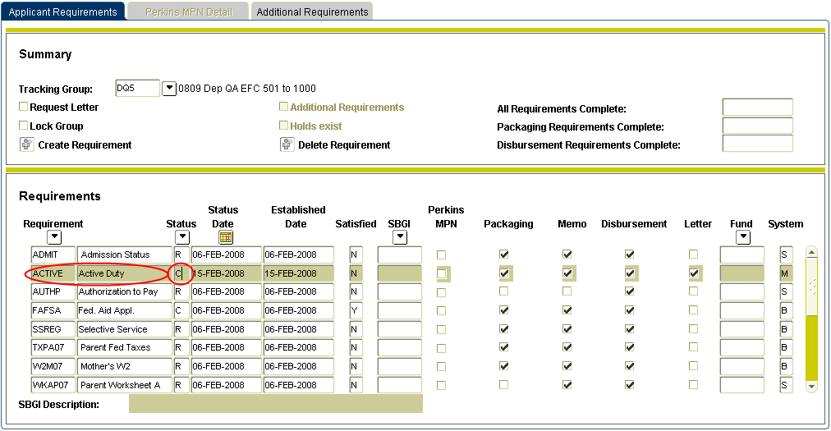
4. Save and Exit form.
5. Access RHACOMM
- Leave message indicating the type of documentation received and that Active Duty is confirmed.
6. IN PROCESS OF BEING DEVELOPED

* * * E N D * * *

