Student Financial Aid

FATRK-101 GADMIT Resolution

Date Issued/Rev: 02/28/2008
General Description: This procedure explains what steps are needed to complete a request for GADMIT.
Responsible Manager: Financial Aid Director
Related References:
Related Procedures:
Related Forms: RRAAREQ
SAAADMS
RSIDEGR
RHACOMM

***************** NOTE: THERE IS NO REQUIRED FORM FOR THIS ******************

The system will complete the request for GADMIT automatically, unless the most recent Admissions Application does not have an "Application Decision" has a code of "E,QE,JE,ED"

PROCEDURE
Procedure:
- Access SAAADMS and verify the most recent Admissions Application
  - To view the most recent Application leave the ‘Term’ field blank
- Next Block, the ‘Application Decision’ Field will not equal a code that represents Fully Admitted Graduate.
  - To be fully admitted as a Graduate Student, the ‘Application Decision’ Field must be equal to E, QE, JE, or ED.
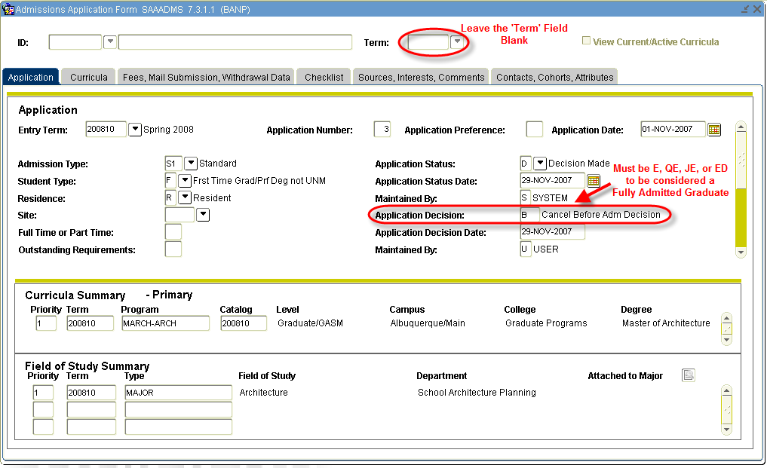
- Scroll Down to prior Admissions Application, verify that ‘Entry Term’ and ‘Application Number’ change.
  - Verify ‘Application Decision’ is equal to E, QE, JE, or ED (if it is not, continue to Scroll Down to view other Admission Applications)
  - Take note of College and Degree,
College MUST be ‘Graduate Programs’, ‘Law’, or ‘Med School’.
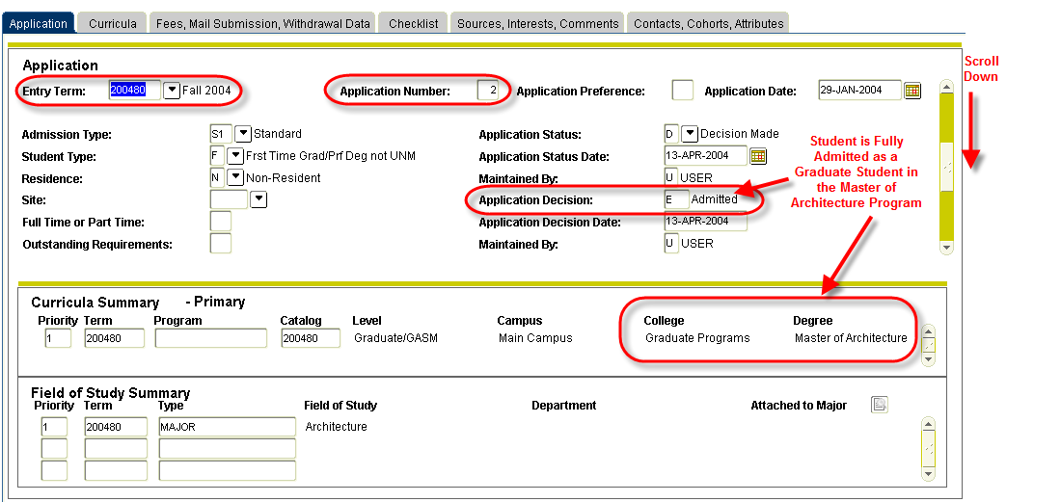
- Exit SAAADMS.
- Access RSIDEGR, verify student has not received degree associated with Admissions Application
(In the case of the example, the student should not have received his Master of Architecture)
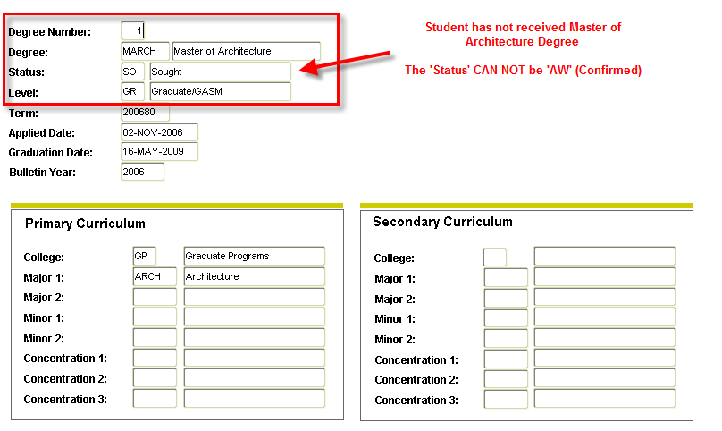
- Exit RSIDEGR.
- Access RRAAREQ, now that is has been confirmed that the student has been Fully Admitted into a Graduate Program and the student has not yet completed the program.
  - Identify GADMIT Tracking requirement Code and update status to ‘C’
- Save and Exit.
- Access RHACOMM
- Leave message in the following format:
GADMIT – STUDENT FULLY ADMITTED INTO GRADUATE PROGRAM FOR 200480. PERSUING MASTER OF ARCHETECTURE DEGREE. COMPLETED GADMIT ON RRAAREQ.
8. Save and Exit
* * * E N D * * *

