Lender Selection through LoboWeb -
LENDER Request on RRAAREQ

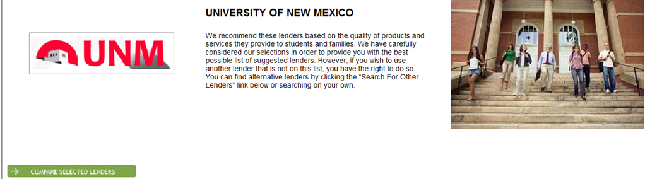
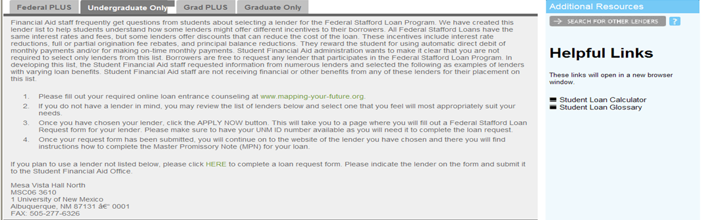
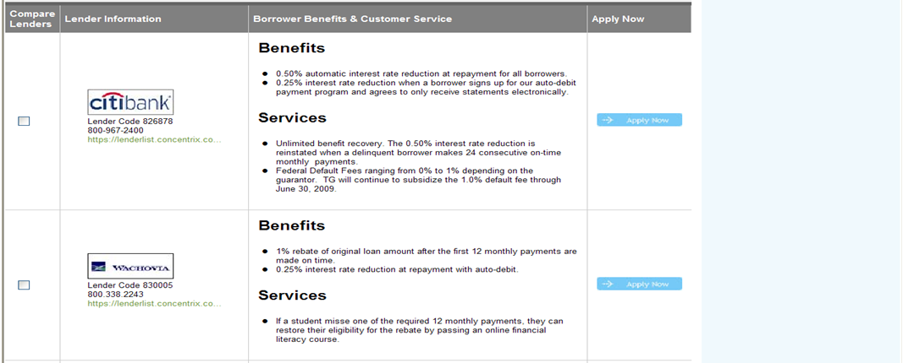
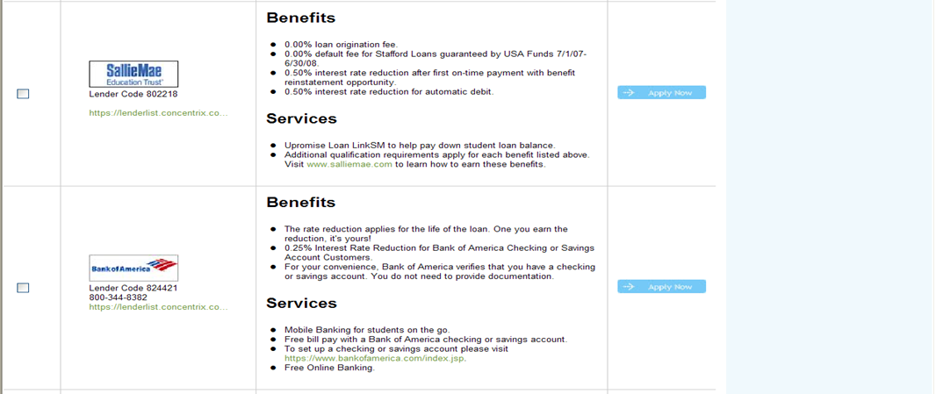

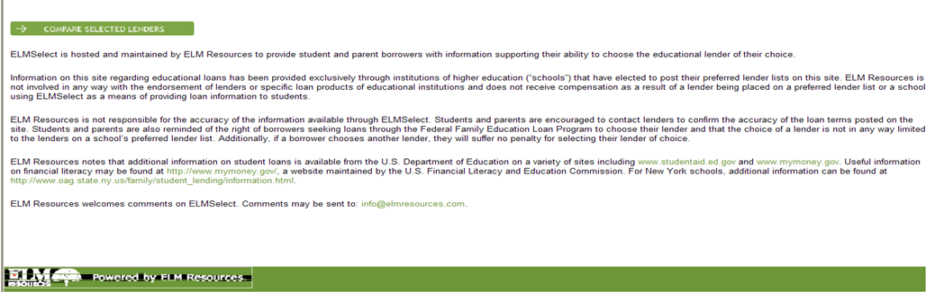
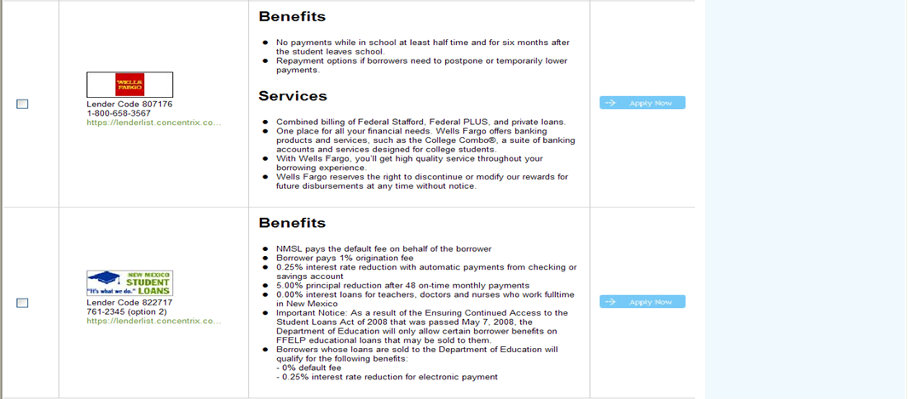

FOR STUDENT USE
Lender | Banner Lender ID | Contact | MPN site
Bank of America | 824421 | 1-800-344-8382 | www.bankofamerica.com/studentbanking
Citibank | 826878 | 1-800-967-2400 | http://studentloan.citibank.com
NMSL | 822717 | 345-8821, 1-800-279-3070 | https://secure.nmeaf.org/unm/
Sallie Mae | 802218 | 1-888-272-5543 | https://opennet.salliemae.com/
Wells Fargo | 807176 | 1-888-511-6364 | http://wfefs.wellsfargo.com/jump/nm/unm.html
UNM as Lender (NMSL)  Graduate Only | 834182 | 345-8821, 1-800-279-3070 | https://secure.nmeaf.org/unm/
Wachovia | 830005 | 1-800-338-2243 | http://wachovia.com/education

