2nd Block of SHATERM – Grade Repeat Codes
This is a brief description of the Repeat Codes on SHATERM. For Satisfactory Academic Progress (SAP), all grades earned at the University of New Mexico are considered in GPA calculation, regardless of grade replacements or academic renewal.
UNM’s Official GPA can be different then that calculated for SAP, many times it is due to a grade replacements and repeated course work. Below are the codes used for grade replacement/repeat identification and how the UNM Records Office calculates these replacements

- I – Count in All. Grades associated with these classes are calculated in BOTH GPA and Hours Earned on the UNM Transcript.
- A – Count in GPA. Grades associated with these classes are calculated in ONLY in GPA; they reflect as attempted, NOT earned on the UNM Transcript.
- E – Grade Replaced. DO NOT count in GPA or Hours on the UNM Transcript.
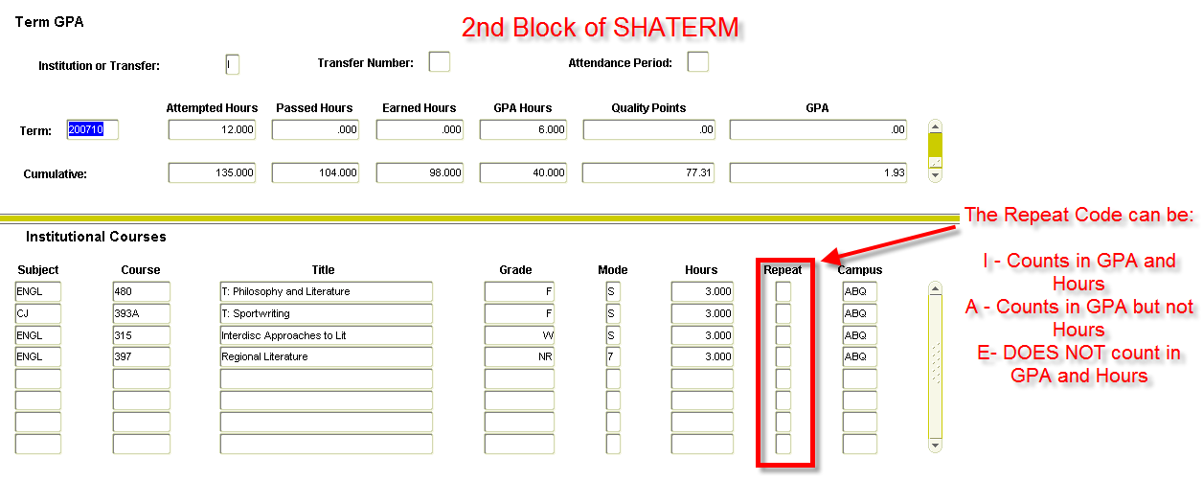
All grades earned at the University of New Mexico are considered in GPA calculation for SAP, regardless of grade replacement.

