Place the Following Students in a QA Group – use the 0809 QA criteria –
- Jessica – UNM ID 101280224
  - EFC 8247
  - Dependent
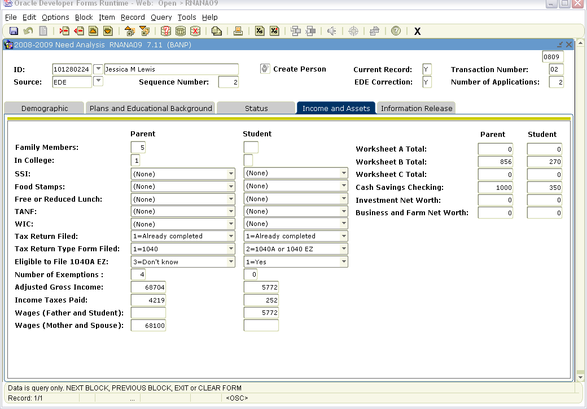
- Luke - UNM ID 101271754
  - EFC 11515
  - Dependent
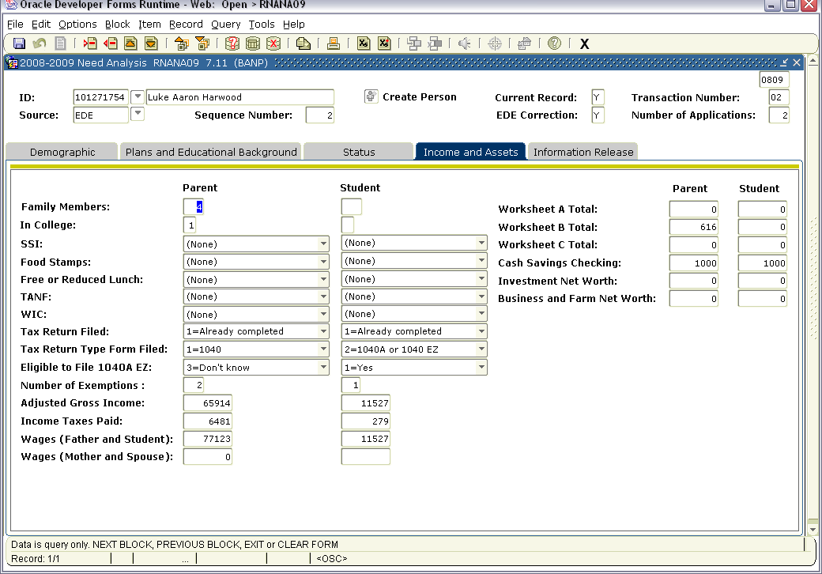

- Elisa – UNM ID 101291490
  - EFC 671
  - Dependent
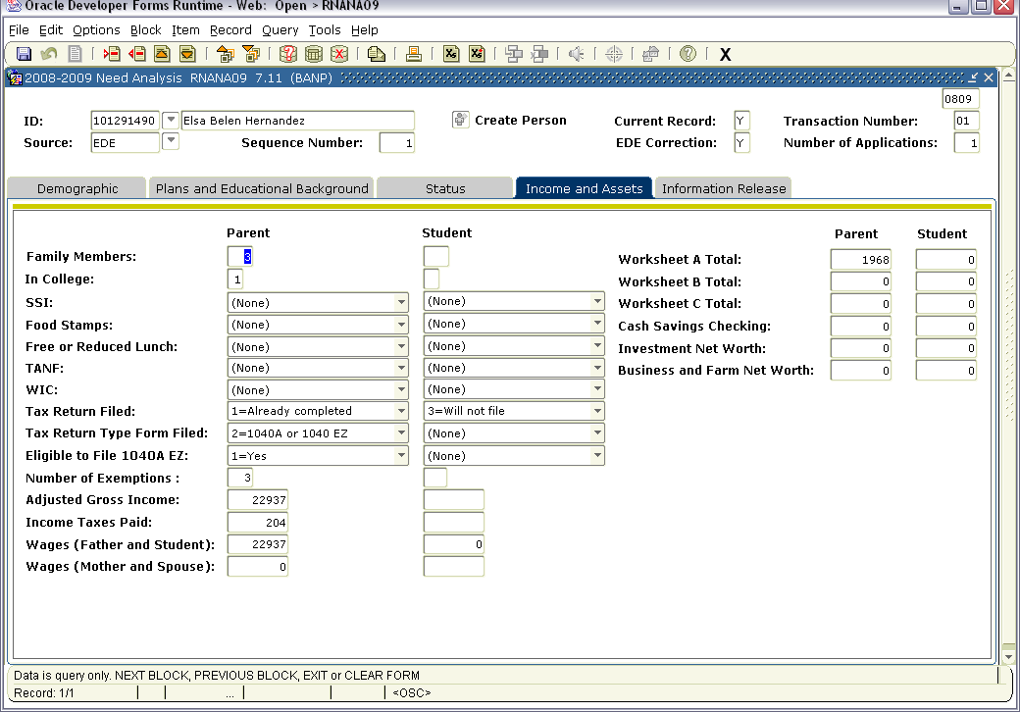
- Janelle – UNM ID 100145694
  - EFC 14569
  - Dependent
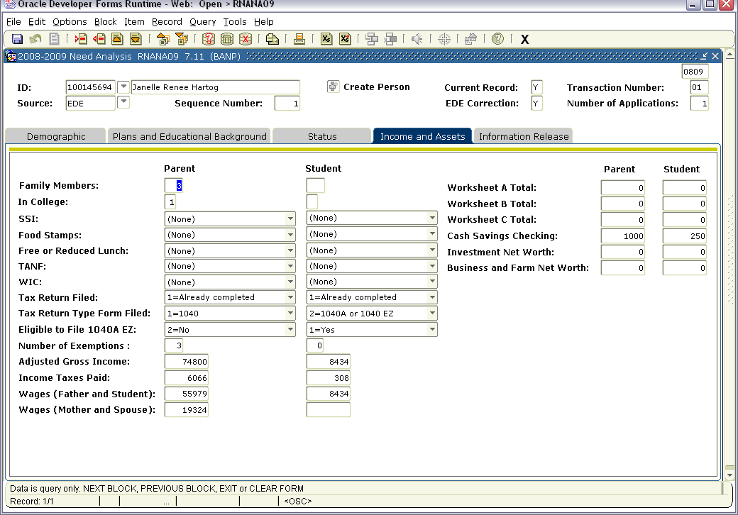

- Kerry – UNM ID 101109321
  - EFC 0
  - Dependent
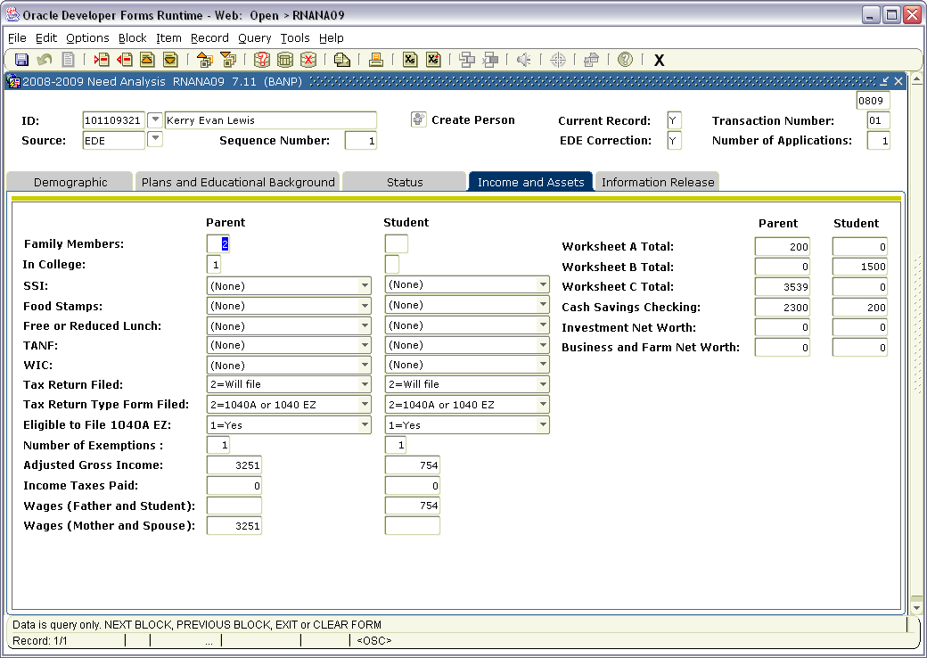
- Pamela – UNM ID 100899686
  - EFC 7891
  - Independent
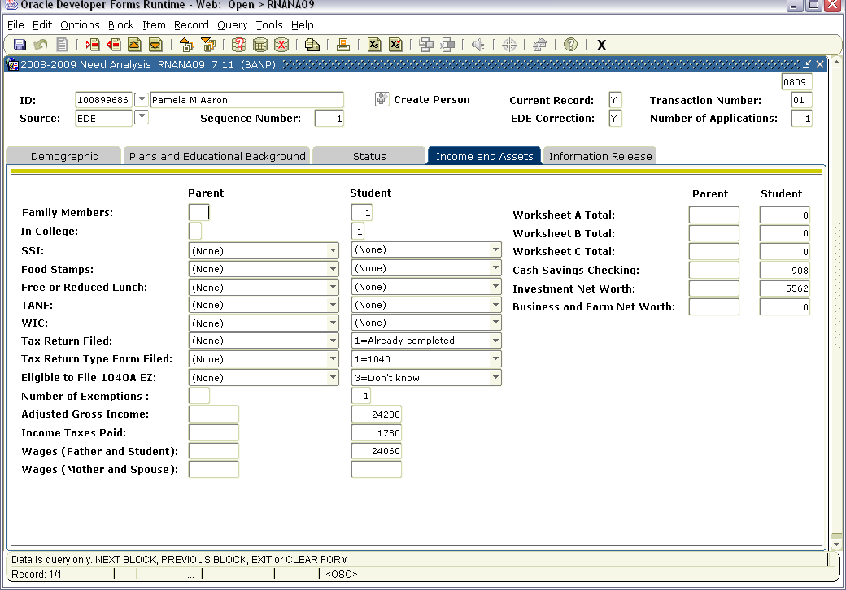

- Tamara – UNM ID 101122022
  - EFC 697
  - Dependent
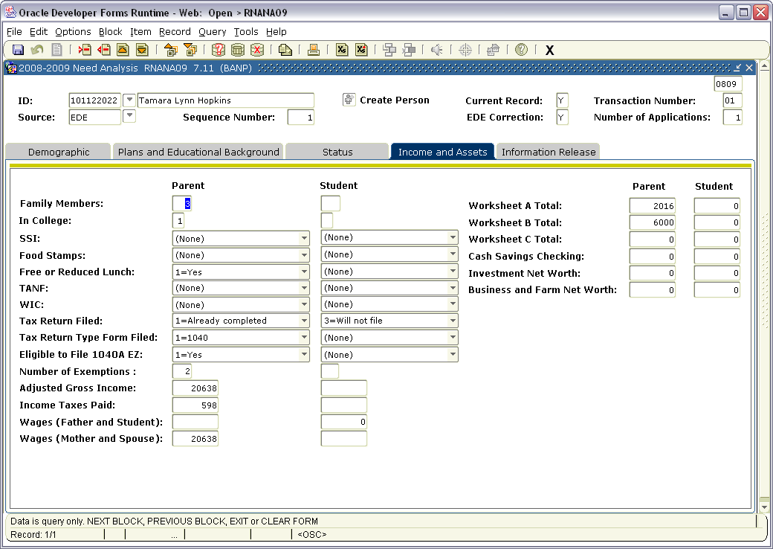

- Widu – UNM ID 101104372
  - EFC 559
  - Independent
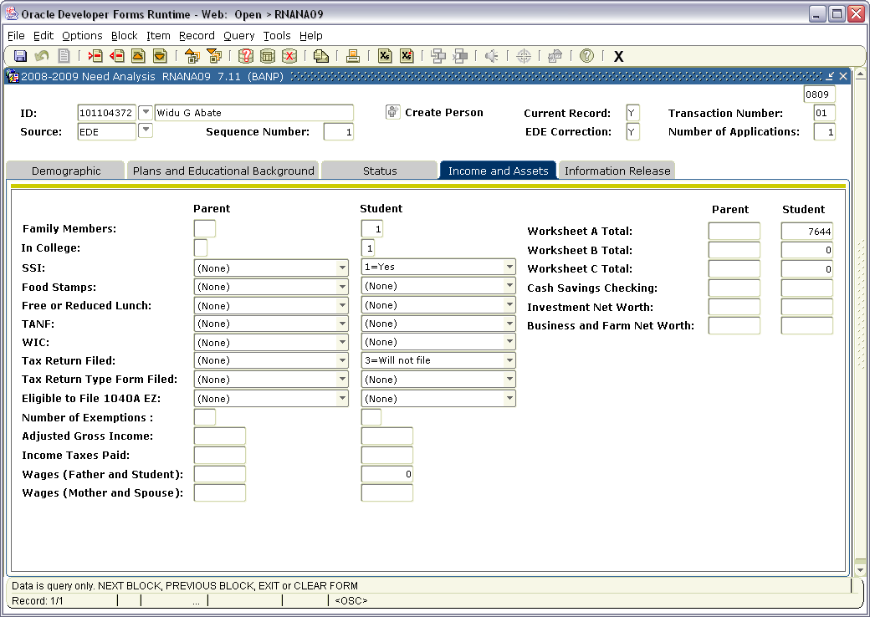

- Madelyn – UNM ID 100247062
  - EFC 2229
  - Dependent
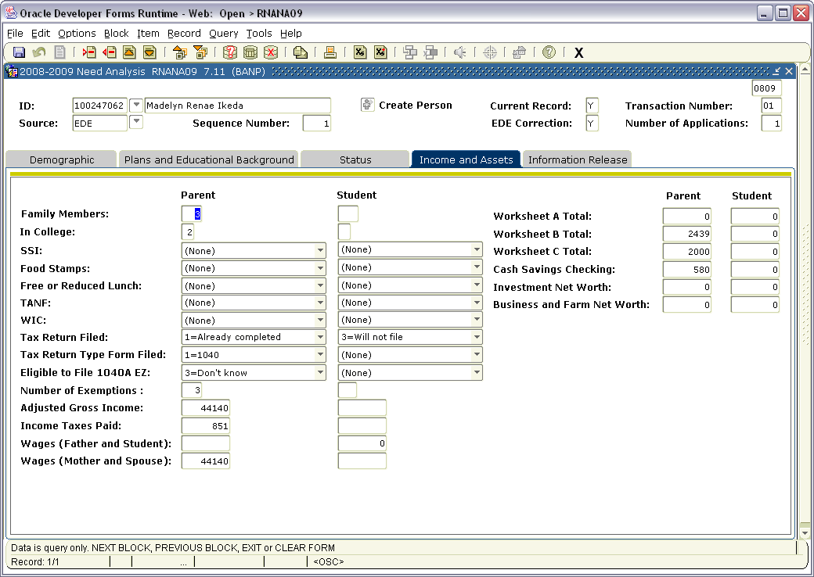

- Erica – UNM ID 100427480
  - EFC 2002
  - Dependent
