- Access ROILOGA
- Enter student ID in the Id Field
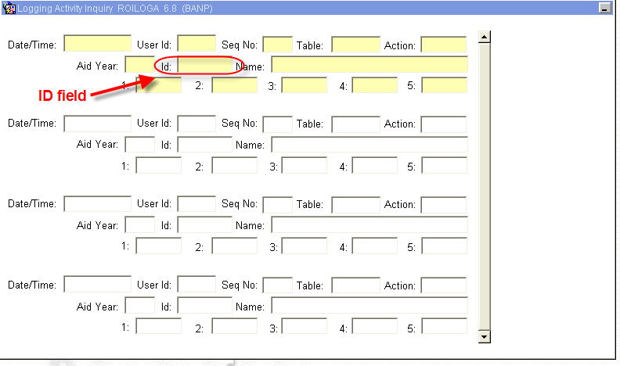
- Execute Query (F8)
- The from will list the adjustments that were made to this student

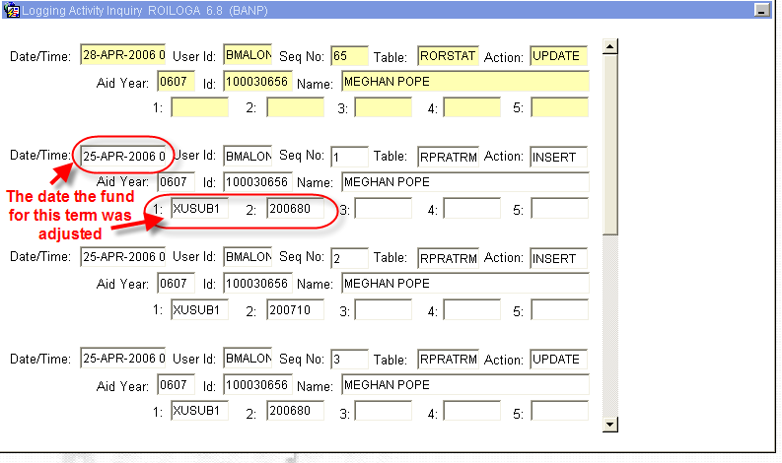

- For more information on the specific transaction, “Click” the date (it will highlight) and perform a Next Block.

