0 – office requirements
49 – Banner
50 - Forms

100 – SAP
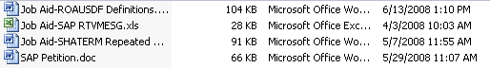
200 – Tracking
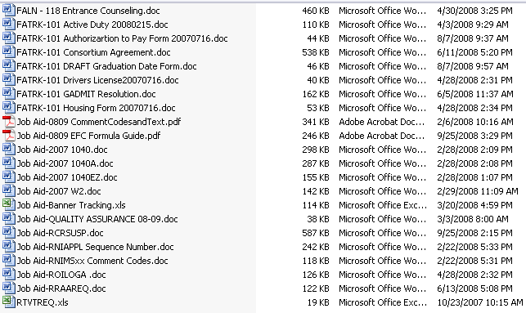
300 – Budgets
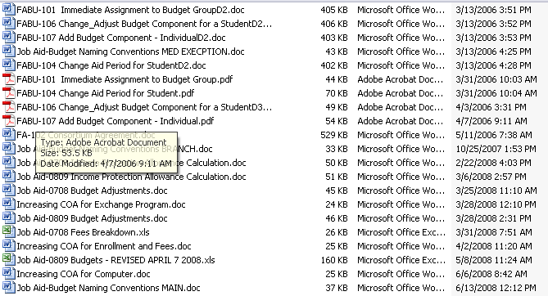
400 – Grant Awarding
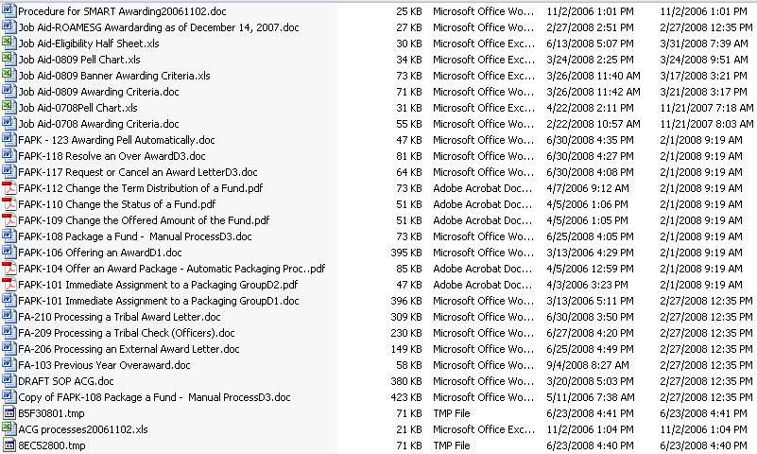
500 – Loan Awarding
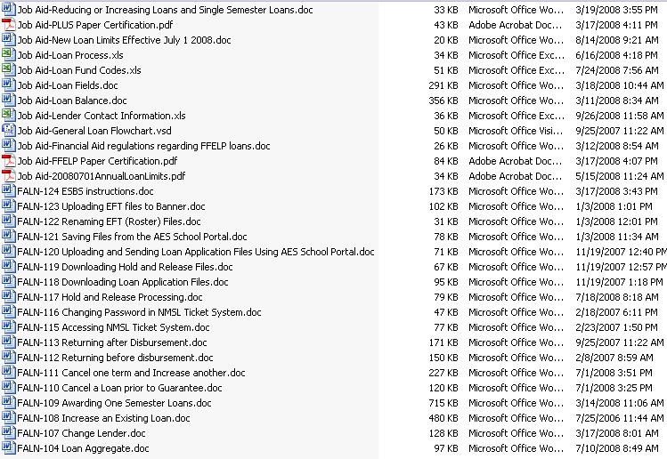
525 – Disbursement
550 – Return of Title IV
575 –Student Employment
600 – Special Circumstances
700 – Independency
750 – Misc
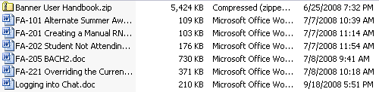
800 – Summer
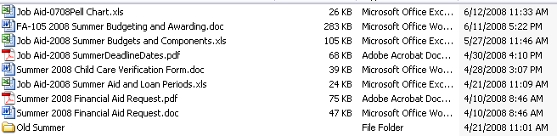
850 – Funds Mgmt
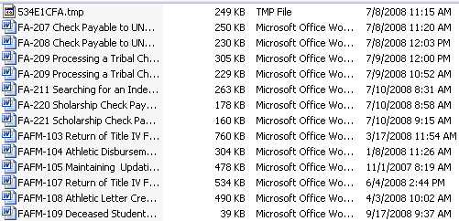
900 - Letters and Notifications

999 – Training Notes