1. Go to the New Mexico School Portal:

https://connections.pheaa.org/portal/newmexico/school/school_portal.cfm

2. Enter your login and password. Select SUBMIT.

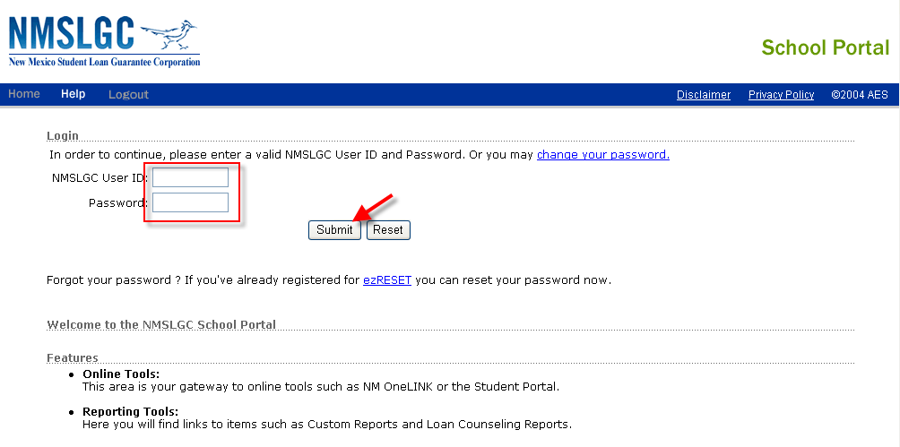
3. Select eCourier SBS (School Based System)

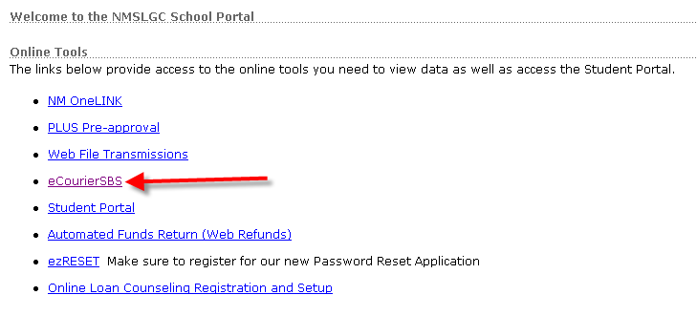

4. Enter student’s Social Security Number (SSN) and select SEARCH

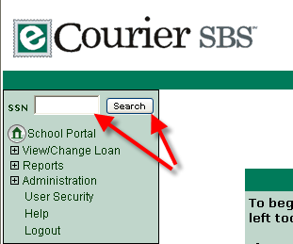

5. Select loan you wish to modify or cancel (NOTE: ONLY GUARANTEED LOANS CAN BE CANCELED.)

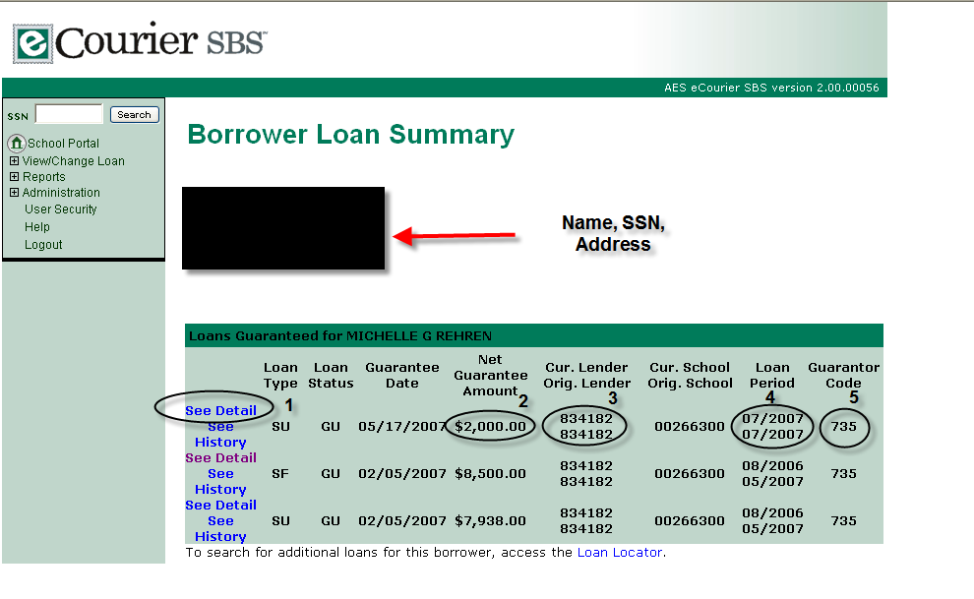
Use these fields to confirm the loan you are working on:

1. SEE DETAIL – selects the loan
2. Net Guarantee Amount
3. Current Lender on loan
4. Loan Period
5. Guarantor Code

6. Change fields as appropriate

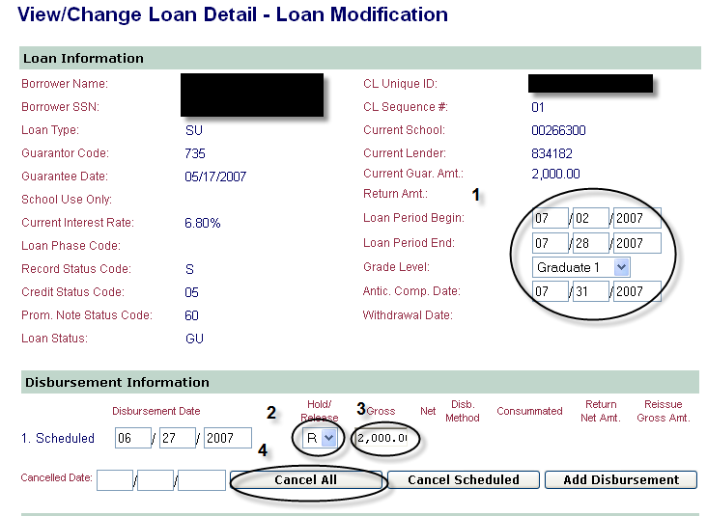

1. Change loan period or graduation date
2. Set a loan to (R)elease, or (H)old – for disbursement
3. Reduce loan amount
4. Cancel all disbursements

7. Update changes
