 | LINK Financial Aid | 

FA-107 Alternate Summer Awarding

Date Issued/Rev: 11/03/05
General Description: This procedure explains how to award loans for the students awarded with summer treated as a header semester.
Responsible Manager: Financial Aid Director
Related Procedures: FABU-101 Immediate Assignment to a Budgeting Group
FABU-104 Change Aid Period for Student
FABU-107 Add Budget Component
FAPK-101 Immediate Assignment to a Packaging Group
FAPK-104 How to Offer an Award Package using Automatic Packaging Process
FAPK-108 Package a Fund Manually
Related Forms: RBAABUD
RNAOV07
RPAAWRD
ROAENRL

PROCEDURE
Procedure:
1. Budget and award student for normal aid period (ie Fall/Spring). See FABU-101, FAPK-101, and FAPK-104.
2. Go to RBAABUD.
3. Change aid period (see FABU-104) to applicable term (ie ASFASP, ASFA).
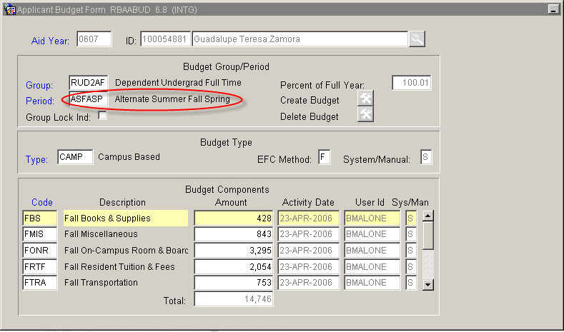
4. Adjust EFC for new budget duration on RNAOV07 (see FABU-104).
5. Add budget components for new summer term (see FABU-107)
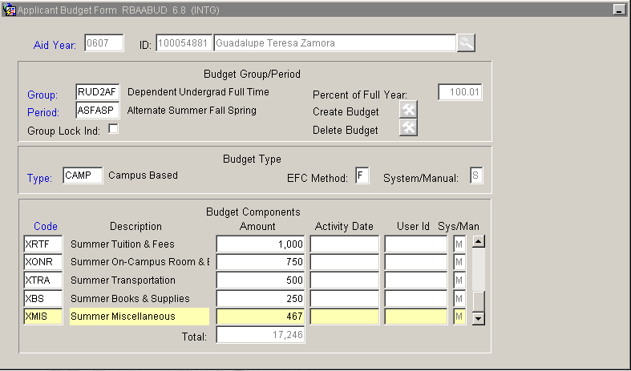
6. Go to RPAAWRD.
a. If FFELP loan exists and has been guaranteed then adjust loan on RPAAWRD and RPAELAP.
b. If FFELP loan exists and has not been guaranteed then delete loan on RPAAWRD and RPAELAP. Re-award loan(s) on RPAAWRD.
c. If no FFELP loan exists then award loan as you would any other aid (see FAPK-108)
7. Go to ROAENRL
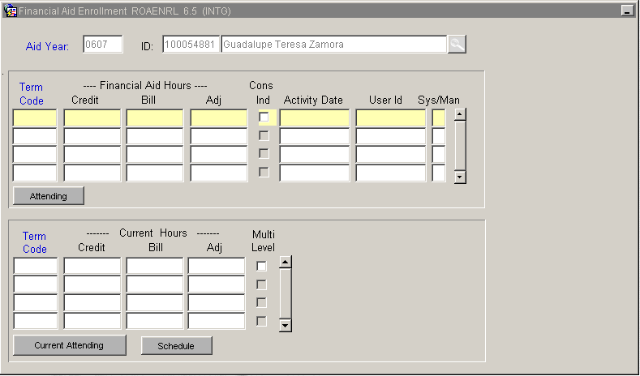
8. Enter Term Code (yyyy61) (ex:200661, 200761, etc)
9. Enter Credit, Bill, and Adjusted hours for the hours a student is anticipated to be enrolled for during the summer term.
10. Click the CONS IND box.
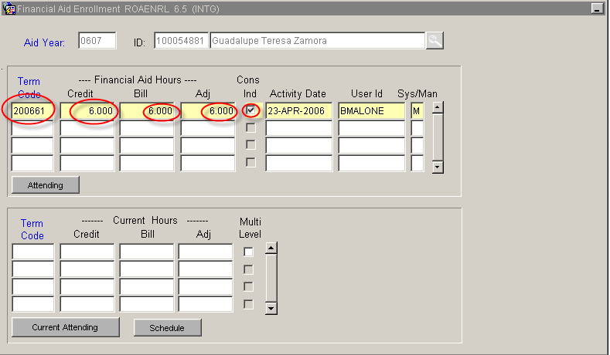
11. Save and Exit
12. Go to RHACOMM and put a note.
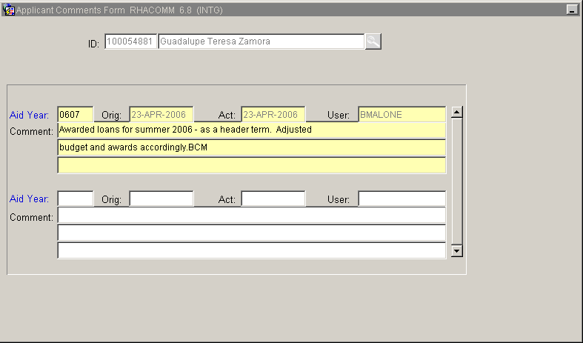
* * * E N D * * *

