 | LINK Financial Aid | 

FA-201 Creating a Manual RNANAxx Record

Date Issued/Rev: 11/03/05
General Description: This procedure explains how to log on Consortium Agreements.
Responsible Manager: Financial Aid Director
Related Procedures:
Related Forms: RNANA07
(ROAPELL)

PROCEDURE
Procedure:
1. Verify FAFSA is complete and signed by the student (and parent if dependent).
2. Go to RNANA07
3. Enter Student ID - if no ISIR exists, MANUAL will populate in the Source Field
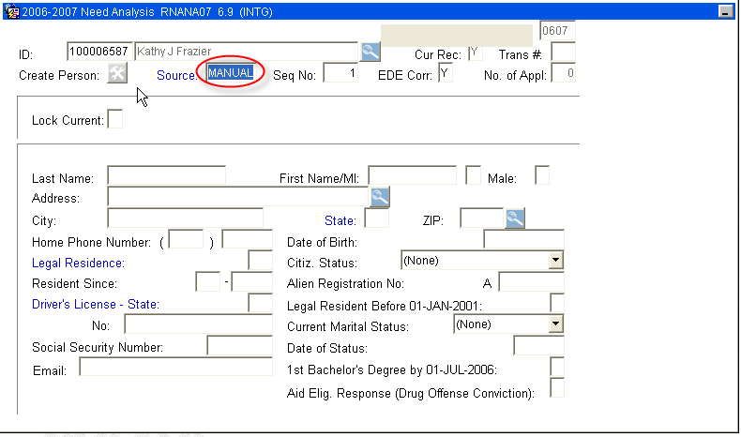
IF SOURCE FIELD READS “EDE” - STOP! ISIR EXISTS FOR STUDENT
4. Once MANUAL Source Field is confirmed, Perform “Next block”
5. You will receive confirmation that a record does not exist for this student. Click “OK”
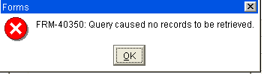
- Enter all FAFSA student data - RNANA07 contains 5 blocks of information.
- Once all information is entered, SAVE
Save
- Select “Calculate Need” from the Options Menu - to perform an INAS Need Calculation on the MANUAL record.
- When the Calculation is complete you will automatically be taken to ROAPELL to vies the “Estimated EFC”
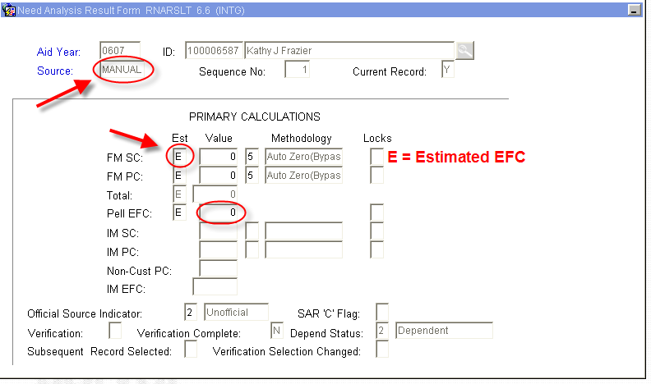

- Exit to return to RNANA07
- Exit to return to main Banner Menu

***Note: The student will not be picked up by Tracking, Budgeting or Awarding - this will have to be done manually.
* * * E N D * * *

