 | LINK Financial Aid | 

FA-103 Previous Year Over Awards

Date Issued/Rev: 11/03/05
General Description: This procedure explains how to log on Previous Year Over Awards on the resource form.
Responsible Manager: Director of Financial Aid
Related Procedures:

Related Forms: RPAARSC
RPAAWRD

1. Go to RPAARSC
2. ID: Type the student’s Banner ID number.
3. Select “Next Block”
4. Select “Insert Record”
5. Enter “PYOVER” code in resource field.
6. Enter the amount of the previous year’s over award in the Actual Amount Field.
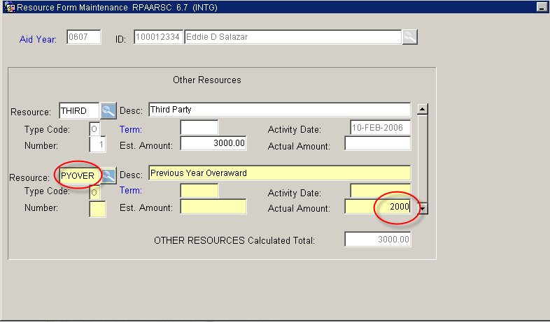
7. Select “Save” and “Exit”
8. Go to RPAAWRD to see if a current year over award has been created.

