 | LINK Financial Aid | 

FA-104 Loan Aggregate Override

Date Issued/Rev: 11/03/05
General Description: This procedure explains how to override Loan Aggregate limits, when a student’s LAGG is resolved, but not yet cleared on RNASL07
Responsible Manager: Financial Aid Director
Related Forms: RNASL07
RNARSLT
RHACOMM
RRAAREQ

PROCEDURE
Procedure:
1. Go to RNASL07 and confirm that either the Sub or Combined loan limits indicator is an “E”
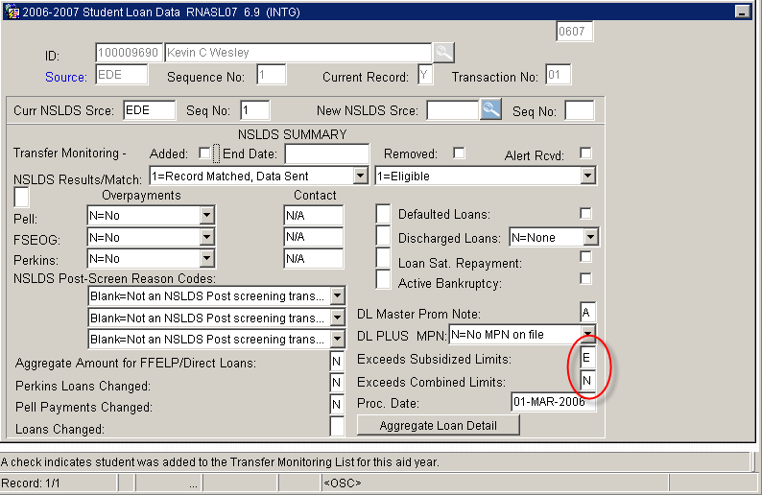
2. Select “Exit”
3. Go to NSLDS and verify that student is no longer exceeding their loan aggregate limits.
4. Go to RHACOMM
5. ID: Type the student’s Banner ID number.
6. Select “Next Block”
7. Enter aid year
8. Type note indicating that the loan aggregate issue has been resolved, and verified on NSLDS. (Put copy of NSLDS screen print in student’s file.)
9. Select “Save” and “Exit”
10. Go to RNARSLT
11. Select “Next Block” three times
12. Select “L=Limit Tests” from the NSLDS OVERRIDE field.
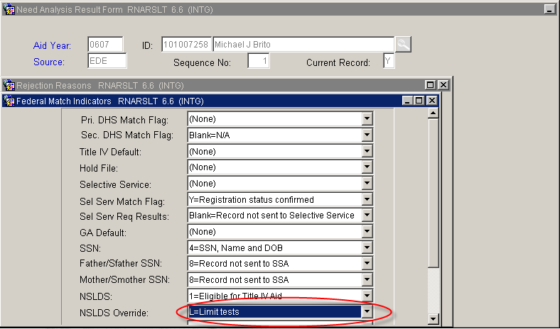
13. Select “Save” and “Exit”
14. Go to RRAAREQ
15. Complete the LAGG mnemonic.
16. Select “Save” and “Exit”

* * * E N D * * *

