Student Financial Aid

FA - 105 Summer Budgeting and Awarding

Date Issued/Rev: 04/03/07
General Description: This procedure explains how to budget and award students for the summer term.
Responsible Manager: Financial Aid Director
Related References: FA – 106 Summer 2007 Aid and Loan Periods
FA – 107 Summer 2007 Budgets and Components
Related Procedures: FABU – 104 Change Aid Period for Student
FABU – 107 Add Budget Component – Individual
FAPK – 108 Packaging a Fund Manually
FAPK – 112 Change the Term Distribution of a Fund
FALN – 103 Award an Electronic Loan to a Student
FALN – 107 Change Lender
Related Forms: ROAENRL
RBAABUD
RNAOVxx
RPAAWRD
RPAELAP

PROCEDURE
Procedure:
1. Receive summer request form from student.
2. Verify student’s enrollment (including hours and weeks enrolled) on ROAENRL
3. Select summer term (e.g. 200760 – Summer 2007) in CURRENT HOURS section of ROAENRL
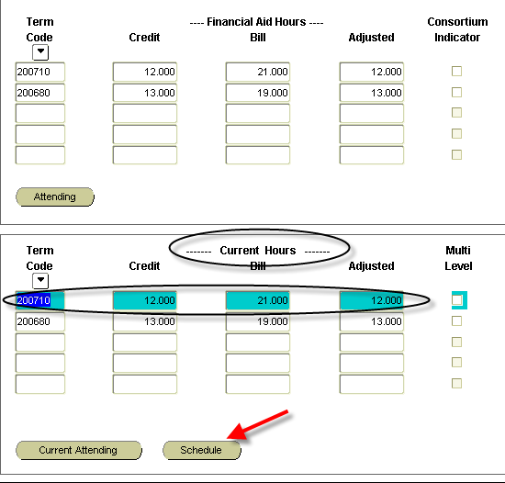
4. Click SCHEDULE button, to display weeks of enrollment for the term.
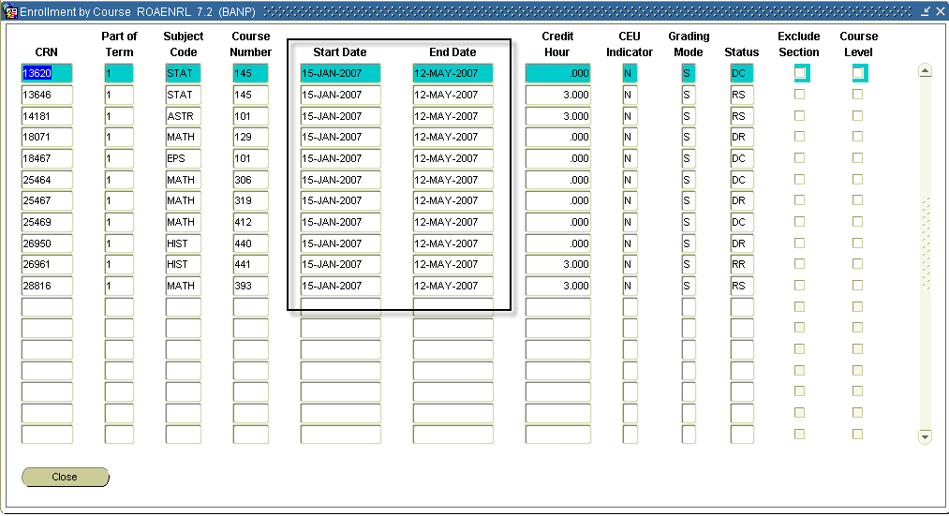
5. Calculate the amount of weeks that student is enrolled from START DATE to END DATE.
- Summer 2007 examples
  - June 4, 2007 – June 30, 2007 – 4 weeks (First Four Weeks)
  - June 4, 2007 – July 14, 2007 – 6 weeks
  - June 4, 2007 – July 28, 2007 – 8 weeks
  - July 2, 2007 – July 28, 2007 – 4 weeks (Second Four Weeks)
6. Determine appropriate aid period (see FA – 106 Summer Aid and Loan Periods).
7. Go to RBAABUD
8. Next block into the form, then previous block twice to get to aid period field (or click in aid period field)
9. Enter appropriate aid period code.
10. Select CREATE BUDGET budget.
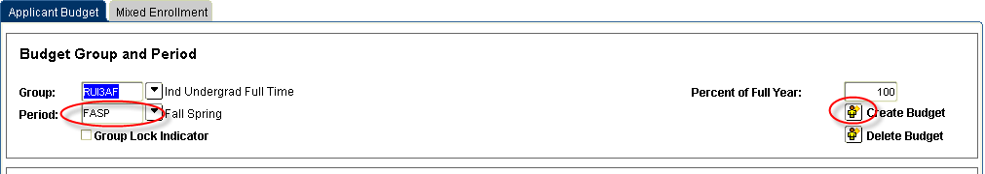
11. Next block to bottom of form.

12. Insert the summer budget components (see FA – 107 Summer 2007 Budgets and Components).
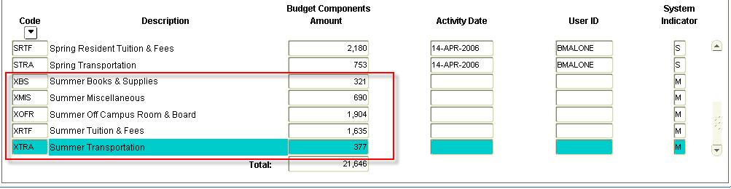
13. Save
14. Go to RNAOVxx (for summer 2007 – use RNAOV07)
15. Next block and unlock the record by changing the Y to N in the LOCK CURRENT RECORD field.
16. Save
17. Next block and change the BUDGET DURATION under FM-STUDENT to the appropriate months (see FA – 106 Summer Aid and Loan Periods).
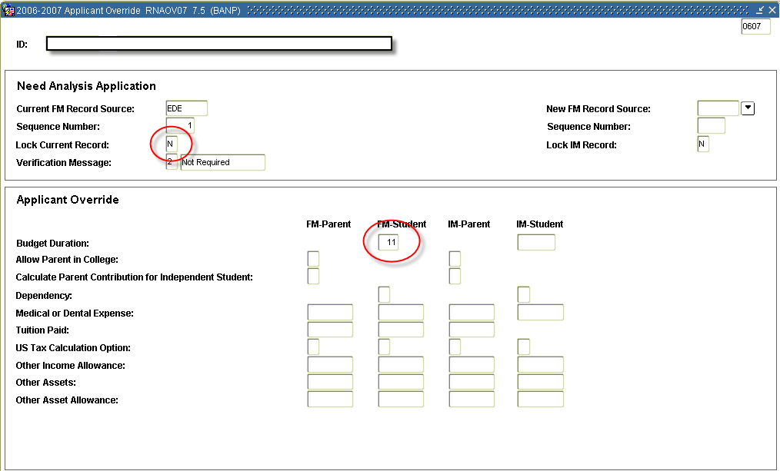
18. Save
19. Select OPTIONS from menu

20. Select CALCULATE NEED (or use F3, and not OPTIONS, to CALCULATE NEED)

21. You will be taken to RNARSxx (RNARS07 for summer 2007) to review the new EFC. (Note: This will only change for dependent students exceeding nine months. However, you still need to perform this step.)
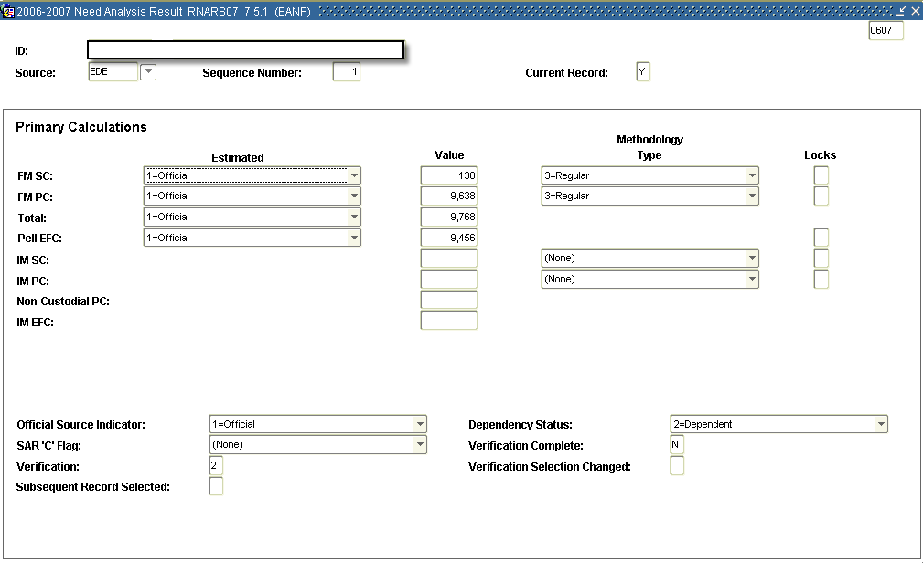
22. Exit form (you will return to RNAOVxx – exit that form, as well.)
23. Go to RPAAWRD
24. If you are adding onto an existing award – go directly to the second block (AWARD BY TERM block).
- If you are creating a new award, enter it on the first block first (when you award it in this fashion it will distribute it according to the aid period – continue onto the AWARD BY TERM block in order to verify that the award is distributed as you intended.)
25. On the AWARD BY TERM block, go to the award(s) you need to adjust.
26. If the summer term does not exist for the award you are adjusting, INSERT RECORD.
27. Enter the term (e.g. 200760), OFFERED, ACCEPTED, and LOAD fields.
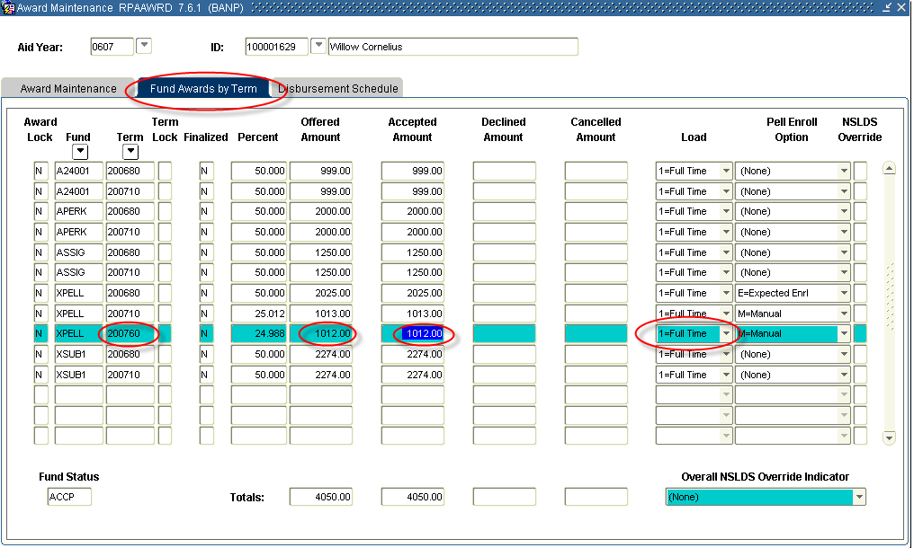

Load | Full Time | ¾ Time | ½ Time
Hours | 6 | 4 | 3

28. Save.

DETERMING SUMMER PELL ELIGIBILITY
1. Determine if student is Pell eligible (first bachelors, degree seeking, EFC eligible, SAP)
2. Determine weeks enrolled, Pell EFC,and enrollment status.
3. Calculate maximum award (see 2006-2007 Pell chart for annual award for enrollment status)
Annual award for enrollment status X weeks enrolled/32 = Maximum pell award
Example: Full time student with zero EFC, enrolled 8 weeks
$4050 x 8/32 = $1013
4. Determine maximum remaining Pell eligibility. Subtract fall and spring Pell amounts received from annual maximum award.
Annual award received fall/spring – Maximum summer pell award
Example: Student received $2025 fall/ $1519 spring ($3544 total)
$4050 - $3544 = $506
5. Determine summer award. Award summer maximum award (#3), or remaining eligibility (#4), which ever is LESS.

SPECIAL PROCESSING FOR LOANS
1. In addition to checking NSLDS, make sure you consider any loans awarded in 07-08 that may not yet be reflected on NSLDS.
2. If you have increased, or awarded a loan, go back to the first block.

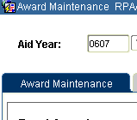

3. Select OPTIONS, then CREATE LOAN APPLICATION (this will take you to RPAELAP).
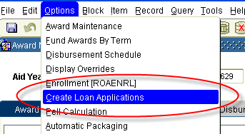
4. On RPAELAP, enter the appropriate LOAN PERIOD (see FA – 106 Summer Aid and Loan Periods).
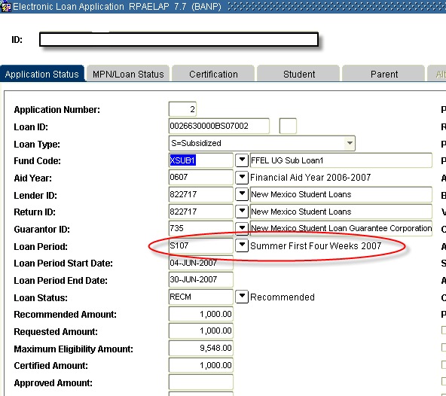

5. Save

NEW LOAN LIMITS EFFECTIVE JULY 1, 2007
- Freshmen maximum rises to $7,500 (no more than $3,500 in subsidized funds)
- Sophomore maximum rises to $8,500 (no more than $4,500 in subsidized funds)
- Graduate maximum rises to $20,500 (no more than $8,500 in subsidized funds)
- Teacher Certificate maximum rises to $12,500 (no more than $5,500 in subsidized funds)
- These increases cannot be disbursed until July 1, 2007. As a result, the student must still be enrolled for the summer term, in order to be considered for the increase.
- However, the student’s full budget can be used when considering loan eligibility (i.e. their full continuous period of enrollment).

When awarding these amounts, you would do all the steps listed above, in addition to the steps listed below:

1. On RPAAWRD, you will need to award the new amount, and SAVE. The award should reject based on Federal Loan Limits. You will then need to select Y in the OVERRIDE field for that fund, and SAVE again. (When Banner 7.8 is released in late April/early May, you can do the OVERRIDE before saving, saving one step.)
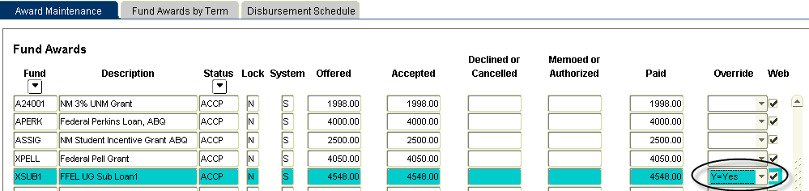

2. When you create the loan application, you will still need to change the loan period (if applicable). However, the loan will CERTIFY for zero dollars. Go to the CERTIFICATION tab and enter the proper certification number. YOU WILL HAVE TO DO THIS FOR ANY LOAN THAT USES THESE EXPANDED ELIGIBILITY AMOUNTS. This should only occur during the 2007 summer, as these changes are in Banner for the 07-08 year. (Sungard decided not to make these amount changes for the 06-07 year, to limit the possibility of awarding and disbursing the higher amounts prior to July 1, 2007.)

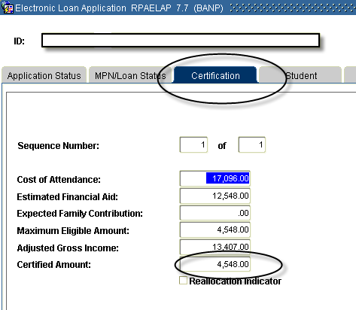

* * * E N D * * *

