 | LINK Financial Aid | 

FA-202 Updating Tracking Files for Students Not Attending

Date Issued/Rev: 05/01/06
General Description: This procedure explains how to update tracking files for students who will not be attending UNM.
Responsible Manager: Financial Aid Director
Related Procedures:
Related Forms: RRAAREQ
RHACOMM

PROCEDURE
Procedure:
1. Receive documentation indicating student will not be attending UNM.
2. Go to RRAAREQ
3. Perform “Next block”
If all Documents are Complete skip to step 6.
4. Tab to the “Status Ind” field and change all “unsatisfied” documents to a “Status” of “Z” (Z = Student Not Attending).
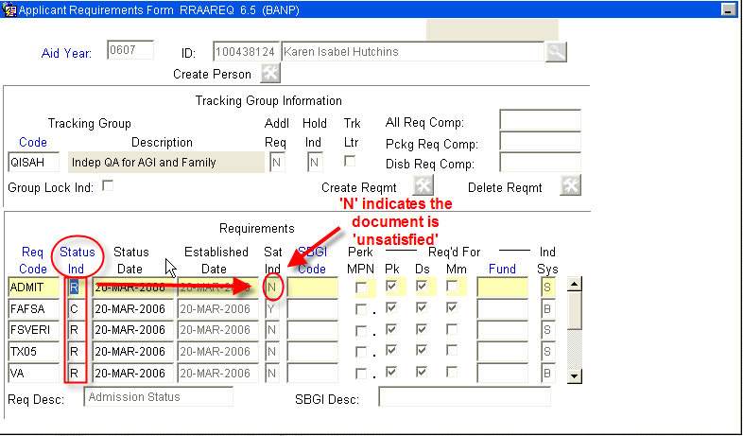
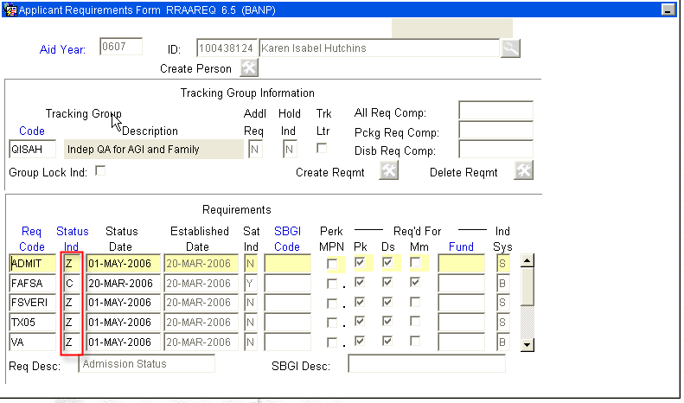
5. Save
6. Click in the Tracking Group Information Block and indicate “NOATND” in the Tracking Group Code Field.
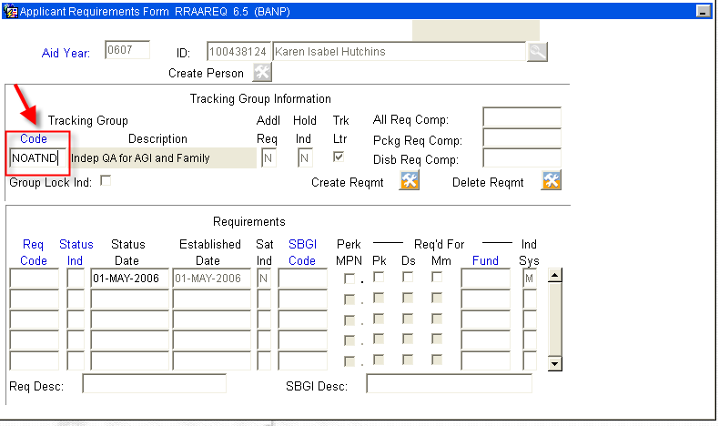
- Next, Press the “Create Reqmt” button .
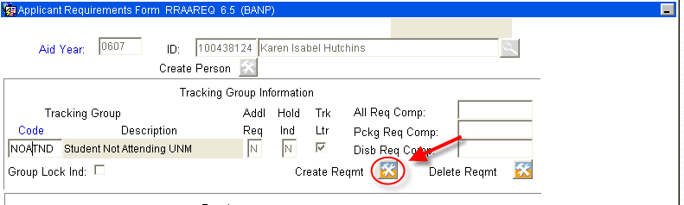
The Status Bar will indicate .

- Re-click the Tracking Group Information Block and deselect the “Trk Ltr” box (so the student does not receive an MIL) and select the “Group Lock Ind” box.
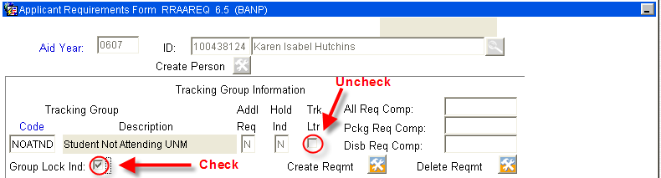

- Save and Exit
10. Go to RHACOMM
Leave note that should include:
- Written confirmation was received from the student that they will not be attending UNM.
11. Save and Exit

***Note: The student will see the tracking doc with “Student Not Attending” as the status on self-service. The student will receive no further MILs.
* * * E N D * * *

