 | LINK Financial Aid | 

FA-203 Override Independency (Approval)

Date Issued/Rev: 05/01/06
General Description: This procedure explains how to override independency.
Responsible Manager: Financial Aid Director
Related Procedures:
Related Forms: RRAAREQ
ROAMESG
RNAOV07
(RNARSLT)
RHACOMM
RNIMS07

PROCEDURE
Procedure:
1. Verify the Independency Petition is complete and approved and a FAFSA is on file in Banner.
***NOTE: If FAFSA is not on file. STOP here! Submit documentation to Processor for STAGE 0.
2. Go to RRAAREQ
3. Insert record
4. Type the Independency Petition mnemonic “INDPET” in new record.
5.a. If the Independency Petition is complete and approved, and an EDE will be sent to override the dependancy
- Enter “C” in Status Ind” field for the Independency Petition
- Change the FAFSA “Status Ind” to “E” - indicating that an EDE will be sent
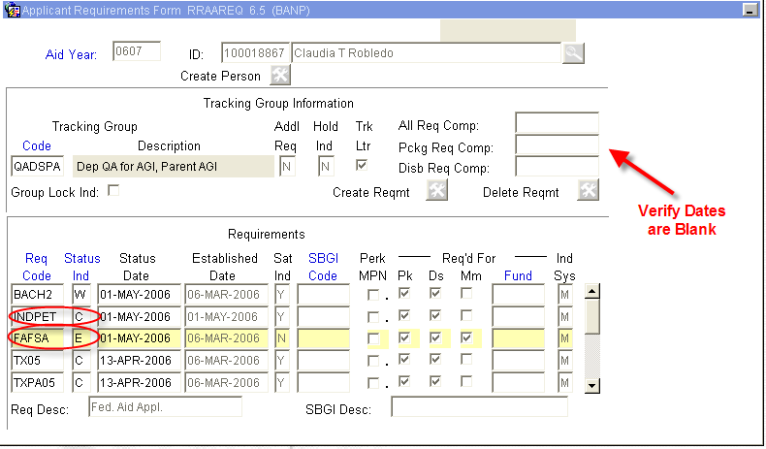
- Also, be sure the “Trk Ltr” box is unchecked (if not, uncheck it)
        - Note: a checked box will generate a MIL
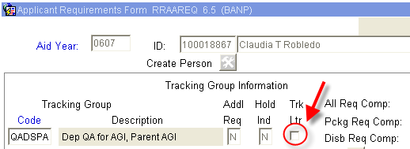
5.b. If Independency Petition is incomplete enter “I” (for ‘Received Incomplete’ status) or “A” (for Additional Information Needed”)
- Save and Exit
- Go to ROAMESG - to send an active message to the student.
- Perform “Next block”
- Tab to “Date” field (leave Message Code field blank)
- Enter date you want message to expire (if no date is entered, the Message will remain active for 1 month)
- Enter your message explaining why Independency Petition is incomplete
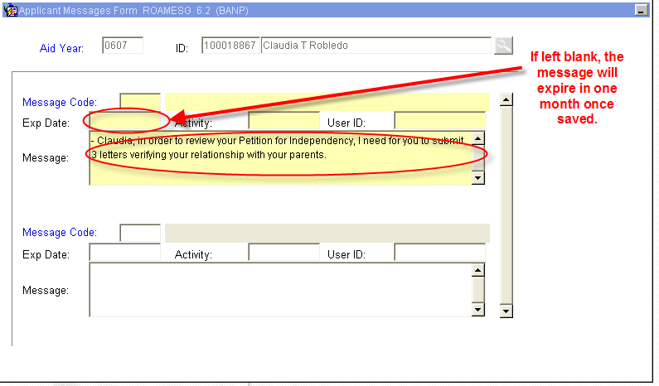
- Save and Exit
6. Go to RNAOV07
7. Perform “Next block”
8. In the Dependency Field, enter ‘I’ for Independent
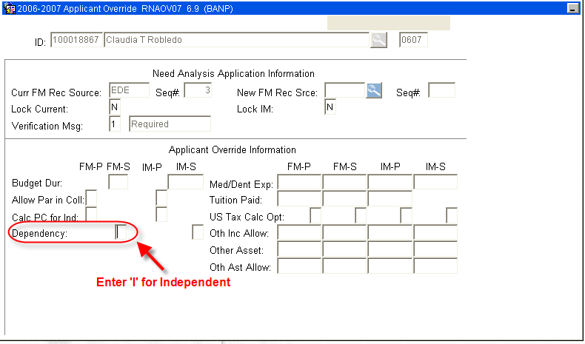
9. Save (by saving you will be generating an EDE to override the dependency status.
10. The ‘Status Bar’ will indicate
11. Next, recalculate need by selecting “Calculate Need” from the Options Menu (or Quick Key F3). This will perform a Need Analysis Calculation and you will be automatically taken to RNARSLT.
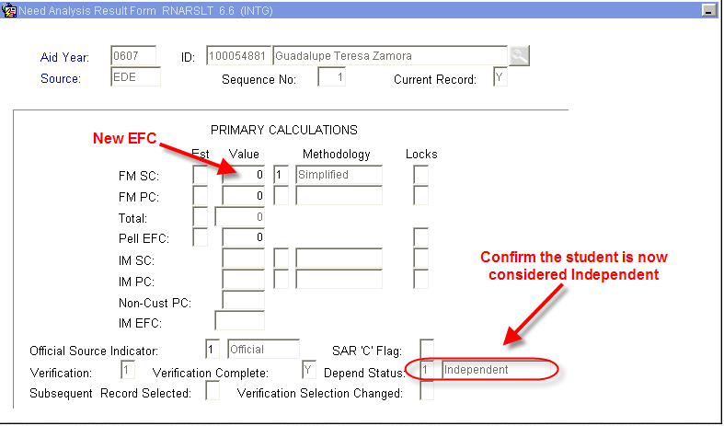
13. Exit will return you to RNAOV07
14. Exit again, will return to the main Banner Menu
15. Access RHACOMM, leave message regarding:
  - Decision on Independency Petition
  - EDE was sent to override Independency Status
16. Wait for EDE to return - turn-around time is between 2 and 4 days. If EDE appears to take an excessive amount of time to return. Please notify a manager.
***Note: When the EDE returns, the FAFSA on RRAAREQ will update from ‘E’ to ‘C’ with the date of the return.
When the EDE returns, you can also verify the Independency update on the second block of RNIMS07
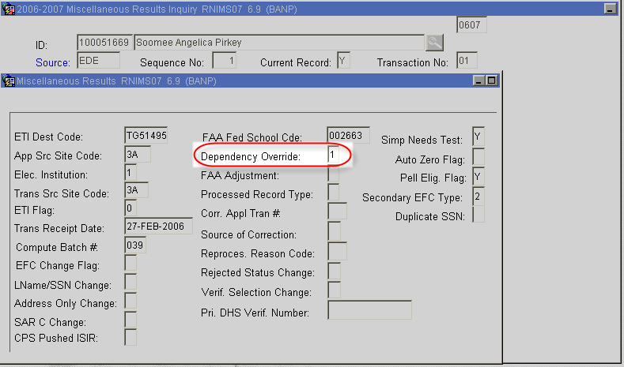

* * * E N D * * *

