 | LINK Financial Aid | 

FA-204 Special Circumstances (Approval)

Date Issued/Rev: 05/01/06
General Description: This procedure explains how to log Special Circumstances.
Responsible Manager: Financial Aid Director
Related Procedures:
Related Forms: RRAAREQ
ROAMESG
ROAPELL
RNAPR07
(RNARSLT)
RHACOMM
RNANA07

PROCEDURE
Procedure:
1. Verify the Special Circumstance is completed, approved and a FAFSA is on file in Banner.
2. Go to RRAAREQ
3. Insert record
4. Type the Special Circumstance mnemonic “SCAPI/SCAPD” (SCAPI = Special Circumstance for Independent Students; SCAPD = Special Circumstance for Dependent Students) in new record.
5.a. If the Special Circumstance is completed and approved, an EDE will be sent to override the current ISIR information.
- Enter “C” in Status Ind” field for the Special Circumstance
- NOTE: ***Only if you will be sending the EDE
  - Change the FAFSA “Status Ind” to “E” - indicating that an EDE will be sent.
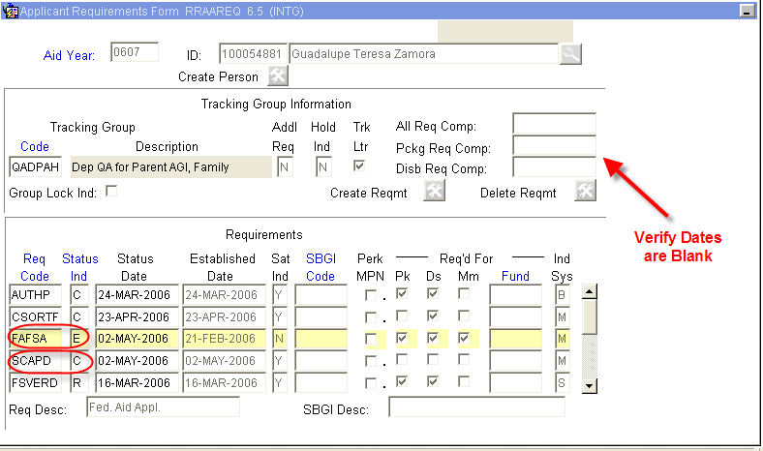
- Be sure “Trk Ltr” box is unchecked (if not, uncheck it):
Note: a checked box will generate a MIL
- Lock the Tracking Group - (this is to ensure the when the corrections return it does not affect the requested tracking docs).
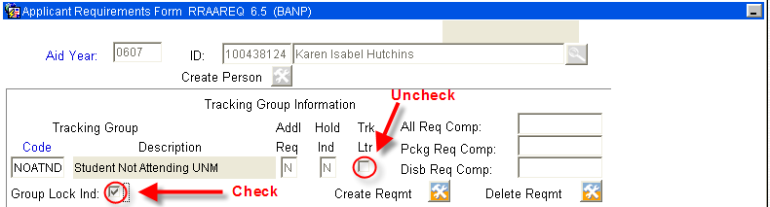
5.b. If Special Circumstances is incomplete enter “I” (for ‘Received Incomplete’ status) or “A” (for Additional Information Needed”)
- Save and Exit
- Go to ROAMESG - to send an active message to the student.
- Perform “Next block”
- Tab to “Date” field (leave Message Code field blank)
- Enter date you want message to expire (if no date is entered, the Message will remain active for 1 month)
- Enter your message explaining why the Special Circumstances is incomplete
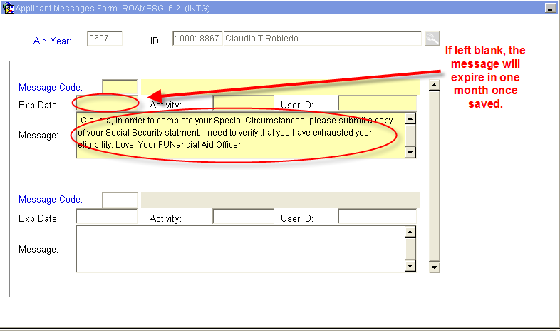
- Save and Exit
- Go to ROAPELL to note the current EFC
  - Perform “Next block”
  - Note the EFC currently on ROAPELL. The Primary Pell EFC (INAS Calculation) will change once the Special Circumstance is saved. When the EDE returns, the Primary SAR EFC (ISIR EFC) will match.
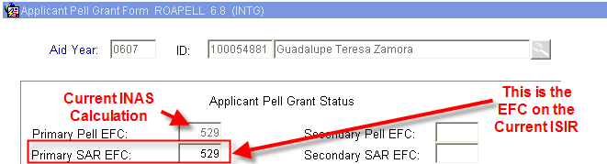

7. Go to RNAPR07
8. Before You Perform a Next Block, Tab to “FM Srce” Field and indicate “SIM” (this is to first simulate an EFC).
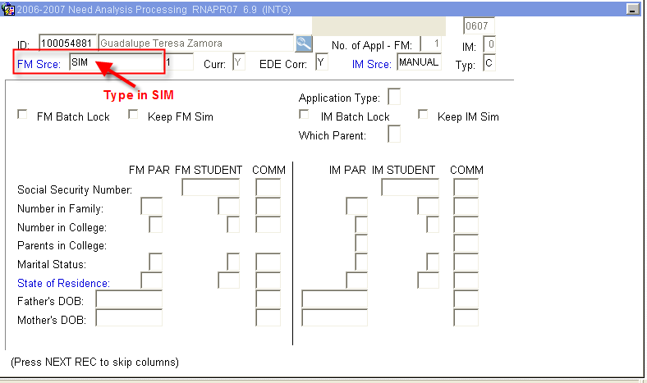
  - Perform “Next block”
- Enter the amounts that will be changing as a result of the Special Circumstances in the “FM PAR” Fields or the “FM STUDENT” Fields.
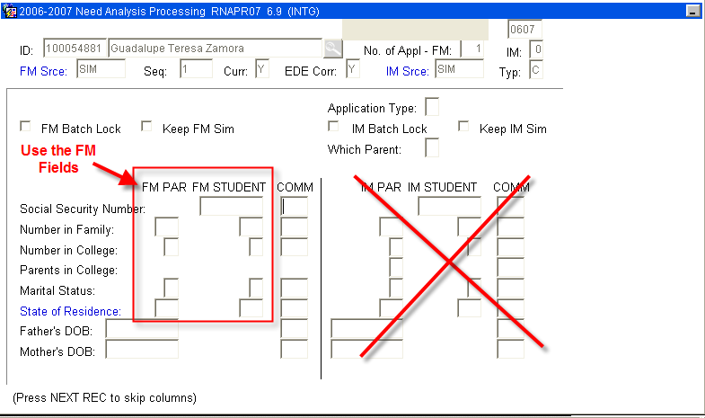
Most of Special Circumstance changes will take place on the Second Block of RNAPR07 (note the scroll bar to access the Work Sheet A, B, C information
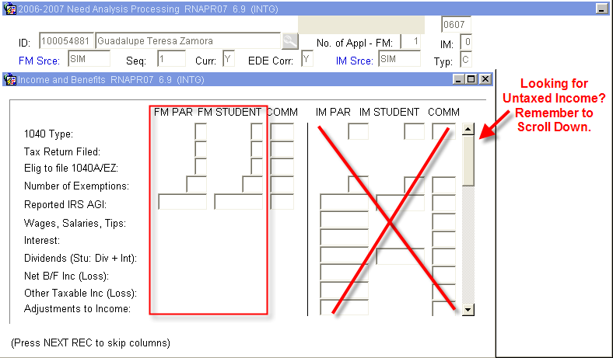
- Once changes are entered, Save
- The ‘Status Bar’ will indicate
- Next, recalculate need by selecting “Calculate Need” from the Options Menu (or Quick Key F3). This will perform a Need Analysis Calculation and you will be automatically taken to RNARSLT.
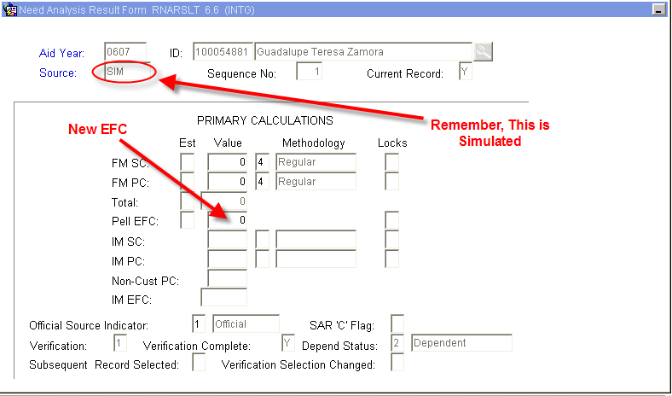
13. Exit will return you to RNAPR07.
14. Return to the First Block of RNAPR07 - to keep the Special Circumstance Changes and generate an EDE, “check” the “Keep FM Sim” Box and Save ,
  - The ‘Status Bar’ will indicate (An EDE will be sent)
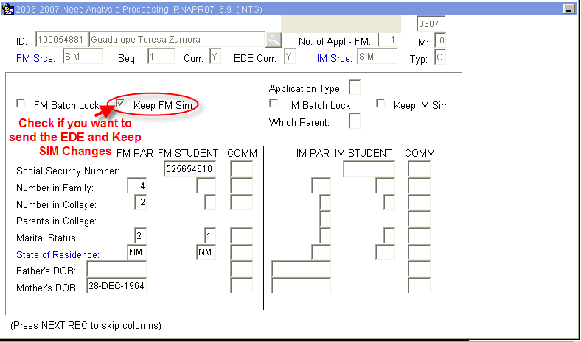
15. Access ROAPELL to verify EFC changes
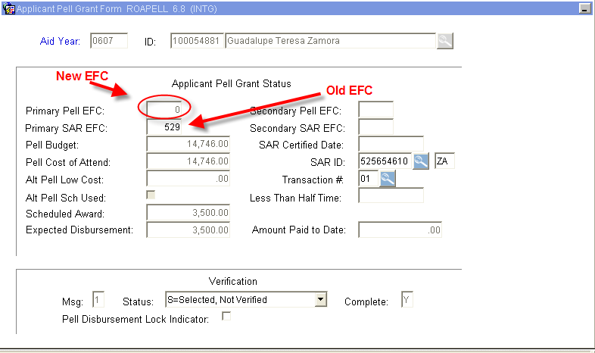

16. Access RNANA07 to indicate Professional Judgment was used by updating the “Prof. Judgdment Used” Field with a “Y” - (the last Block of RNANA07)
  - Save
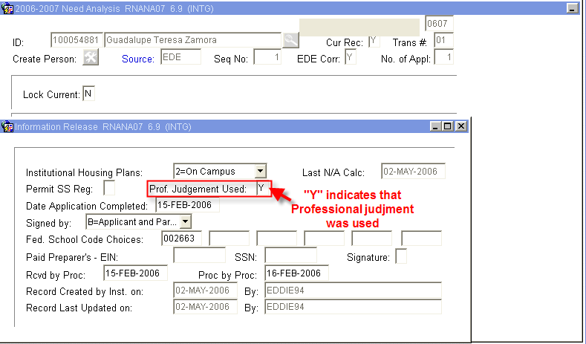
15. Access RHACOMM, leave message regarding:
  - Decision on Special Circumstance
  - Reason EDE was sent
16. Wait for EDE to return - turn-around time is between 2 and 4 days. If EDE appears to take an excessive amount of time to return. Please notify a manager.
***Note: When the EDE returns, the FAFSA on RRAAREQ will update from ‘E’ to ‘C’ with the date of the return and the EFCs on ROAPELL will match.
* * * E N D * * *

