 | LINK Financial Aid | 

FA-205 Processing a BACH2

Date Issued/Rev: 05/01/06
General Description: This process describes how to process a BACH2.
Responsible Manager: Financial Aid Director
Related Procedures:
Related Forms: RNANA07
A BACH2 Form will be requested if a student answers:
  - “1st Bachelor’s Degree by 01-JUL” field = ‘1’ (Yes) AND student is NOT admitted into a UNM Graduate program; OR
  - “Year in College” field is ‘6’ (1st YR Grad/Professional) or 7 (Cont Grad/Professional or Beyond) AND student is NOT admitted into a UNM Graduate Program; OR
  - “Degree/Cirt” field = ‘8’ (Grad/Professional) AND student is NOT admitted into a UNM Graduate Program; OR
  - “Graduate or Professional” field = ‘1’ (Yes) AND Student is NOT Admitted into a UNM Graduate Program; OR
  - “Degree/Cirt” field = ‘2’ (2nd Bachelors Degree)

On the MIL and LoboWeb, the BACH2 form requests:
- Admission to Grad Program/Level in 2nd Bachelor's Program

And a message of:
- According to our records, you have indicated you will be working on a degree beyond your first Bachelor's Degree for the 2006-2007 school year, however, you have not been admitted into a graduate or professional program. To receive financial aid you must be fully admitted to a UNM Graduate Program OR be admitted in to a 2nd Bachelor's Degree Program. Once you complete the graduate admissions process, our records will update automatically. If you are working on a Second Bachelor's Degree please complete and return the enclosed form.
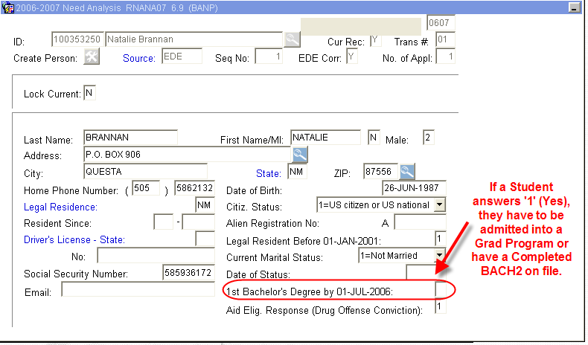
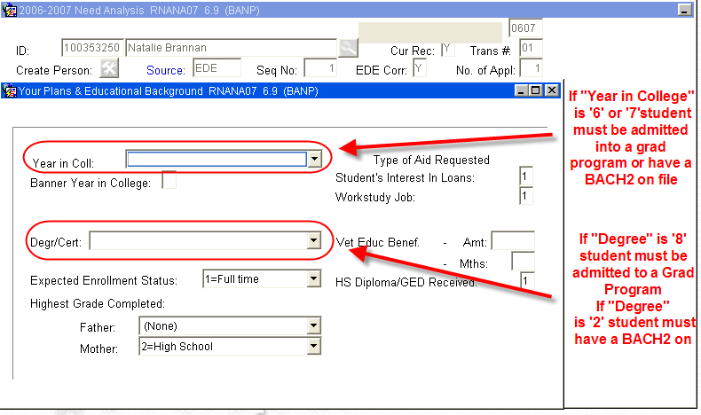

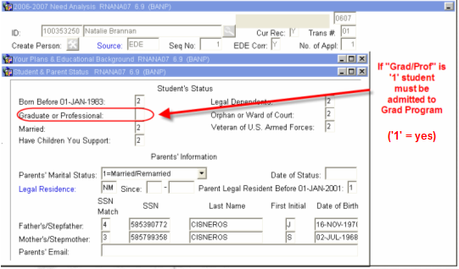
These 4 above fields are related to one another. They should always be consistent with each other and with the documentation on RRAAREQ.

If a student is receiving a BACH2
- “1st Bachelor’s Degree by 01-JUL” field = ‘1’ (Yes)
- “Year in College” field between ‘0’ and ‘5’. (0 = 1st time freshman; 5 = 5th Year/other undergrad)
- “Degree/Cert” field = ‘2’ (2nd Bachelors Degree)
- “Graduate or Professional” field = ‘2’ (No)
**Note: BACH2 students can be considered dependents

If student is a Graduate Student:
a. “1st Bachelor’s Degree by 01-JUL” field = ‘1’ (Yes)
- “Year in College” field = ‘7’ OR ‘8’. (7 = 1st time Grad/Prof; 8 = Con’t Grad/Prof)
- “Degree/Cert” field = ‘8’ (Grad/Prof)
- “Graduate or Professional” field = ‘1’ (Yes)
**Note: Grad students are considered Independent
If a student is an Undergraduate Student (neither BACH2 nor Grad Student):
- “1st Bachelor’s Degree by 01-JUL” field = ‘2’ (No)
- “Year in College” field between ‘0’ and ‘5’. (0 = 1st time freshman; 5 = 5th Year/other undergrad)
- “Degree/Cert” field = ‘1’, ‘3’, ‘4’, ‘5’, OR ‘6’ (1 = First Bach Degree, 3 = Assoc Degree, 4 = Assoc Degree, 5 = Cert/Diploma, 6 = Cert/Diploma)
- “Graduate or Professional” field = ‘2’ (No)
**Note: Undergraduate students may be considered Dependents

Changing and saving any of the fields below will result in an EDE being sent - you may want to consult your friendly processor before making any of these changes on RNANA07:
- First Bachelors Degree by July 1
- Degree/Cert (This is a change from the FAM system)
- Graduate Professional

PROCEDURE if the student is in a Second Bachelor’s Degree
Procedure:
- Verify documentation is complete and has appropriate signatures.
- Confirm first Bachelor’s Degree on either RSIPCOL or RSIDEGR
RSIPCOL
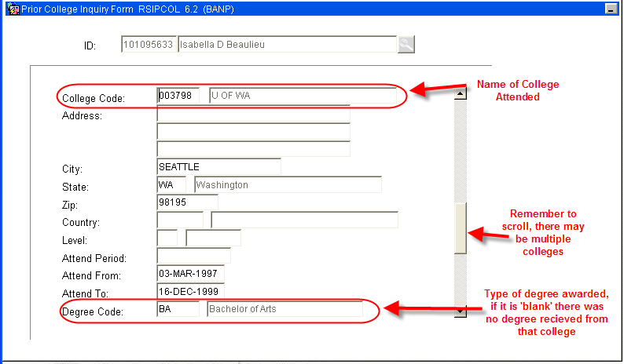

RSIDEGR will display if a Degree is “Pending” or has been received (“Confirmed”) from UNM -
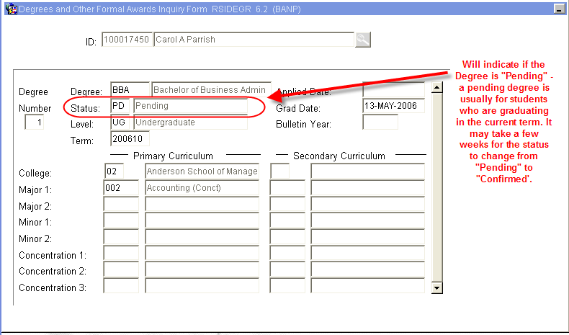
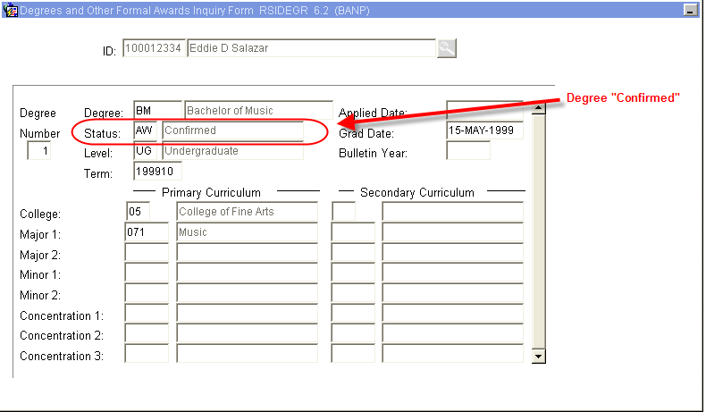
- Verify Student Information on RNANA07. For a BACH2 RNANA07 should read:
  - “1st Bachelor’s Degree by 01-JUL” field = ‘1’ (Yes)
  - “Year in College” field between ‘0’ and ‘5’. (0 = 1st time freshman; 5 = 5th Year/other undergrad)
  - “Degree/Cert” field = ‘2’ (2nd Bachelors Degree)
  - “Graduate or Professional” field = ‘2’ (No)
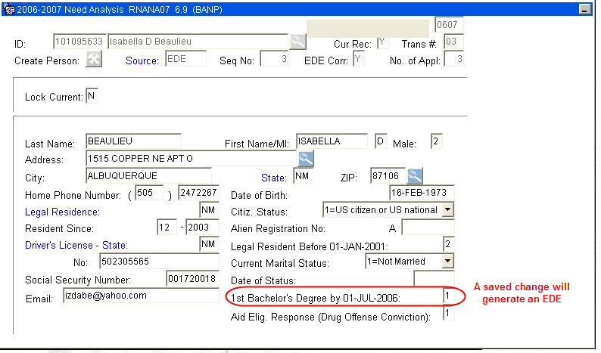
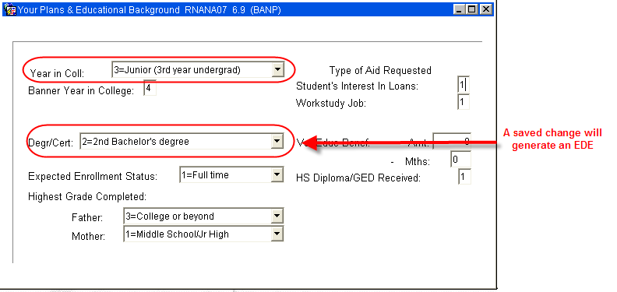
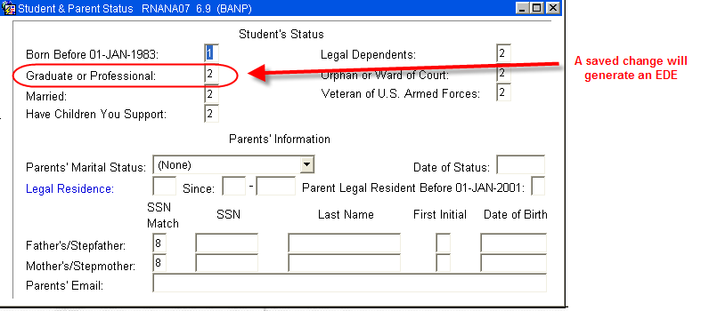
***Make note of any saved changes that will generate an EDE
Changing and saving any of the following fields will result in an EDE being sent:
- First Bachelors Degree by July 1
- Degree/Cert (This is a change from the FAM system)
- Graduate Professional

- Access RRAAREQ, update BACH2 status to ‘C’ for complete
IF an EDE is being sent, update FAFSA to ‘E’
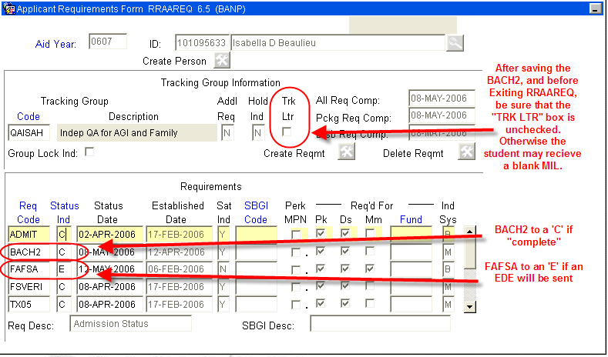
- Access RHACOMM and leave a note regarding the BACH2 (If an EDE is being sent, be sure to include information about the EDE in the note.
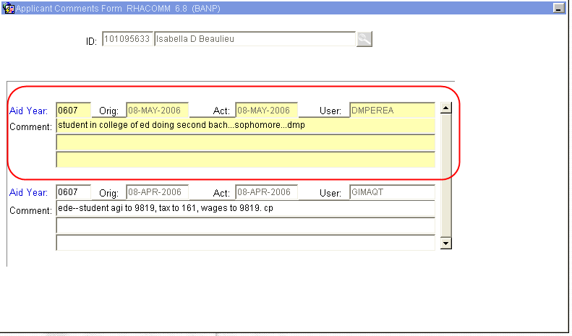
PROCEDURE if the student is a Graduate Student
Procedure:
- There is no need to update any information on RRAAREQ. Once the student is admitted into a Graduate program, the BACH2 request will be waived by the system.
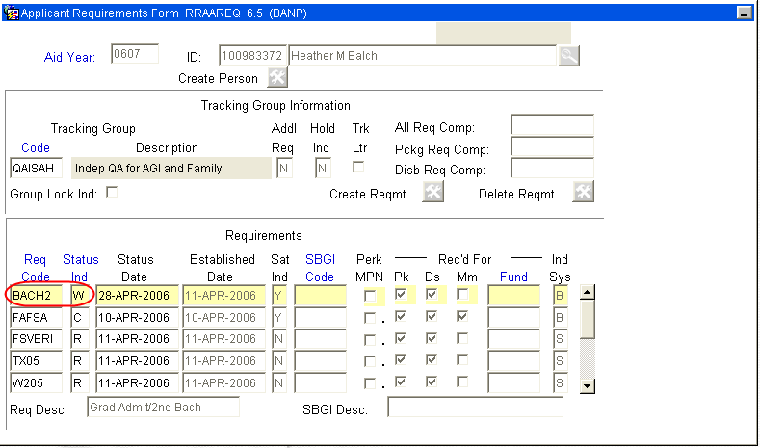
- The BACH2 was waived because the student has been fully admitted into a graduate program. This can be verified on RSISTDN and RSIAPPL.

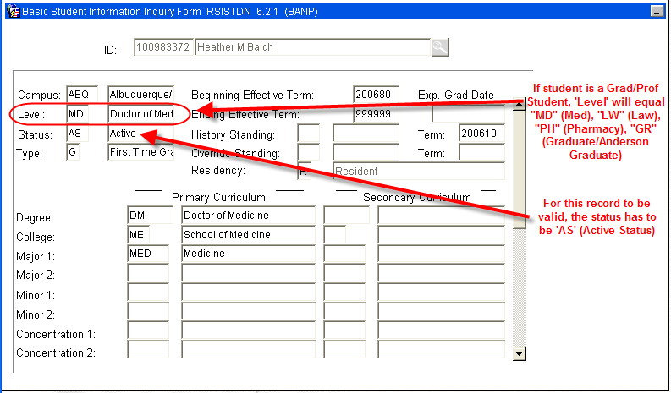
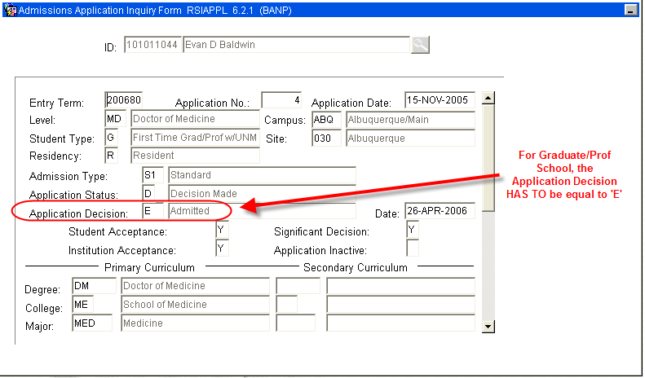
***NOTE - if Application decision is not equal to ‘E’, the student may be provisionally admitted. If this is the case, the system will waive the BACH2 request and request a GADMIT (-Confirmation of Full Admission into a Graduate Program).
- Verify Student Information on RNANA07. For a Graduate Student RNANA07 should read:
  - “1st Bachelor’s Degree by 01-JUL” field = ‘1’ (Yes)
  - “Year in College” field = ‘7’ OR ‘8’. (7 = 1st time Grad/Prof; 8 = Con’t Grad/Prof)
  - “Degree/Cert” field = ‘8’ (Grad/Prof)
  - “Graduate or Professional” field = ‘1’ (Yes)
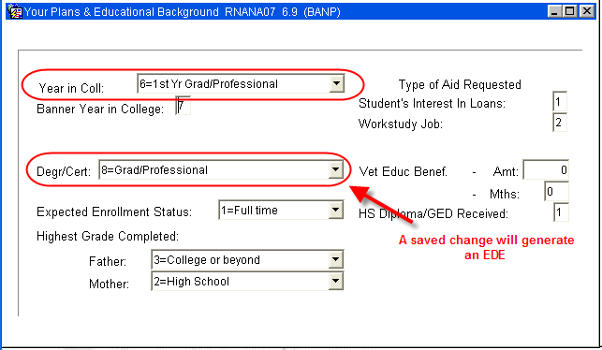
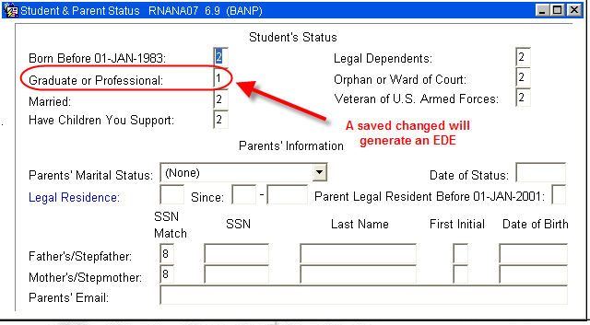
***Make note of any saved changes that will generate an EDE
Changing and saving any of the following fields will result in an EDE being sent:
- First Bachelors Degree by July 1
- Degree/Cert (This is a change from the FAM system)
- Graduate Professional
PROCEDURE if the student is an Undergraduate Student
Procedure:
- Verify Student Information on RNANA07. For an Undergraduate Student RNANA07 should read:
  - “1st Bachelor’s Degree by 01-JUL” field = ‘2’ (No)
  - “Year in College” field between ‘0’ and ‘5’. (0 = 1st time freshman; 5 = 5th Year/other undergrad)
  - “Degree/Cert” field = ‘1’, ‘3’, ‘4’, ‘5’, OR ‘6’ (1 = First Bach Degree, 3 = Assoc Degree, 4 = Assoc Degree, 5 = Cert/Diploma, 6 = Cert/Diploma)
  - “Graduate or Professional” field = ‘2’ (No)
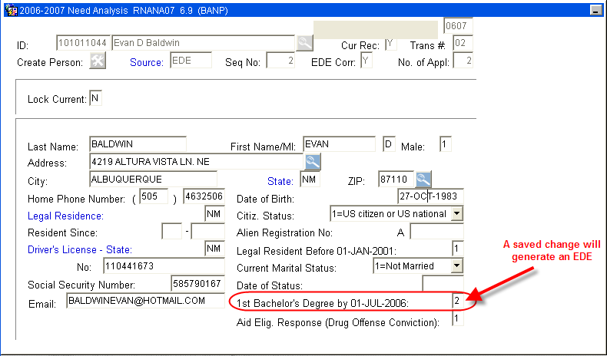
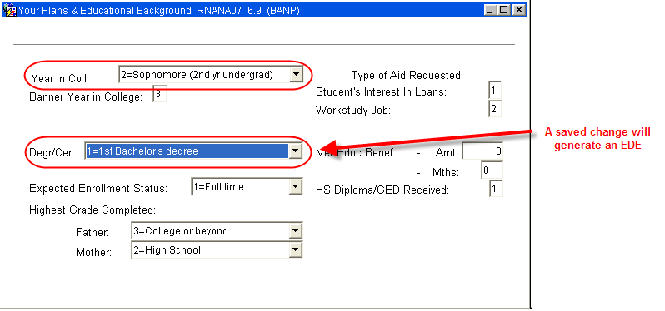

***Make note of any saved changes that will generate an EDE
Changing and saving any of the following fields will result in an EDE being sent:
- First Bachelors Degree by July 1
- Degree/Cert (This is a change from the FAM system)
- Graduate Professional

- Access RRAAREQ, update BACH2 status to ‘W’ for Waived
IF an EDE is being sent, update FAFSA to ‘E’
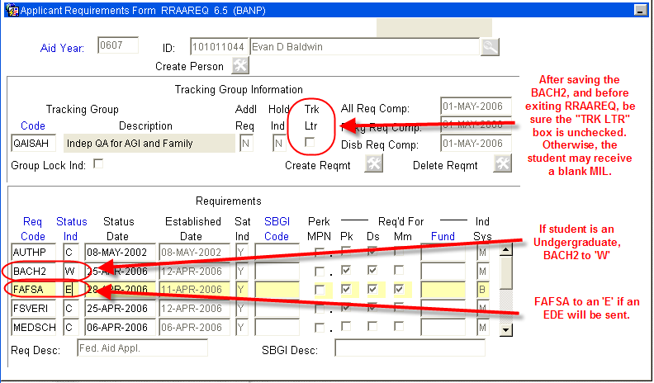
- Access RHACOMM and leave a note regarding the BACH2 (If an EDE is being sent, be sure to include information about the EDE in the note.
***Make note of any saved changes that will generate an EDE
Changing and saving any of the following fields will result in an EDE being sent:
- First Bachelors Degree by July 1
- Degree/Cert (This is a change from the FAM system)
- Graduate Professional

