 | LINK Financial Aid | 

FA-206 Processing an External Award Letter

Date Issued/Rev: 05/01/06
General Description: This procedure explains how to award an estimate from an external award letter.
Responsible Manager: Financial Aid Director
Related Procedures:
Related Forms: RRAAREQ
RPAAWRD

PROCEDURE to award an estimate from an external award letter
Procedure:
- Verify external award letter
  - The student who is issued the award.
  - The amount of the award.
  - The year for which the award is made.
  - The term (i.e. Fall, Spring, Summer)
- Access RRAAREQ
  - Perform ‘Next Block’ twice - to the ‘Non-Coded Requirements’ Block
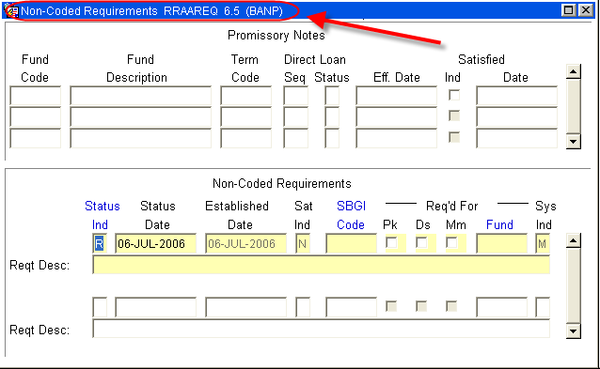

- Log the Award Letter in the ‘Non-Coded requirements” portion of the form:
  - Always enter “C” (for “complete” in the ‘Status Ind’ field
  - Tab to the ‘Fund’ Field’ enter the fund code that you are using for awarding.
    - For a list of values (F9), double click in the Fund field to search for a “Fund Code”
    - NOTE: When searching for an Estimate try %Est% or:
- Most Estimates will be A22006 “Estimated Ext Scholatship”
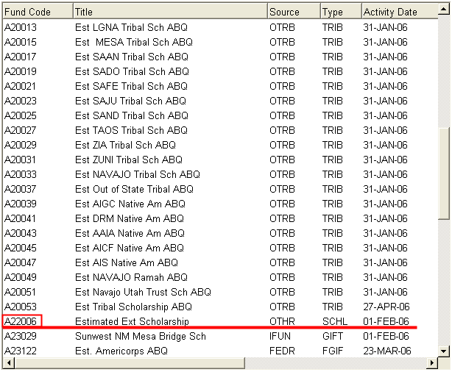

  - Once the Fund has been entered, Tab (once) to the ‘Reqt Desc’ field and enter information about the award:
NOTE: there are only 60 spaces to use, try to provide as much information in as little space as possible
- The Source of the Award
- The Term of the award (i.e. fall only $1000, fall/spg $1000 per semester)
- And that an Estimate was placed on RRAAREQ - “EST RRAAREQ”
- ‘Save’
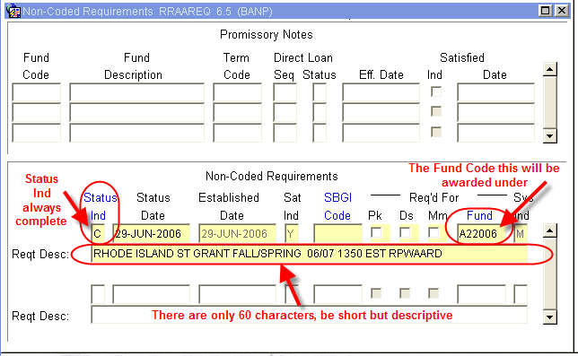
- Access RPAAWRD and award the Estimate with the Fund Code placed on RRAAREQ and ‘Save’
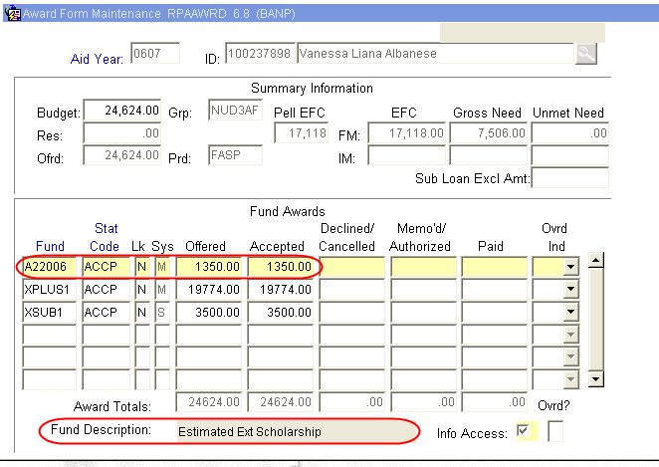
- Verify estimate does not create an Over Award. If Over Award is created, follow the procedure for correcting Over Award.
- If there is no Over Award, you may suppress the award letter. Otherwise an award letter will be sent.

~ Fin ~

