 | LINK Financial Aid | 
FA-209 PROCEDURE to Process a Tribal Check
For Officers

Date Issued/Rev: 05/01/06
General Description: This procedure explains how to process a Tribal Check.
Responsible Manager: Financial Aid Director
Related Procedures:
Related Forms: RRAAREQ
ROAMESG
ROASTAT
ROAENRL
SGASTDN

PROCEDURE to Process a Tribal Check
Procedure:
- Confirm Check Log and Student Eligibility:
      - Access RRAAREQ, Check Log
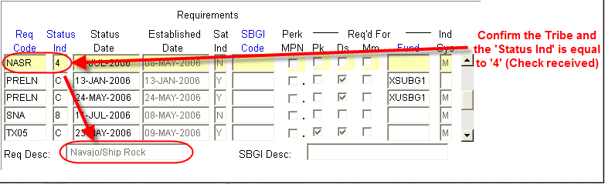
      - Next Block on RRAAREQ, Confirm Certification
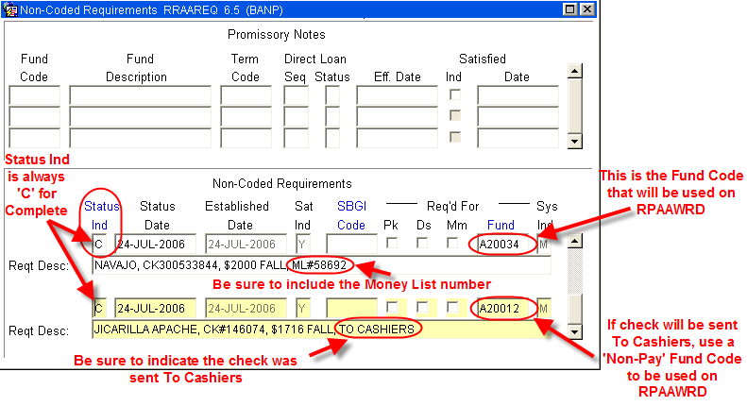

      - Access RPAAWRD, confirm Estimate Award
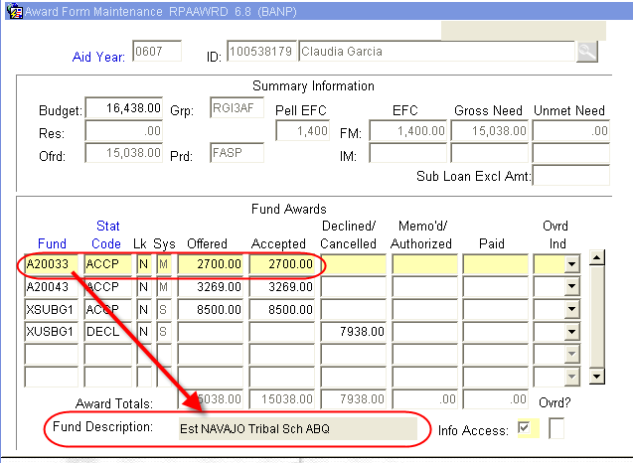
      - Access ROAENRL, Confirm Enrollment
- If Student is Enrolled Less Than Full-Time: contract Tribe to confirm fund eligibility on a less than full-time status
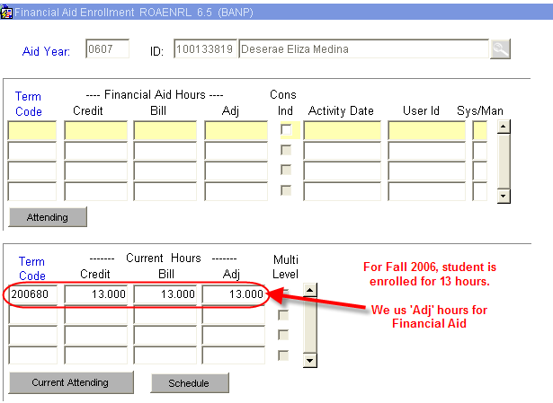

      - Access ROASTAT, Verify SAP status on second block:
- If Student is NOT Meeting Satisfactory Academic Progress: contract Tribe to confirm fund eligibility based on current SAP status.
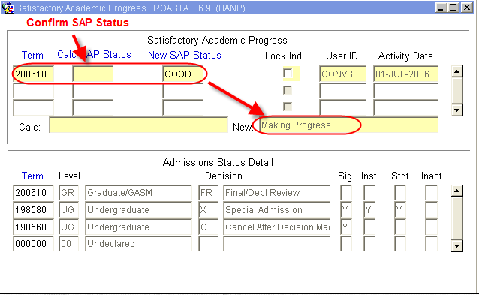

- Access RPAAWRD
      - Adjust Estimate as needed

      - Make award using Fund Code written on Check Stub (Also found on the second block of RRAAREQ)

      - If over award is created, follow over award reduction procedure)

- Access RHACOMM;
      - Leave note with the following information and in the following format:

~ Fin ~

