 | LINK Financial Aid | 
FA-209 PROCEDURE to Process a Tribal Check
For FUNDS

Date Issued/Rev: 05/01/06
General Description: This procedure explains how to process a Tribal Check.
Responsible Manager: Financial Aid Director
Related Procedures:
Related Forms: RRAAREQ
ROAMESG

PROCEDURE to Process a Tribal Check
Procedure:
- Verify external check
      - Date Stamp the check stub
      - Highlight the SSN and UNM ID, Tribe, term, and year on physical Check Stub (Add as Appropriate)
- Log Check, Access RRAAREQ
  - Look for the Needs Analysis Documentation on the First Block of RRAAREQ - the Needs Analysis name should correspond to the Tribe making the Check Payment.
    - If NO Needs Analysis: search for the appropriate Tribe and set ‘Status Ind’ to ‘4’ (Check Received)
    - IF MORE THAN ONE Needs Analysis: Be sure that you update the Needs Analysis that is tied to the Check that you logging.
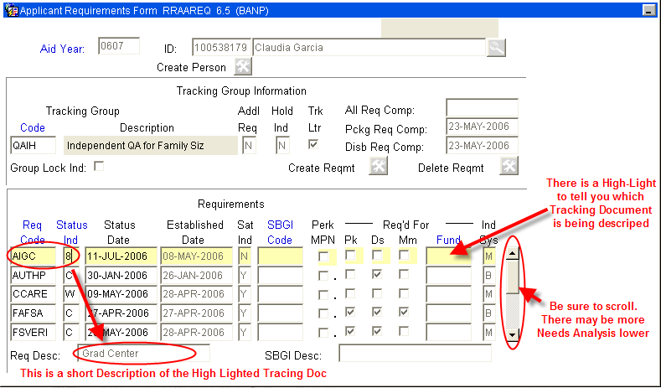
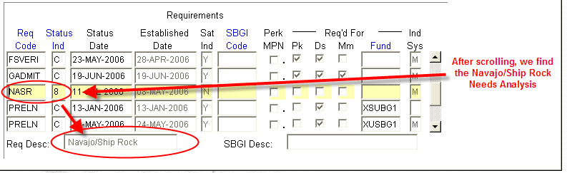
  - Update the Needs Analysis “Status Ind” with the code of ‘4’ (Check Received). This will display on self-service that the Check for this Needs Analysis has been received and suppress the Missing Information Letter.
    - NOTE: You may double click in the “Status Ind” field for a list all values. ***Numbers are used for the logging of Checks and Needs Analysis
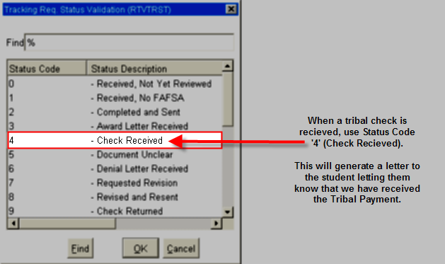
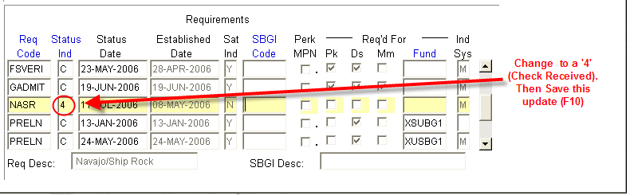
  - Save (F10)
  - Perform ‘Next Block’ - to the ‘Non-Coded Requirements’ Block
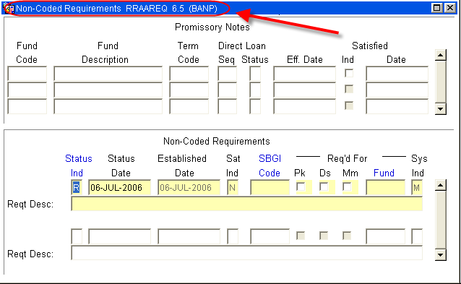
- Log the Check in the ‘Non-Coded requirements” portion of the form:
  - Always enter “C” (for “complete” in the ‘Status Ind’ field
  - Tab to the ‘Fund’ Field’ enter the fund code that you are using for awarding.
    - For a list of values (F9), double click in the Fund field to search for a “Fund Code”, This is the Fund Code the Officers will be using to award and ties the disbursement to the FOAPAL.
    - NOTE: When searching for an Tribal Fund Code try searching on a few letters that abbreviate the Tribe or the fist three letters of the Tribe. For Example: For Navajo try:
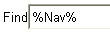
For Santo Domingo try:
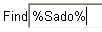
- Once the Description is found, decide which fund code to use.
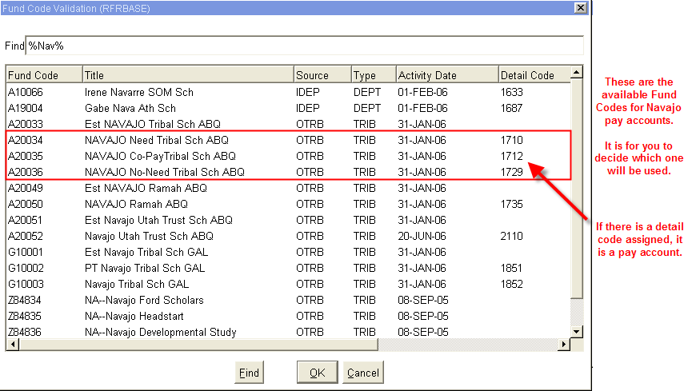
  - Once the Fund has been entered, Tab (once) to the ‘Reqt Desc’ field and enter information about the award:
NOTE: there are only 60 spaces to use, try to provide as much information in as little space as possible
- The Source of the Award
- Check Number
- The Term of the award (i.e. fall only $1000, fall/spg $1000 per semester)
- The Money List Number (if any)
- Indicate if the Check was sent to Cashiers for signature
- ‘Save’

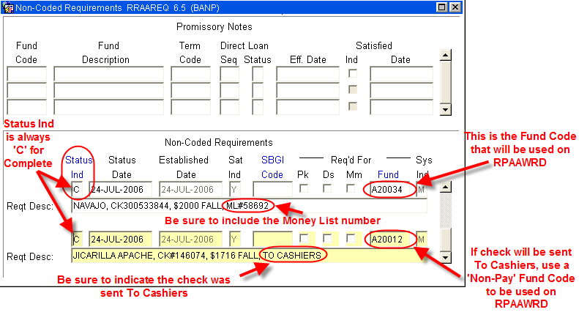
- IF DISBURSED THROUGH A PAY ACCOUNT (MONEY LIST):
  - Access RFRMGMT, Add money to Fund if needed (follow fund increase procedures)
  - On physical check Stub:
      - Endorse Check with UNM Stamp
      - Check Number
      - Tribe
      - Term of Award
      - Write Fund Code for RPAAWRD
      - Banner Index Code
      - Students’ Name
      - Students’ UNM ID
      - The Money List Number
  - Copy check stub 3 times:
      - Office records
      - For Copy of Money List
      - For Officer - forward copy to Officer for verification and awarding

  - Complete Money List
  - Copy Money List for Office records

- IF CHECK IS TO BE SENT TO CASHIERS:
  - Access ROAMESG, for message to student
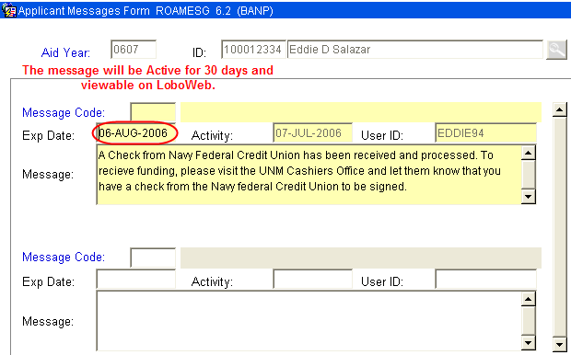

You may also send the student an email by accessing RNANA07 - the email address is on the first block.
  - Separate Check from Stub
  - Endorse Check with UNM Stamp (if applicable)
  - On physical check Stub:
      - Check Number
      - Tribe
      - Term of Award
      - Write Fund Code for RPAAWRD
      - Banner Index Code
      - Students’ Name
      - Students’ UNM ID
  - Copy check stub 2 times:
      - Office records
      - For Officer (include Officer Name) - forward copy to Officer for verification and awarding
  - Deliver Check to Cashiers Office
    - Checks are held at Cashiers, in the “Grey Box” for student signature.
~ Fin ~

