 | LINK Financial Aid | 

FA-210 Processing a Tribal Award Letter

Date Issued/Rev: 05/01/06
General Description: This procedure explains how to award an estimate from a Tribal award letter.
Responsible Manager: Financial Aid Director
Related Procedures:
Related Forms: RRAAREQ
RPAAWRD
RHACOMM

PROCEDURE to award an estimate from a Tribal award letter
Procedure:
NOTE: If Check is attached to award letter, copy award letter and forward originals to the Funds area for check processing
- Verify external award letter
  - Stamp
  - The student who is issued the award.
  - The amount of the award.
  - The year for which the award is made.
  - The term (i.e. Fall, Spring, Summer)

- Access RRAAREQ
  - Look for the Needs Analysis Documentation on the First Block of RRAAREQ - the Needs Analysis name should correspond to the Tribe sending the Award Letter.
    - If No Needs Analysis Information Exists on RRAAREQ: GO TO STEP 3
    - If There Is More Than One Needs Analysis: Be sure that you update the Needs Analysis that is tied to the Award Letter that you logging.
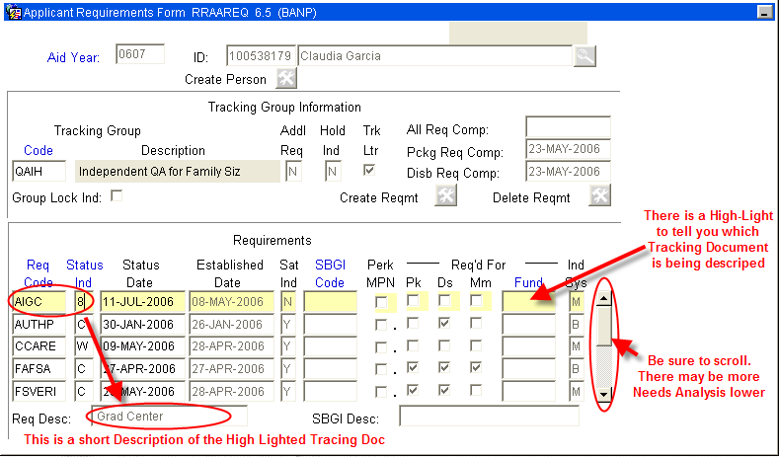
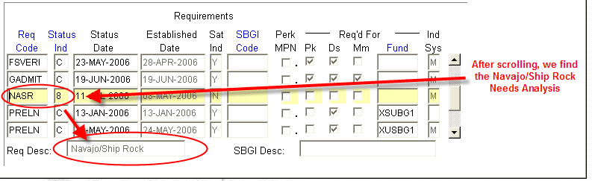
  - Update the Needs Analysis “Status Ind” with the code of ‘3’ (Award Letter Received). This will display on self-service that the Tribal Award Letter for this Needs Analysis has been received.
  - Suppress the MIL.
    - NOTE: You may double click in the “Status Ind” field for a list all values. ***Numbers are used for the logging of Checks and Needs Analysis
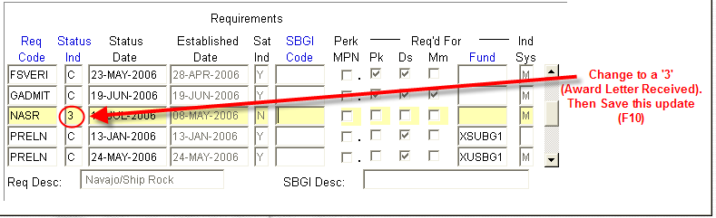
  - Perform ‘Next Block’ - to the ‘Non-Coded Requirements’ Block
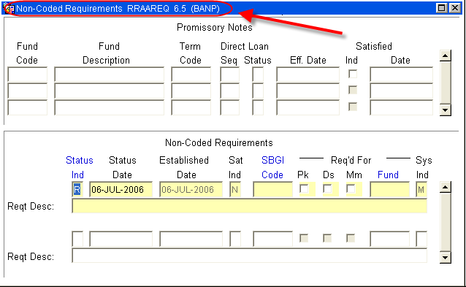
- Log the Award Letter in the ‘Non-Coded requirements” portion of the form:
  - Always enter “C” (for “complete” in the ‘Status Ind’ field
  - Tab to the ‘Fund’ Field’ enter the fund code that you are using for awarding the estimate.
***NOTE: The Fund code should correspond to the Fund Code used on RPAAWRD for
awarding the estimate.
    - For a list of values (F9), double click in the Fund field to search for a “Fund Code”
    - NOTE: When searching for an Estimate try %Est% or:
- Use the estimate for the tribe making the award. Each tribe has its own estimate.
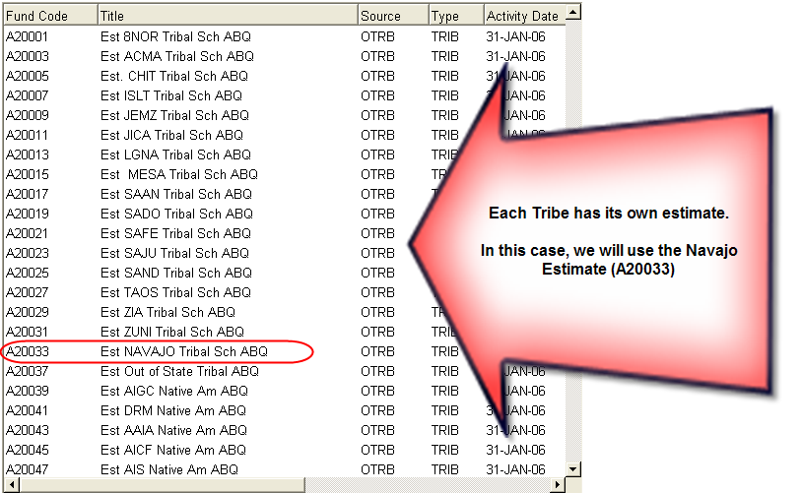

  - Once the Fund has been entered, Tab (once) to the ‘Reqt Desc’ field and enter information about the award:
NOTE: there are only 60 spaces to use, try to provide as much information in as little space as possible
- The Source of the Award
- The Term of the award (i.e. fall only $1000, fall/spg $1000 per semester)
- And that an Estimate was placed on RRAAREQ - “EST RRAAREQ”
- ‘Save’
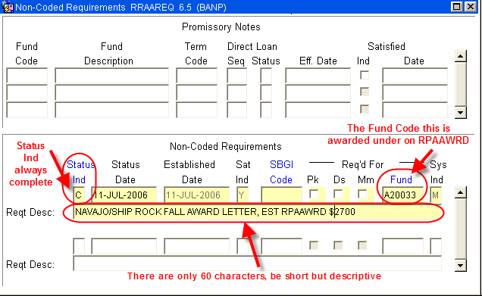
- Access RPAAWRD and award the Estimate with the Fund Code placed on RRAAREQ and ‘Save’
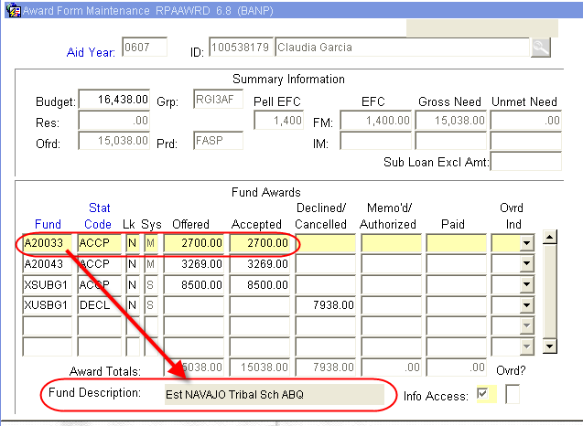
- Verify estimate does not create an Over Award. If Over Award is created, follow the procedure for correcting Over Award.
- If there is no Over Award, you may suppress the award letter. Otherwise an award letter will be sent.

- Access RHACOMM to indicate the receipt of the Award Letter, and awaiting the receipt of the Check.
~ Fin ~

