 | LINK Financial Aid | 

FA-211 Searching for a Fund Index Number

Date Issued/Rev: 05/23/06
General Description: This procedure explains how to search for a fund index number.
Responsible Manager: Financial Aid Director
Related Procedures:
Related Forms: RFRBASE
TSADETC

PROCEDURE
Procedure:
- Access RFRBASE.
- Click on ‘AR Detail’ to access Accounts Receivable information
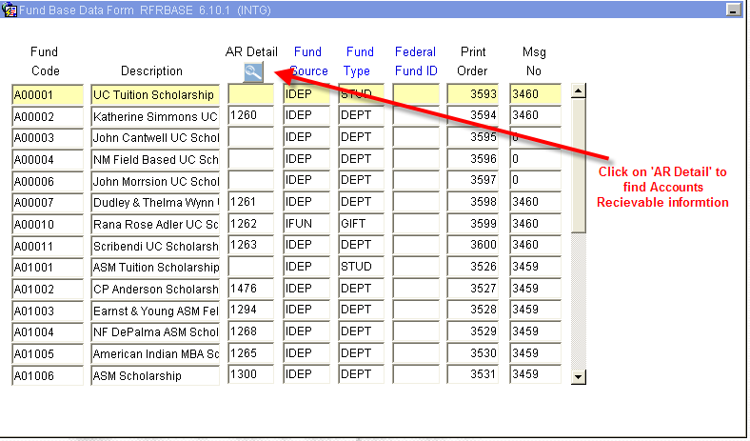
This will bring up TSADETC
NOTE: this form may appear first:
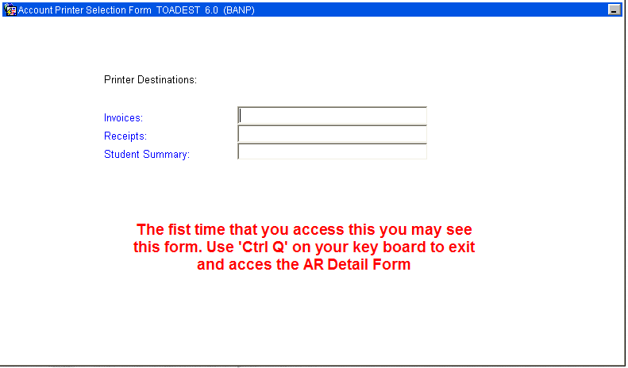

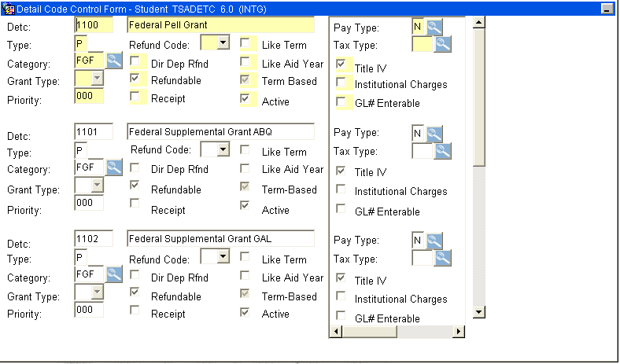

- Use F7 (Enter Query) and enter a short ‘Name’ of the account you are searching for.
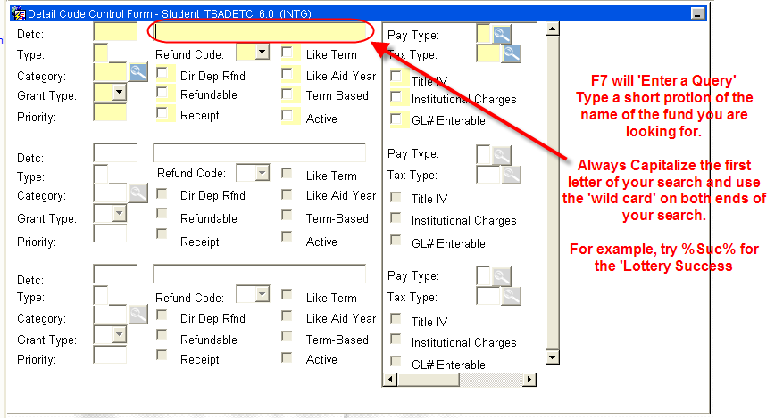

- F8 to ‘Execute the Query’
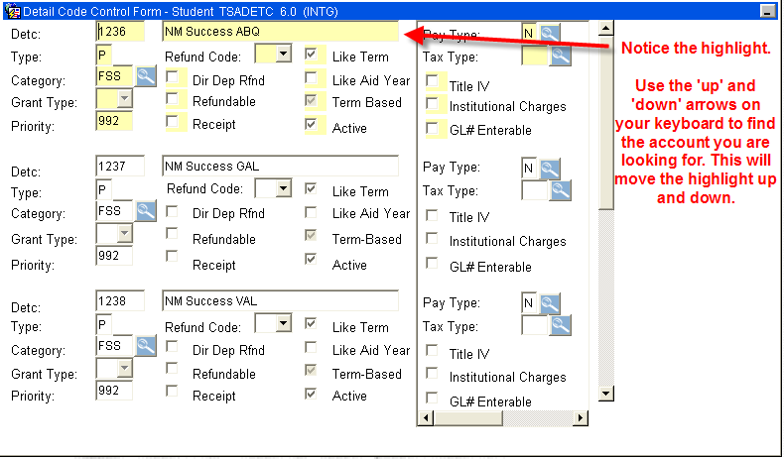

- Once the account is found (and highlighted), perform ‘Next Block’ to bring up Finance Information on this account.
