 | LINK Financial Aid | 

FA-220 Processing an External Check Made

Payable to UNM ONLY (Money List)
For Scholarships

Date Issued/Rev: 07/18/06
General Description:
This procedure explains how to process an external check made payable to UNM only. Money List
Responsible Manager: Financial Aid Director
Related Procedures: Adding money to a fund
Related Forms: RRAAREQ
RPAAWRD
ROAENRL
(RFRMGMT)

PROCEDURE to process an external check made payable to
UNM ONLY.
Procedure:
- Verify external check
      - Date Stamp the check stub.
      - Access RPAAWRD, confirm Estimate Award
            - NOTE: Estimate Outside Loans are FUND CODE: XENT4L
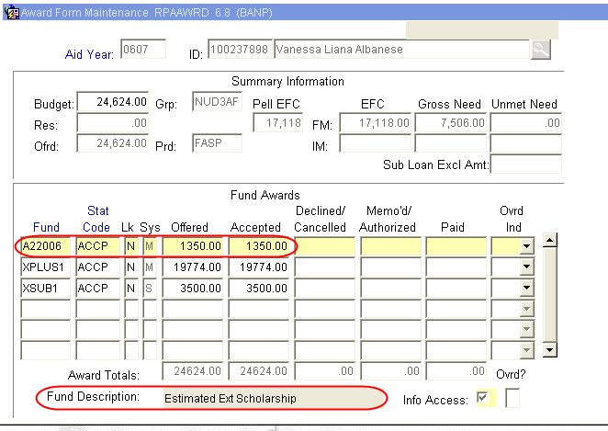
      - Access ROAENRL, Confirm Enrollment
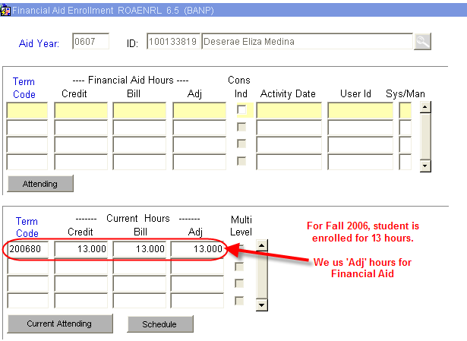

- Log Check, Access RRAAREQ
  - Perform ‘Next Block’ twice - to the ‘Non-Coded Requirements’ Block
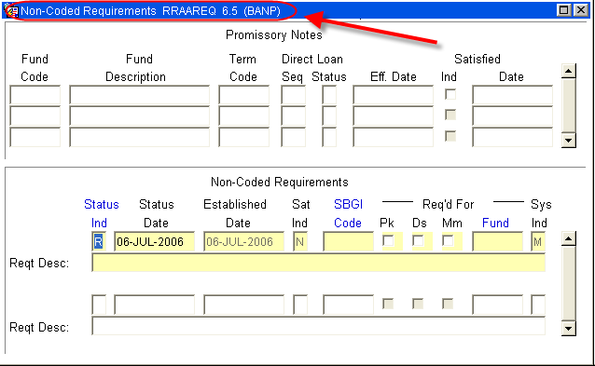
- Log the Check in the ‘Non-Coded requirements” portion of the form:
  - Always enter “C” (for “complete” in the ‘Status Ind’ field
  - Tab to the ‘Fund’ Field’ enter the fund code that you are using for awarding.
    - For a list of values (F9), double click in the Fund field to search for a “Fund Code”
    - NOTE: When searching for an External fund Code try %Ext% or:

- This is a list of all the current External Fund Codes (as of July 6, 2006
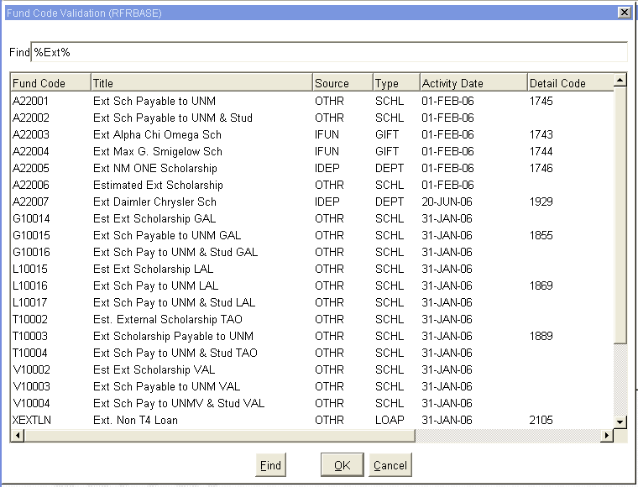

  - Once the Fund has been entered, Tab (once) to the ‘Reqt Desc’ field and enter information about the award:
NOTE: there are only 60 spaces to use, try to provide as much information in as little space as possible
- The Source of the Award
- Check Number
- The Term of the award (i.e. fall only $1000, fall/spg $1000 per semester)
- The Money List Number, if any
- ‘Save’
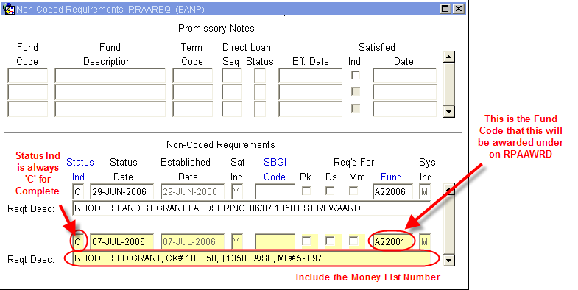

- Access RFRMGMT, Add money to Fund if needed (follow fund increase procedures)
- On physical check:
      - Endorse Check with UNM Stamp
      - Write Fund Code for RPAAWRD
      - Banner Index Code
      - Student’s Name
      - Students UNM ID
      - The Term of the Award
      - The Money List Number
- Copy check for Office records
- Complete Money List
- Copy Money List for Office records
~ Fin ~

