 | LINK Financial Aid | 

FA-221 Overriding the Current ISIR Record

Date Issued/Rev: 10/19/06
General Description: This procedure explains how to override the current ISIR Transaction with a different ISIR Transaction.
Responsible Manager: Financial Aid Director
Related Procedures:
Related Forms: RNAOV07
RNIAPPL
ROAIMMP
ROAPELL
RPAAWRD
NOTE: RNIAPPL will provide a list of all ISIR and EDE transactions for a Financial Aid Applicant
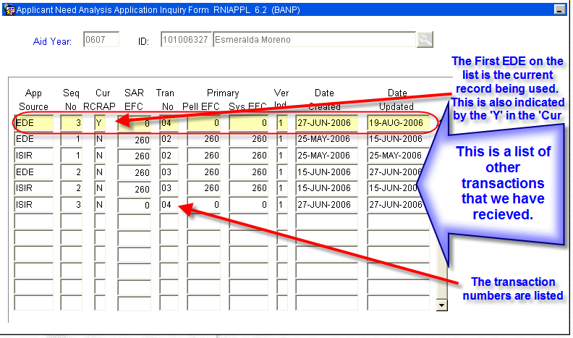

PROCEDURE
Procedure:
1. Access RNAOV07
2. Identify if current ISIR Record is locked
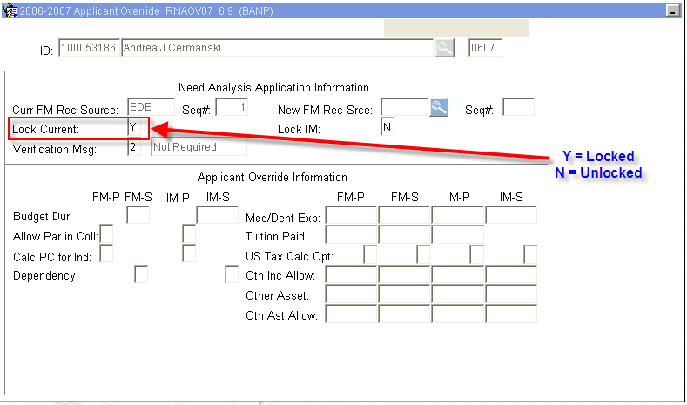
- If the ‘Lock Current” is equal to ‘Y’ (meaning the ISIR is Locked), unlock the Current ISIR by changing the ‘Lock Current’ to ‘N’
- SAVE (F10).
3. Once the Current ISIR Record is unlocked, ‘click’ on the search button (F9) for the ‘New FM Rec Srce’ field to access all ISIRs on record for the student (this will bring up RNIAPPL).
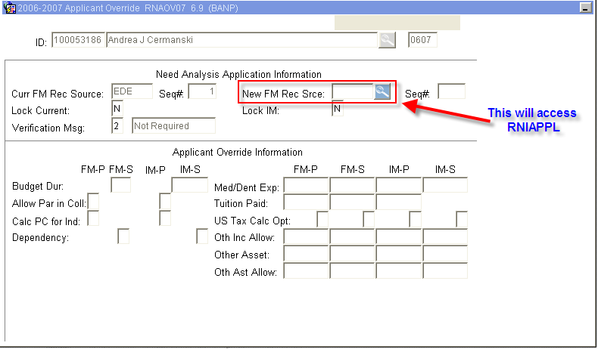
4. On RNIAPPL, identify and highlight the EDE source that you would like to make current and ‘Select’ (Shift F3 or ‘double click’) the EDE transaction to be loaded as current.
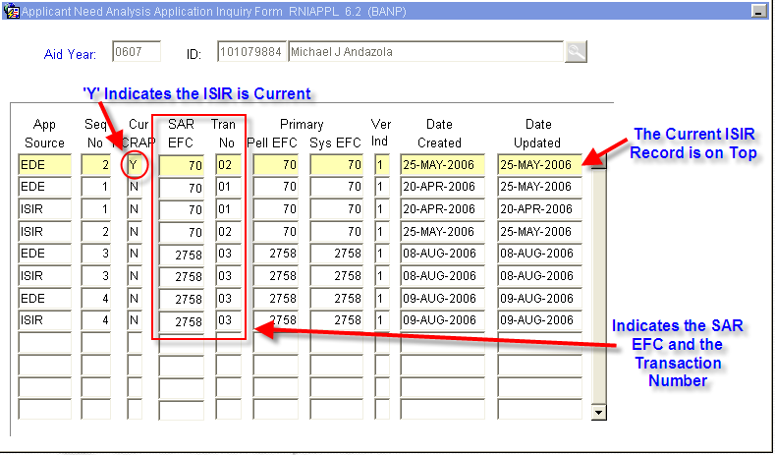
NOTE: ONLY SELECT the EDE RECORDS – ISIRs can not be loaded.
5. Once the EDE transaction is selected, it will be taken to the the ‘New FM Rec Srce’ field on RNAOV07.
NOTE: This field will indicate the Banner Sequence Number which may be different from the Transaction Number.
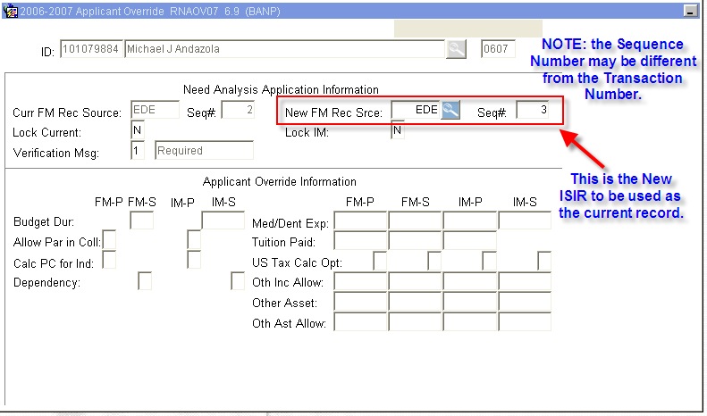
6. Save (F10) and receive the message
Go to ROAIMMP
7. Perform “Next block”
8. The student will need to be run through Three Processes IN ORDER:
- Tracking followed by SAVE (F10).
- Access RRAAREQ to see if additional documents were requested as a result f the ISIR transaction change.
- Needs Analysis Calculation followed by SAVE (F10).
- After running the Need Analysis Calculation, the system will go to RNARSLT to confirm EFC.
- Exiting RNARSLT will return to ROAIMMP
- Only if document verification is complete - Immediate Pell Calculation followed by SAVE (F10).
- NOTE: this process will award re-award Pell. Only award if verification is complete
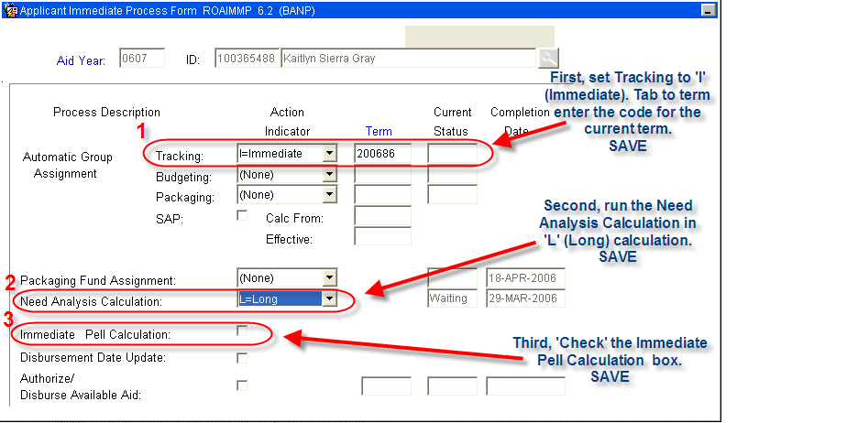
9. Exit ROAIMMP
10. Access RRAAREQ to verify if additional tracing documents were requested.
11. Access RPAAWRD to confirm Pell Award.
12. Notify Awarding Officer of EFC Change to verify award eligibility.

* * * E N D * * *

