 | LINK Financial Aid | 
FA-221 PROCEDURE to process an external check made
Payable to UNM and The Student (Or Student Only)
For Scholarships

Date Issued/Rev: 05/01/06
General Description: This procedure explains how to process an external check made payable to UNM and the Student (or Student Only). Non Money List
Responsible Manager: Financial Aid Director
Related Procedures:
Related Forms: RRAAREQ
ROAMESG
RRAAREQ
ROAENRL

PROCEDURE to process an external check made
Payable to UNM and The Student
Procedure:
- Verify external check
      - Date Stamp the check stub.
      - Access RPAAWRD, confirm Estimate Award
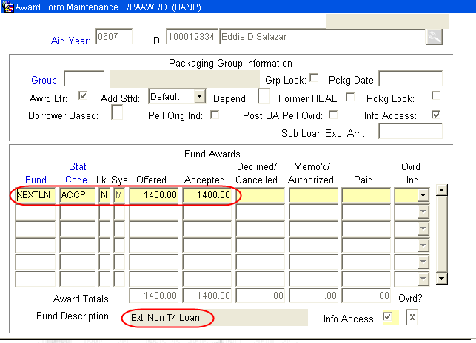
      - Access ROAENRL, Confirm Enrollment
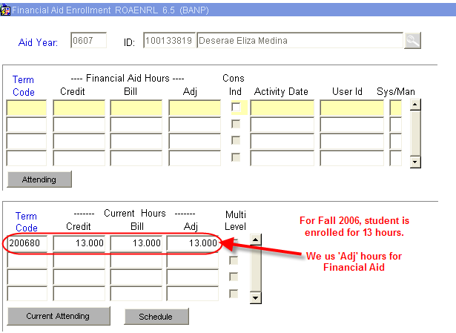

- Log Check, Access RRAAREQ
  - Perform ‘Next Block’ twice - to the ‘Non-Coded Requirements’ Block
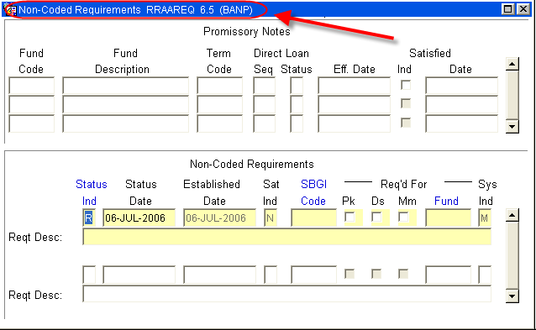
- Log the Check in the ‘Non-Coded requirements” portion of the form:
  - Always enter “C” (for “complete” in the ‘Status Ind’ field
  - Tab (once) to the ‘Reqt Desc’ field and enter information about the award:
NOTE: there are only 60 spaces to use, try to provide as much information in as little space as possible
- The Source of the Award
- Check Number
- The Term of the award (i.e. fall only $1000, fall/spg $1000 per semester)
- Indicate if the Check was sent to Cashiers for signature
- ‘Save’
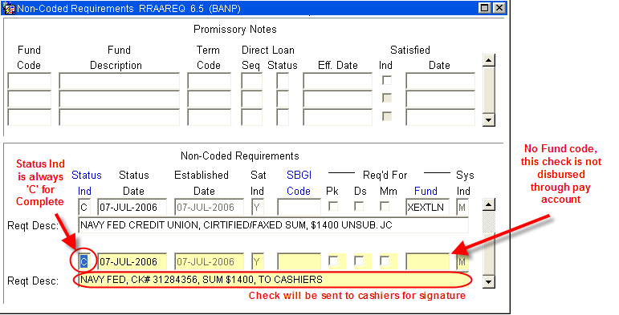
- Access ROAMESG, for message to student
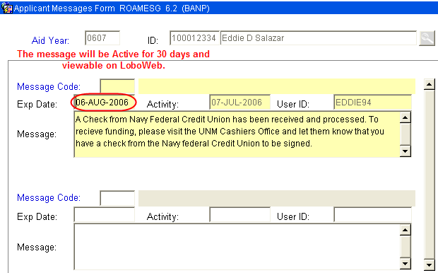

You may also send the student an email by accessing RNANA07 - the email address is on the first block.
You may also access the students email account on GOAEMAL if no RNANA07 record exists.

- Separate Check from Stub
      - Make one copy for file
- Deliver Check to Cashiers Office
    - Checks are held at Cashiers, in the “Grey Box” for student signature.

~ Fin ~

