Student Financial Aid

FALN – 114 Loan Fields

Date Issued/Rev: 09/24/07

General Description: This identifies the fields on RPAELAP.

Responsible Manager: Financial Aid Director

Related Procedures: NA

Related Forms: NA

Application Status

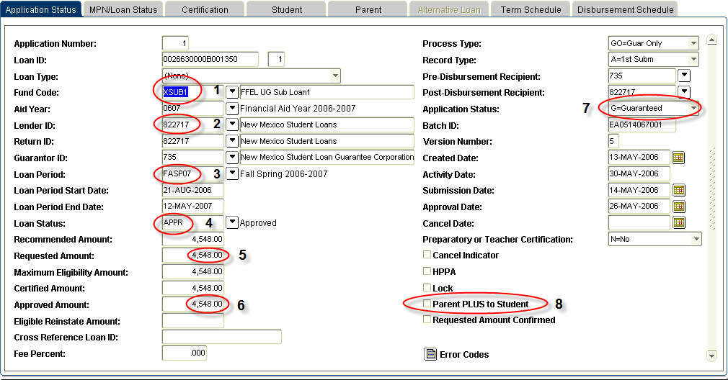
1 – Fund code – pulled from RPAAWRD
2 – Lender ID
3 – Loan Period – auto-populates from the aid period on RPAAWRD
4 – Loan status – starts at RECM (recommended), after loan is guaranteed it will move to APPR (approved)
5 – Requested amount – pulled from RPAAWRD
6 – Approved amount – returned from lender after Guarantee
7 – Application status:
Ready – record has not yet been sent to guarantee agency. Should change to SENT that evening when extract runs. You could delete this record, if it was created in error. THIS IS THE ONLY TIME YOU SHOULD EVER DELETE A RPAELAP RECORD.

Sent – record has been sent to the guarantee agency. We are awaiting a response. Do not make any adjustments to the loan record on RPAELAP when the loan is in this status.

Application Approved – no prom note, but loan is otherwise approved. NO PROM NOTE.

Guaranteed – NMSL/UNM as Lender – loan approved, prom note on file.
Texas Guarantee lenders – does not indicate promissory note status – loan is guaranteed

Guaranteed/Prom Note Received - Sallie Mae/USA Funds – loan approved, prom note on file

Pending – possible problem with the loan approval, or a missing prom note. We will need to contact NMSL for these types.

Denied/Rejected – loan is denied or rejected.
8 – Parent PLUS to Student – check when awarding an XPLUS1, leave blank for all other loans including XPLUP1

Certification block

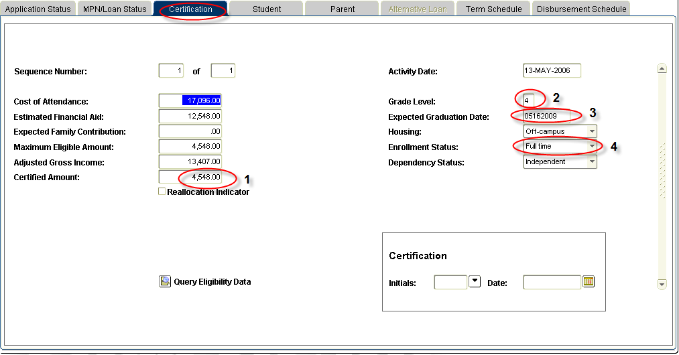

1 – Certified Amount – only place to adjust, cannot adjust on the 1st block.
2 – Grade Level – where to update if the grade level changes
3 – Expected Graduation Date – must be equal to or greater than loan period end date
4 – Enrollment Status – must be greater than ‘less than half time’

Student Information block

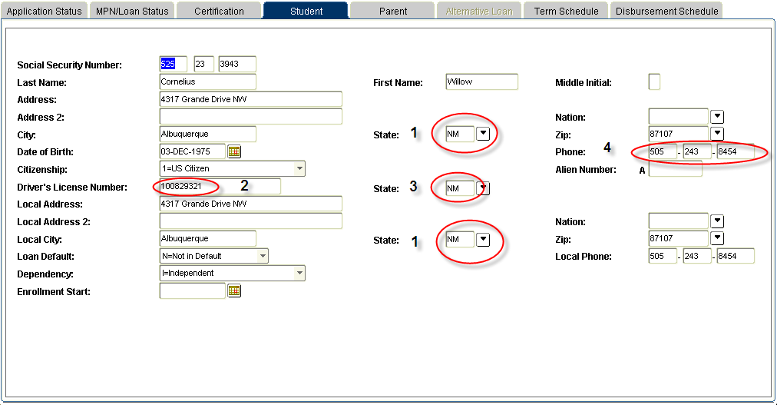

1 – Address State (Note: This is requested twice – local and primary.) This is pulled from SPAIDEN.
2 – Driver’s License Number. This is pulled from RNANAxx. When updating this field, complete DRIVE on RRAAREQ, and update the DL # on RNANAxx.
3 – Driver’s License State. This is pulled from RNANAxx. When updating this field, complete DRIVE on RRAAREQ, and update the DL # on RNANAxx.
4 – Phone Number. This is pulled from SPAIDEN. Must contain 10 digits.

Parent information block

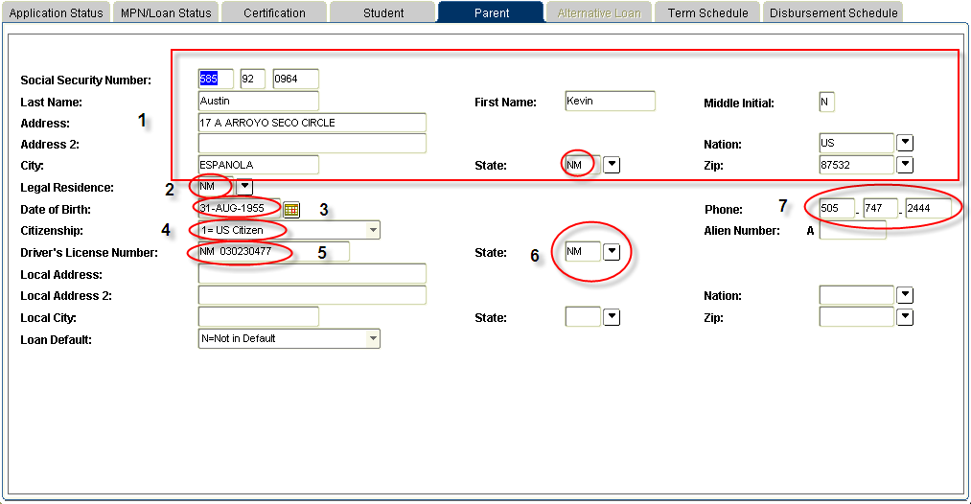

1 - Parent Name, SSN, Address
2 - Legal Residence
3 - Date of Birth
4 – Parent’s Citizenship
5 – Driver’s License Number
6 – Driver’s License State
7 – Phone Number. Must be 10 digits.

Term Schedule block

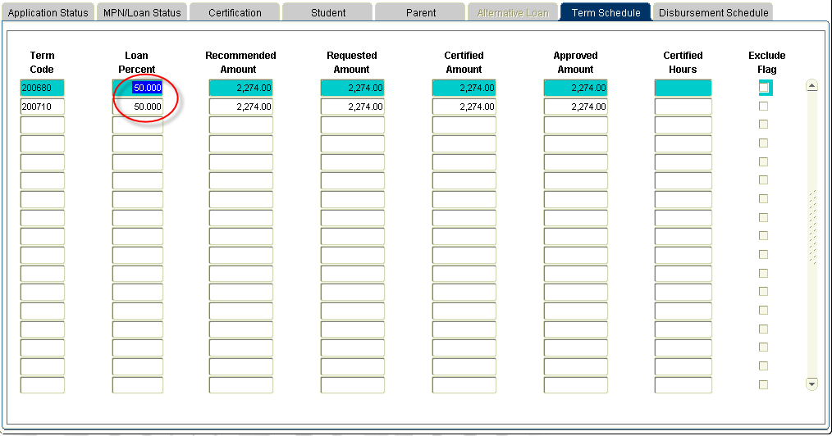

How the award is split by term. Loan percent is adjustable.

Disbursement block

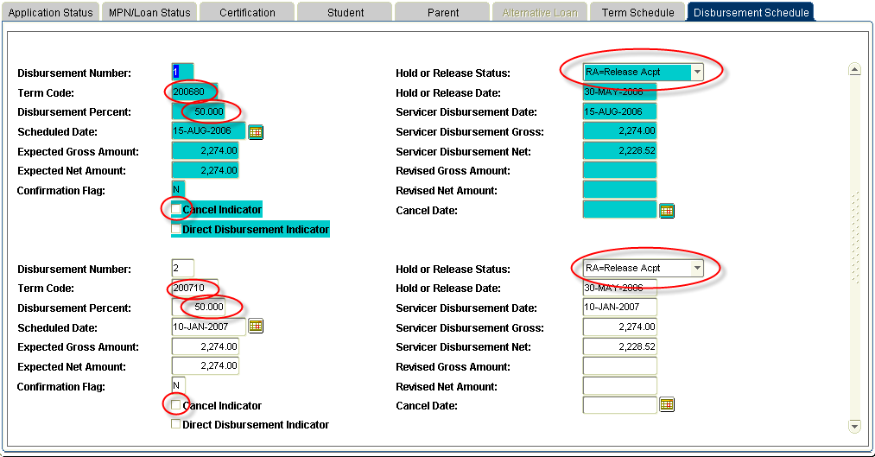

Separate record for each term.

Disbursement Percent is adjustable. This drives the MEMO process.

If we receive money on a loan that has the CANCEL INDICATOR checked for that term, the money will not release, and there will not be a message on ROIDISB.

This block is locked by term, when we are within 4 of the SERVICER DISBURSEMENT DATE (with the exception of the DISBURSEMENT PERCENT). As a result, if we need to remove a CANCEL INDICATOR after the record is locked, it must be done by our ITS staff.

Hold or Release Status – driven by the hold and release process. DO NOT update these fields – it will not go out with the change files.

