Student Financial Aid

FALN 115 – Accessing the NMSL Ticket System

Date Issued/Rev: 02/16/07
General Description: This procedure explains how to access the NMSL ticket system. This system is secured, which allows for the transmission of social security numbers when re-requesting funds from NMSL.
Responsible Manager: Financial Aid Director
Related Procedures: N/A
Related Forms: N/A

PROCEDURE
Procedure:
1. Go to: https://unm.nmstudentloans.org/dcl/

2. Log in with your USER and PASSWORD. Your USER ID is your last name followed by the first initial of your first name (e.g. maloneb for Brian Malone). Your initial password is the same as your USER ID. (You will need to change your password after your first log in.)

3. Select “New Ticket” (upper left hand corner)

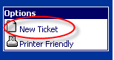

A blank ticket will appear:

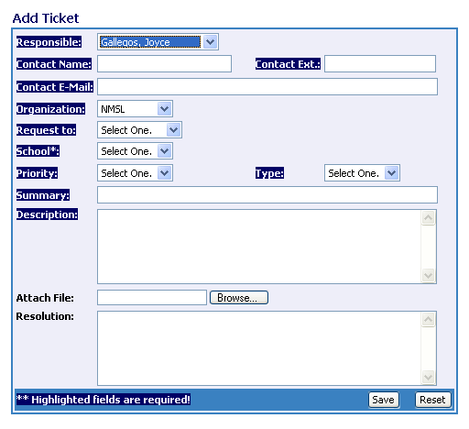

4. Fill in the ticket as follows:

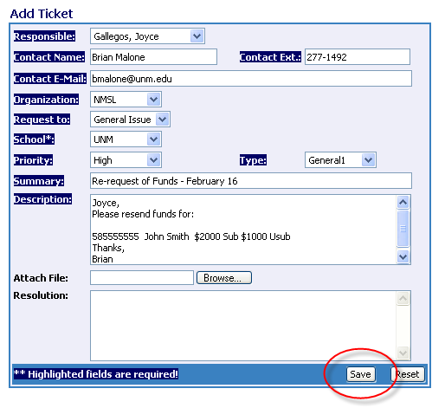
Responsible: Herrera, Georgia
Contact Name: <Your name>
Contact Ext: <Your phone number>
Contact E-Mail: <Your email address>
Organization: NMSL
Request to: General Issue
School: UNM
Priority: High
Type: General1
Summary: “Re-request of Funds <insert current date>”
Description: Student’s SSN, Student’s Name, Loan Type(s), Loan Amount(s)

5. Click SAVE

You will get a confirmation email that the ticket has been submitted. When the ticket has been finished, you will also get an email.
* * * E N D * * *

