Student Financial Aid

FALN 116 – Changing Password in the NMSL Ticket System

Date Issued/Rev: 02/16/07
General Description: This procedure explains how to change your password in the NMSL Ticket System.
Responsible Manager: Financial Aid Director
Related Procedures: N/A
Related Forms: N/A

PROCEDURE
Procedure:
1. Go to: https://unm.nmstudentloans.org/dcl/

2. Log in.

3. Select ADMIN

4. Select Change Password from the ADMIN menu

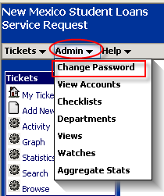

5. Enter current password.
6. Enter new password.
7. Confirm new password.
8. Select CHANGE.

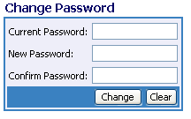
Your password has now been changed.
* * * E N D * * *

