 | LINK FINANCIAL AID  AWARD PACKAGING | 
 | FAPK-117 Request or Cancel an Award Letter | Date Issued: 7/31/2026
General Description:
This procedure explains how to request an award letter or cancel an award letter.
Responsible Manager: Director of Financial Aid
Related Procedures:
UNM-100 Search Three Times
Related Forms:
RPAAWRD Award Maintenance Form
PROCEDURE

- From the direct access field of the main menu type RPAAWRD and press ENTER. Do NOT click on the magnifying glass. (see screen sample on next page.)
- ID: Required. Type the student’s Banner identification number.
- Correct student found?
- If yes, continue.
- If not, go to UNM-100 or search tools and locate the correct student.
- From the menu bar, select “Options/Toggle Summary/Packaging Group Information.”
- Choose action needed:
- If requesting an Award Letter, click the box to activate the letter. 
- If canceling an Award Letter, click the box to de-activate the letter. □
NOTE: When a change is made to the amount of an award, the Award Letter flag automatically displays. The next time award letters are printed, an award letter will then generate.
- More award letters to process?
- If yes, select “Save,” and return to step 2.
- If not, select “Save,” and select “Exit.”

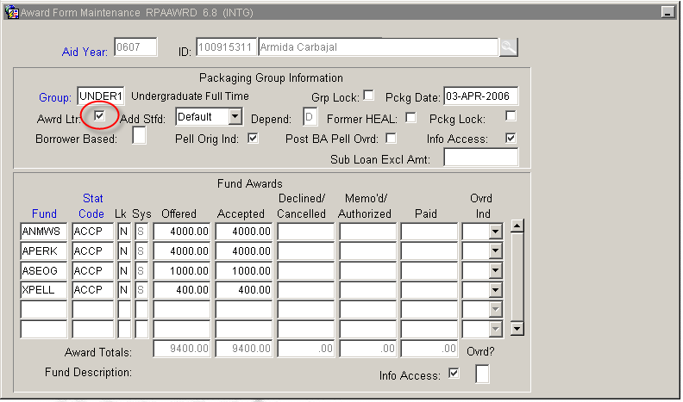

* * * E N D * * *

