 | LINK Financial Aid  AWARD PACKAGING MODULE | 

FAPK-123 Awarding Pell Automatically

Date Issued/Rev: 11/03//05
General Description: This procedure explains how to
Responsible Manager: Director of Financial Aid
Related Forms:
ROAIMMP Applicant Immediate Process Form

PROCEDURE
Procedure:
- Go to: ROAIMMP
- ID: Required. Type the student’s UNM identification number.
- Select “Next Block”
- Immediate Pell Calculation: Click the box next to Immediate Pell Calculate.

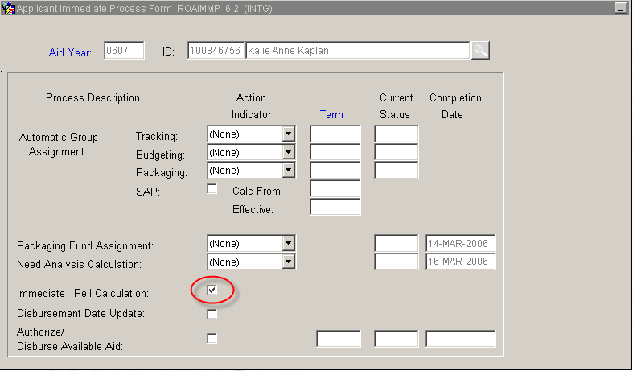

5. Select “Save”
6. Select “Exit”

* * * E N D * * *

