Exam 1 - (100 pts.)
Stat 145 – Spring 2013

Name_______________________________________ Section Number:__________

Short Answer Questions: For credit show your work. Round final answers to two decimal places and include units in all final answers.

- The number of shark attacks per year worldwide over a recent 5-year period is: 71, 64, 61, 65, and 59. Calculate the mean and standard deviation of annual shark attacks over this 5-year period. Include units in your final answers.

- (5 pts.) mean:

- (6 pts.) standard deviation:

2. The table below lists the number of car thefts in a large city over a recent 14-day period is:
52 | 75 | 57 | 61 | 56 | 62 | 54
58 | 78 | 65 | 77 | 59 | 76 | 55

(a). (5 pts.) Construct a stemplot of these data. Split the stems.

(b). (5 pts.) Give the five-number summary for these data. Show your work.

(c). (5 pts.) Illustrate the distribution of the number of car thefts with a boxplot. Provide a labeled and reasonable scale.

3. Suppose, as is roughly true, Americans consume an average of 1.64 cups of coffee daily. Assume American coffee consumption is normally distributed with a standard deviation of 0.26 cups.

- (6 pts.) Using the 68-95-99.7 rule, how much coffee does the top 2.5% of Americans drink daily?

- (6 pts.) What percent of Americans drink less than 1 cup of coffee daily?

- (6 pts.) What percent of American drink more than 2 cups of coffee daily?

- (6 pts.) What percent of Americans drink between 1.5 and 2 cups of coffee daily?

- (6 pts.) Complete the following sentence and support your answer (i.e. show work):

15% of Americans drink ________ or more cups of coffee daily.

Multiple Choice (4 pts. each): Circle the letter for each of your answers. For credit show your work where indicated.

4. | A company has three divisions and three conference rooms for meetings. To keep track of the use of their facilities, for each meeting held in the company the division holding the meeting is recorded, the room for the meeting is recorded, and the length of time of the meeting is recorded. Which of the variables is quantitative?
 | A) | the division holding the meeting
 | B) | the conference room for the meeting
 | C) | the length of time for the meeting
 | D) | All of the above

5. | A description of different houses for sale includes the following variables. Which of the variables is categorical?
 | A) | the square footage of the house
 | B) | whether or not the house has a finished basement
 | C) | the monthly electric bill
 | D) | All of the above

6. | When drawing a histogram, it is important to
 | A) | eliminate the extremes to minimize the effect of skewness.
 | B) | choose class intervals so all contain a similar number of observations.
 | C) | make certain the mean and median are contained in the same class interval so the correct type of skewness can be identified.
 | D) | label the vertical axis so the reader can determine the counts or percent in each class interval.

7. | There are three children in a room, ages 3, 4, and 5. If a 4-year-old enters the room,
 | A) | the mean age will stay the same, but the standard deviation will increase.
 | B) | the mean age will stay the same, but the standard deviation will decrease.
 | C) | the mean age and standard deviation will stay the same.
 | D) | the mean age and standard deviation will increase.

8. | For the following density curve, the median is
 | A) | 0.50.
 | B) | 1.50.
 | C) | 2.00.
 | D) | 3.50.

Use the following to answer questions 9-11:

The histogram below shows the time visitors to a museum spent browsing an exhibit on a Saturday. There were 300 visitors that day. The following histogram is of the data collected.

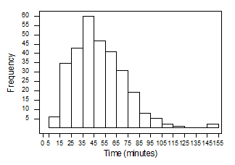

9. | The number of visitors that spent less than 25 minutes at the museum that day is closest to
 | A) | 25.
 | B) | 40.
 | C) | 60.
 | D) | 80.

10. | SHOW WORK. The percent of visitors spending more than 85 minutes at the museum is closest to
 | A) | about 5%.
 | B) | about 20%.
 | C) | about 30%.
 | D) | over 40%.

11. | The histogram
 | A) | is skewed right.
 | B) | has one or more outliers.
 | C) | is asymmetric.
 | D) | All of the above

12. | A Normal density curve has which of the following properties?
 | A) | It is symmetric.
 | B) | It has a peak centered above its mean.
 | C) | The spread of the curve is proportional to the standard deviation.
 | D) | All of the above

Use the following to answer questions 13-14:

The bar graph below gives the distribution of the most popular colors for cars and light trucks sold globally in 2010.

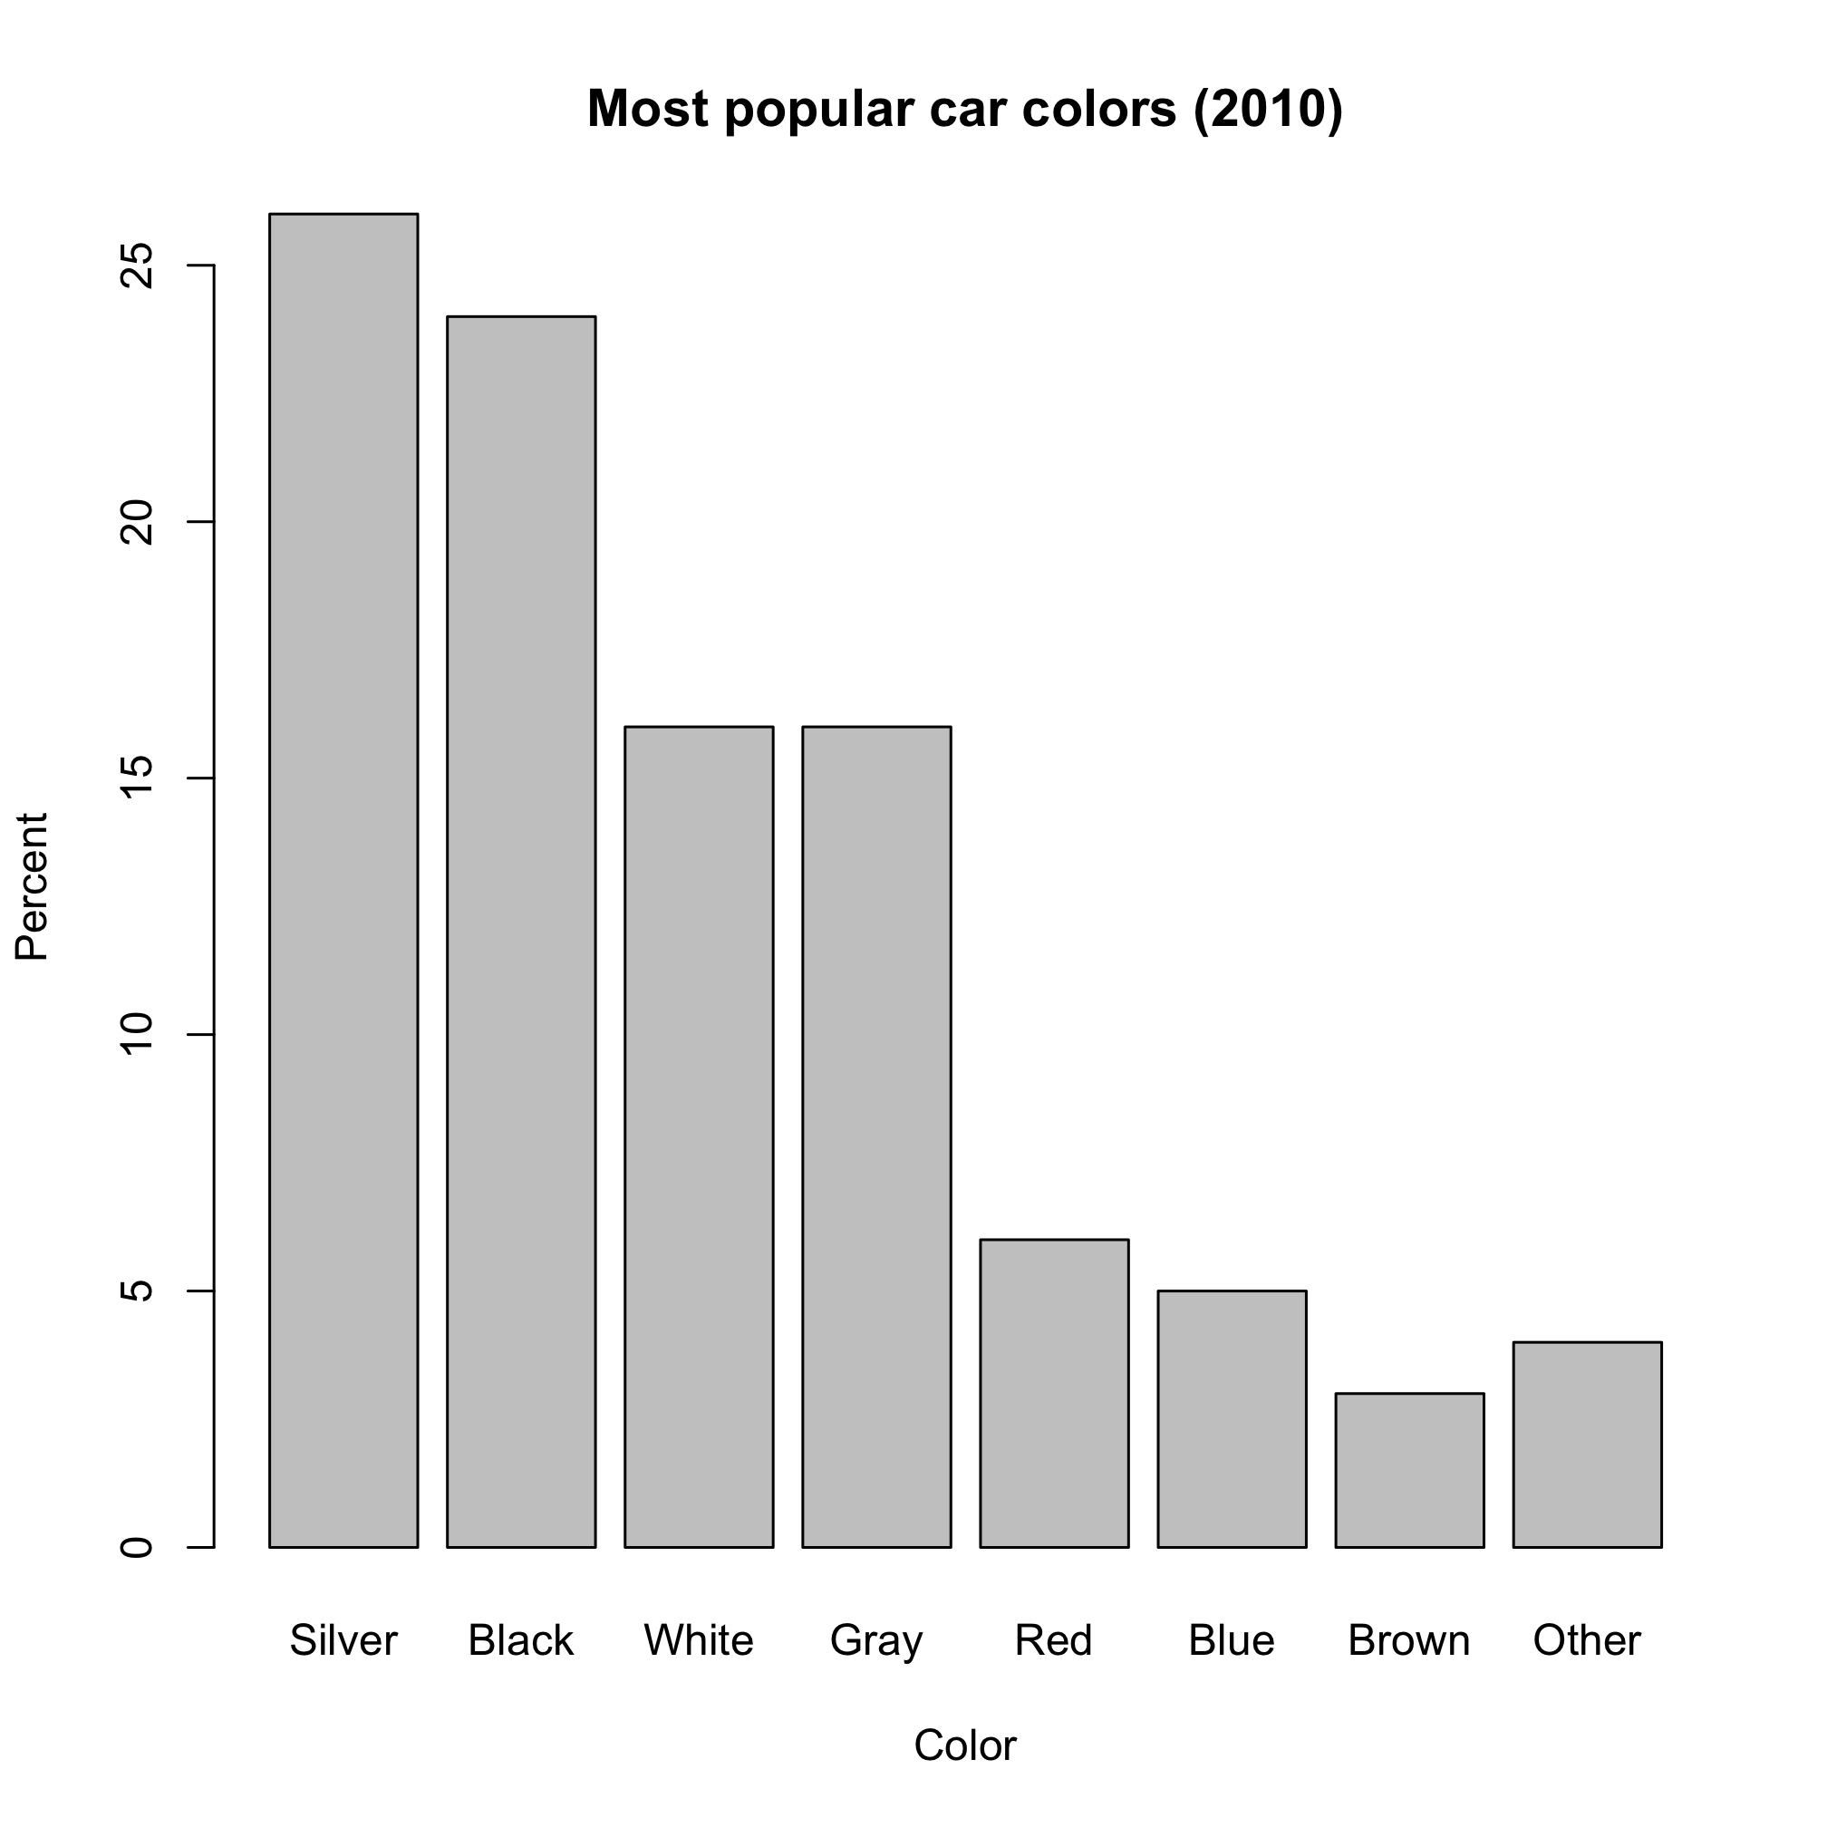
13. | Approximately what percent of cars sold in 2010 were white?
 | A) | 6%
 | B) | 9%
 | C) | 16%
 | D) | 24%

14. | Which one of the following kinds of plots would also be appropriate for these data?
 | A) | a boxplot
 | B) | a pie chart
 | C) | a histogram
 | D) | All of the above

