Accessing Podcasts
Using The Education Podcast Network (EPN)  - Go to http://epnweb.org/  - Choose a topic from the list on the left-hand column titled Subject Specific Podcasts and click on the link to open it (Figure 1).  - Another list will appear with specific podcasts for the subject you chose. Select one and a menu of available episodes will appear.  - Select the title of the podcast episode you wish to listen to and double-click on the radio button that says POD (Figure 2).  - The podcast will automatically play as an MP3, usually opening in a new window.  Using podbean.com  - Go to http://www.podbean.com/  - On the right-hand side of the page is a list of subjects under Hottest Tags to Watch (Figure 3).  - Click on Education and another page will open with different podcasts to choose from. Pick one and click the “Play now” button which looks like this:  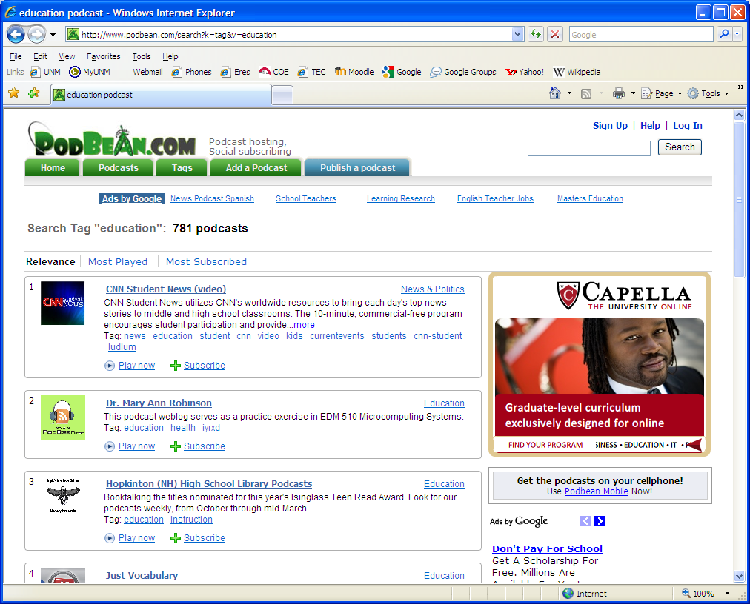  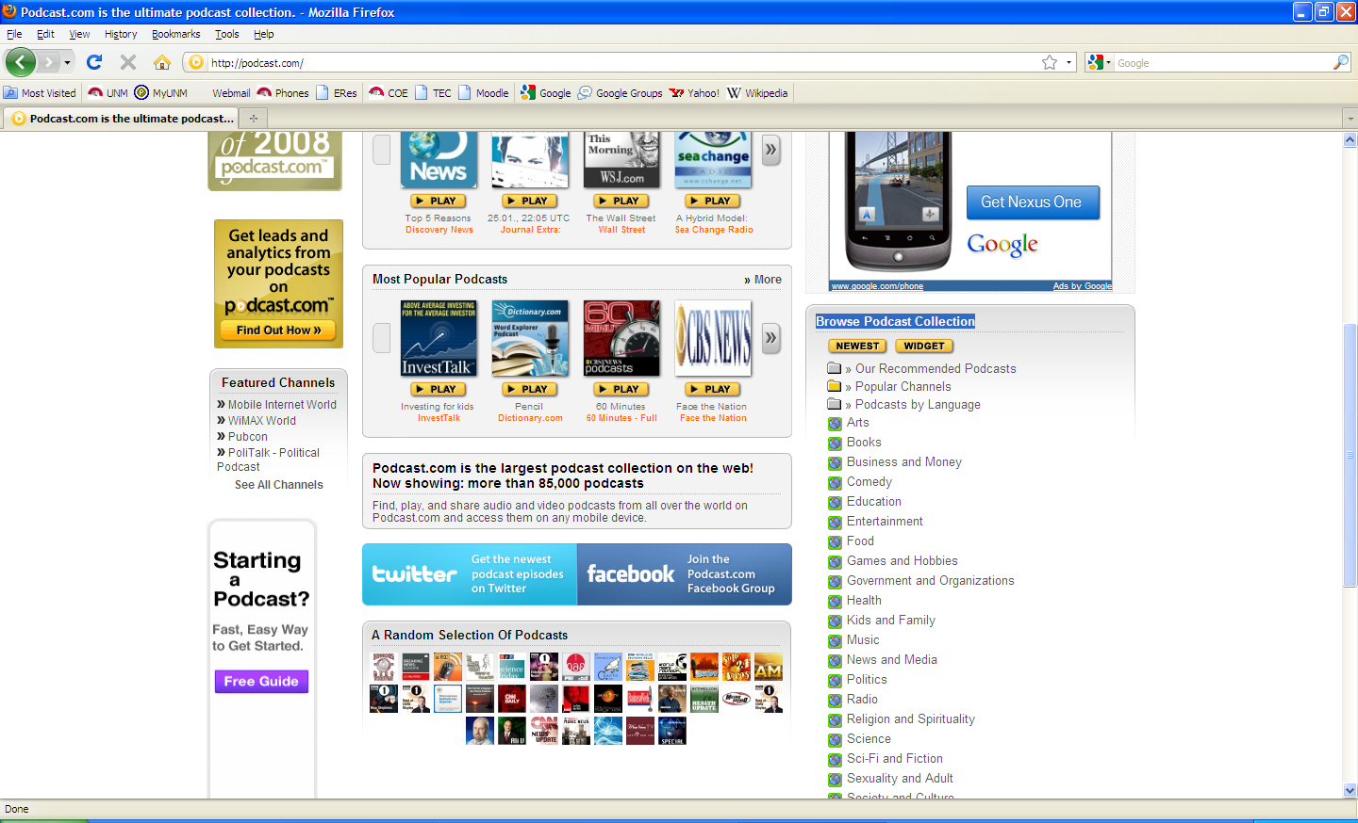  - The podcast will automatically start playing in new window. You also have the option of subscribing to a particular podcast which will enable you to listen to all of the podcasts created by that podcast host.  Figure 4: podcast.com Homepage  Using podcast.com  - Go to http://podcast.com/  - Scroll down until you see the heading Browse Podcast Collection on the right-hand side of the page (Figure 4).  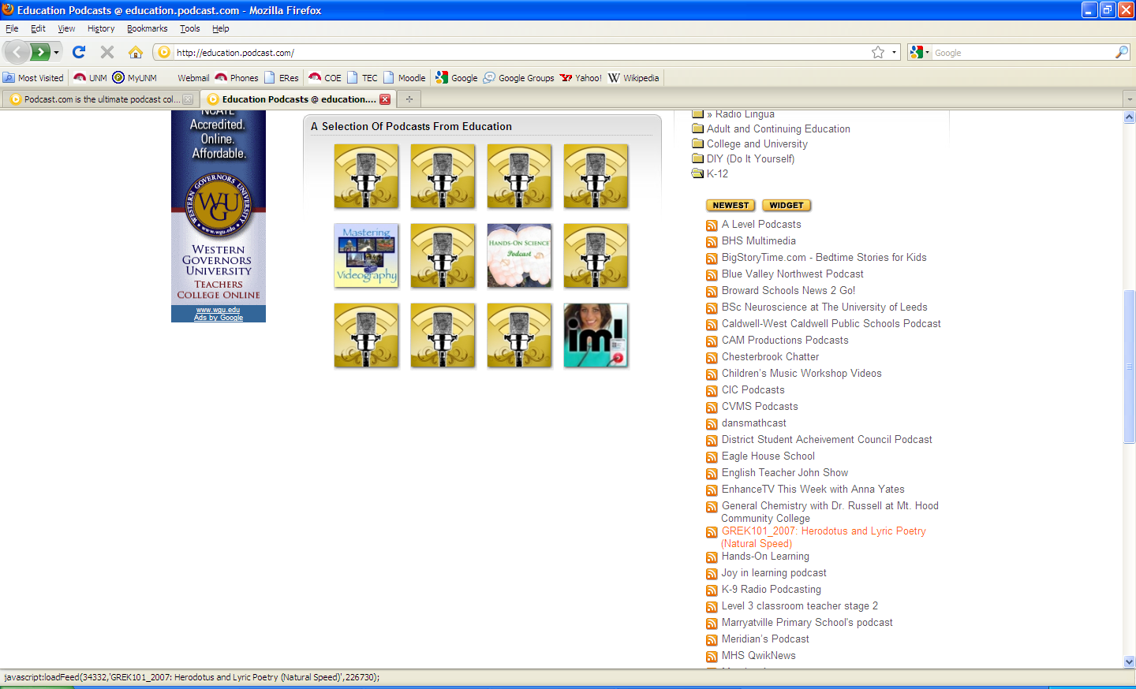  - Click on the Education link to open a new page showing the available Educational Podcasts.  Figure 5: K-12 Educational Podcasts  - Go to Browse Education Podcasts Collection on the right-hand side of the page and select a topic folder.  - If you choose the K-12 folder, a list of possible podcast hosts opens up in a drop down menu (Figure 5). Here you can find a variety of educational podcasts.  - Clicking on a podcast title will open a list of episodes. Pick an episode and click on the yellow PLAY button.  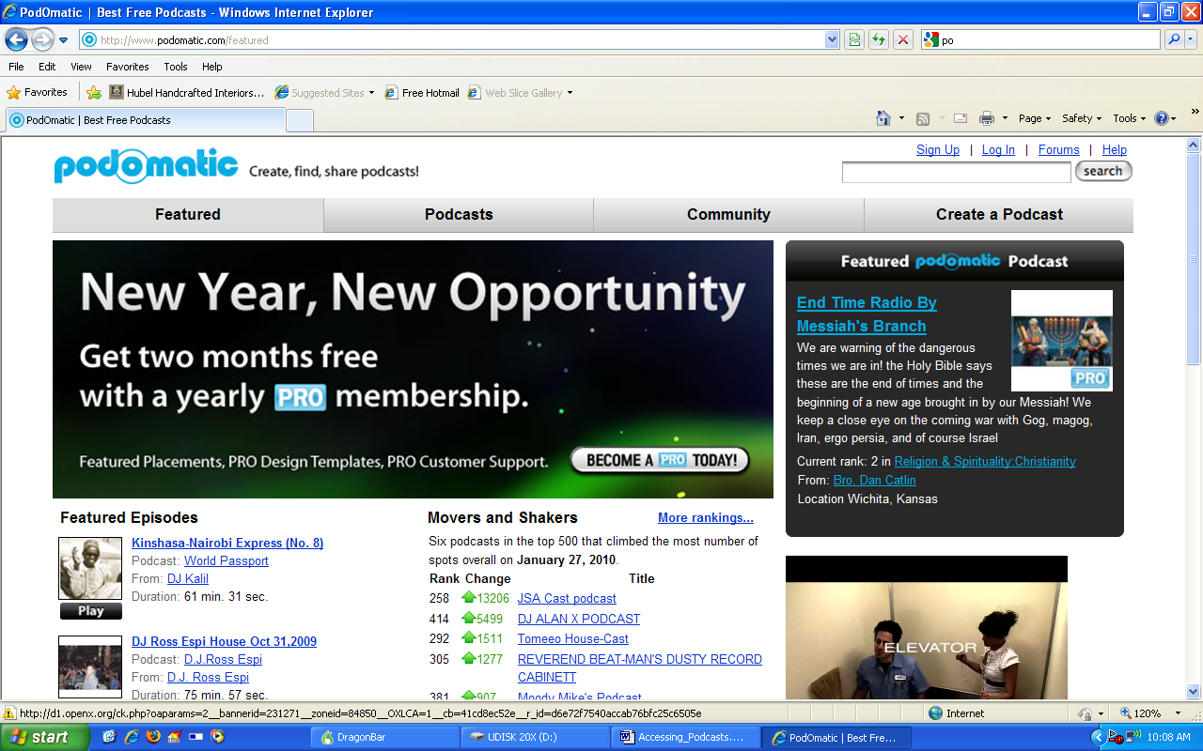  Using podomatic.com  Figure 6: podomatic.com Homepage  - Go to http://www.podomatic.com/featured  - Click on the Podcasts tab at the top of the page (Figure 6).  - Under the large heading All Categories on the left-hand side of the page, find the smaller heading Categories, then choose the Education link.  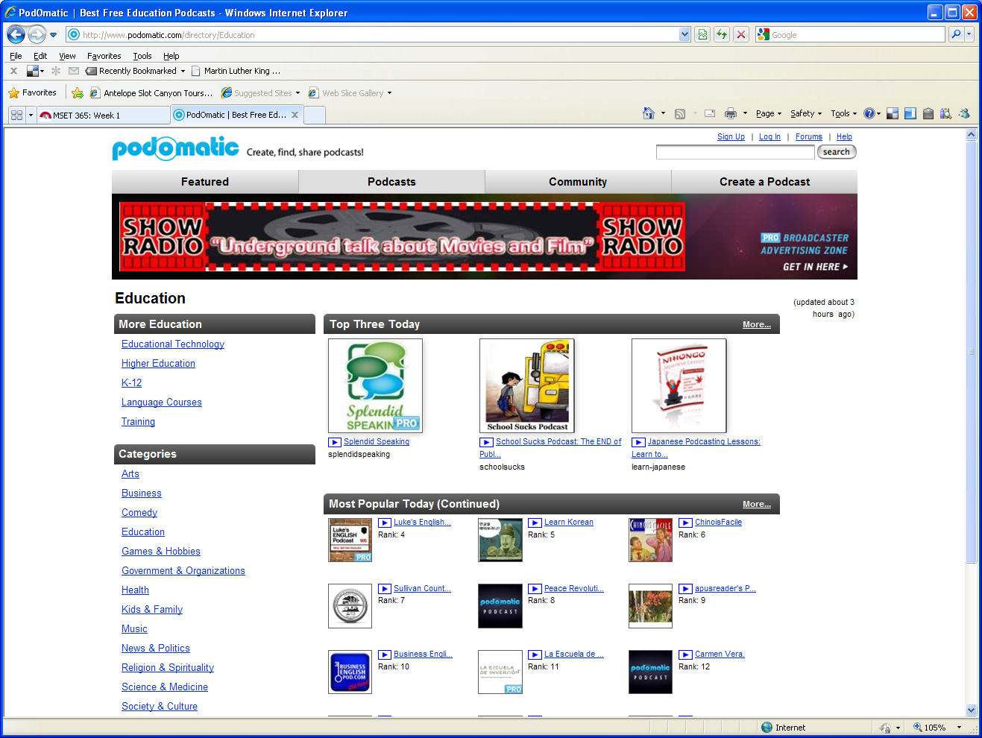  - In the new window, choose a podcast from the Top Three Today heading or the Most Popular Today heading. Browse through these selections by clicking the More link as shown in Figure 7.  Figure 7: Accessing More Podcast Episodes on podomatic.com  - You can also browse more options under the heading More Education in the left-hand column.  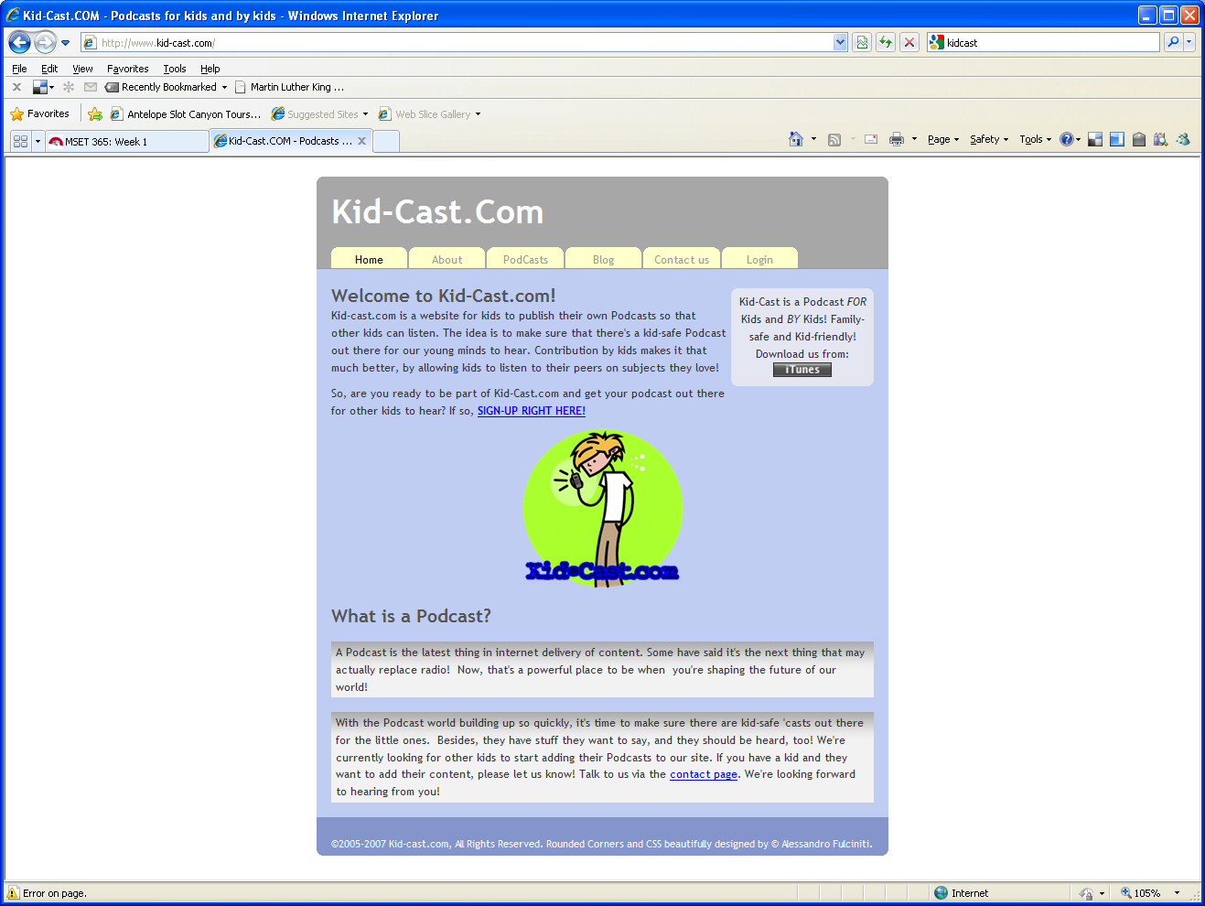  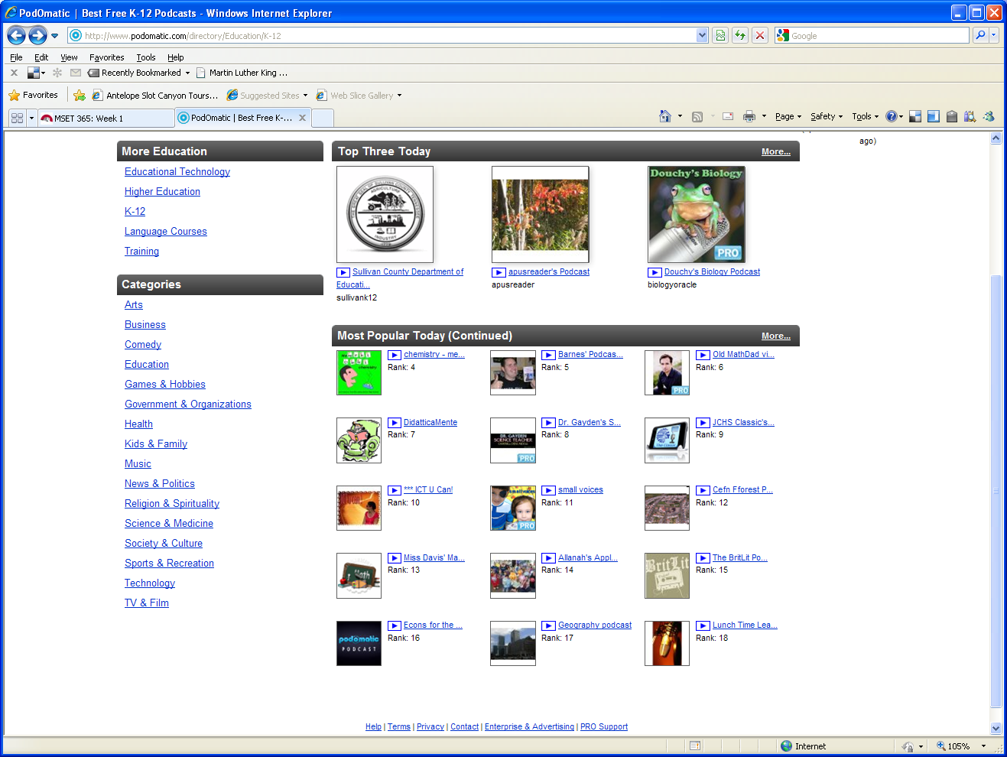  - When you have selected an episode, click on the button next to the title and the episode will open in a new window and start playing.  Figure 8: Kid-cast.com Homepage  Using Kid-Cast.com  - Go to http://www.kid-cast.com/ This site contains podcasts created by kids for kids, and gives good examples of using podcasts in the classroom.  - Click on the PodCasts tab (Figure 8) at the top of the page. This opens a menu of possible episodes to choose from.  - When you click on an episode it should look like Figure 9. Press the play button and the podcast will start playing.  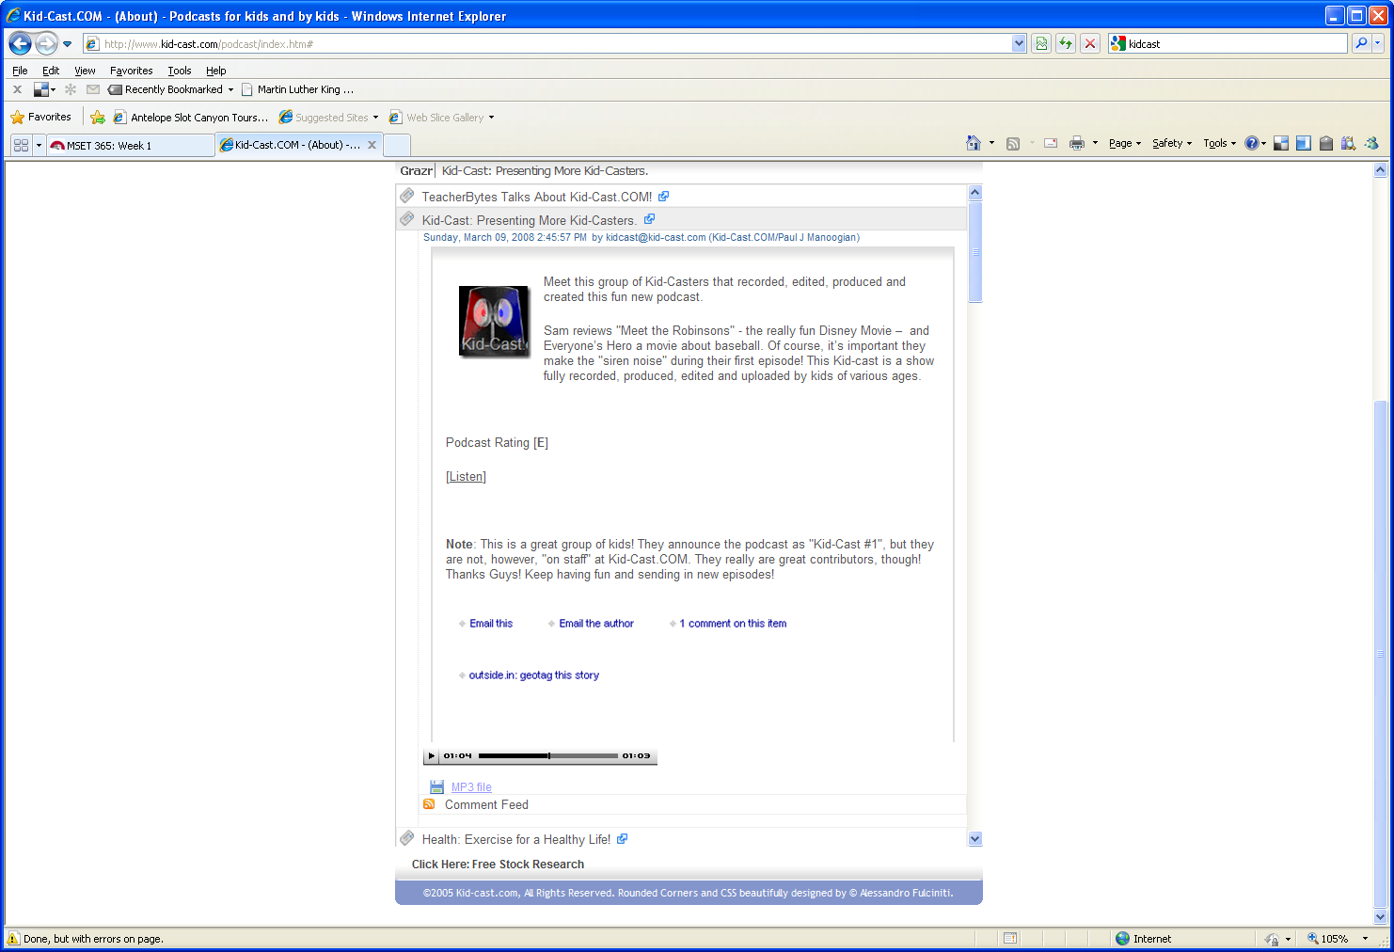  Figure 9: Play Button for Podcasts on Kid-cast.com | 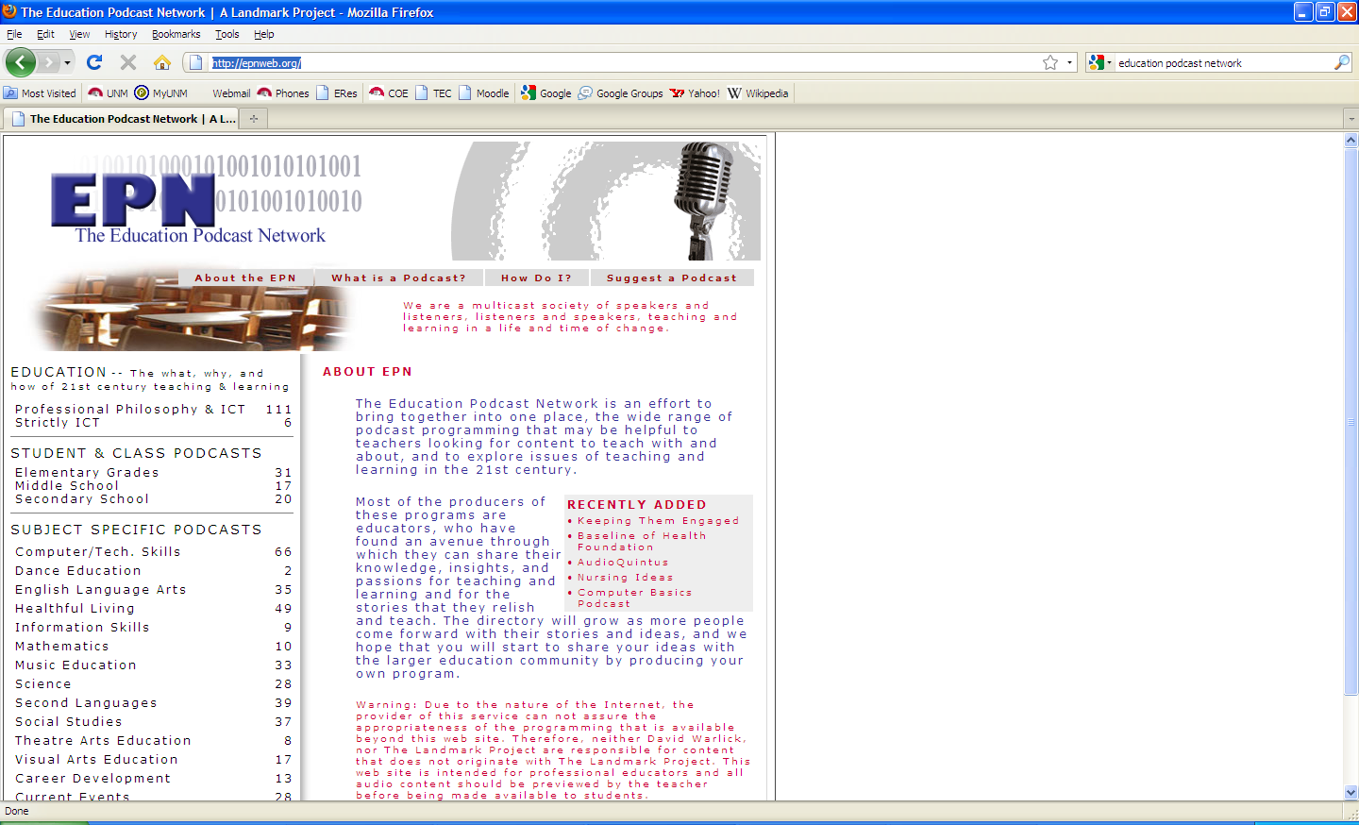  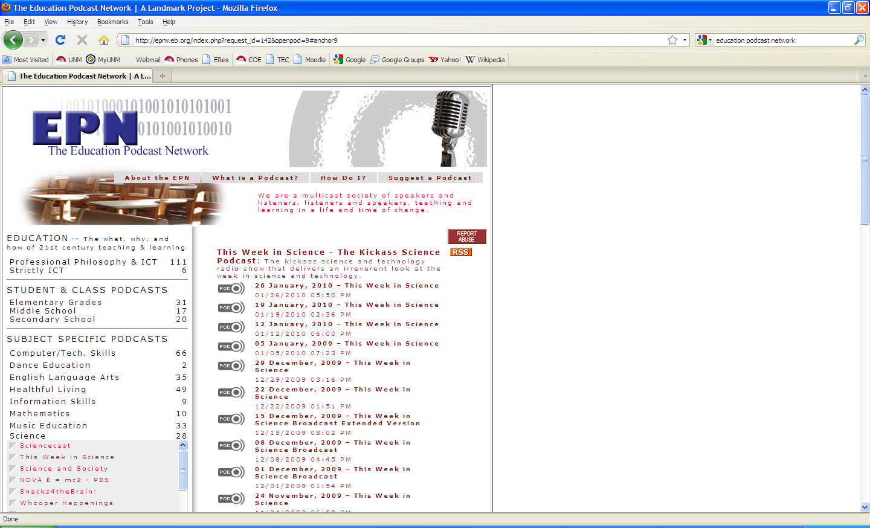  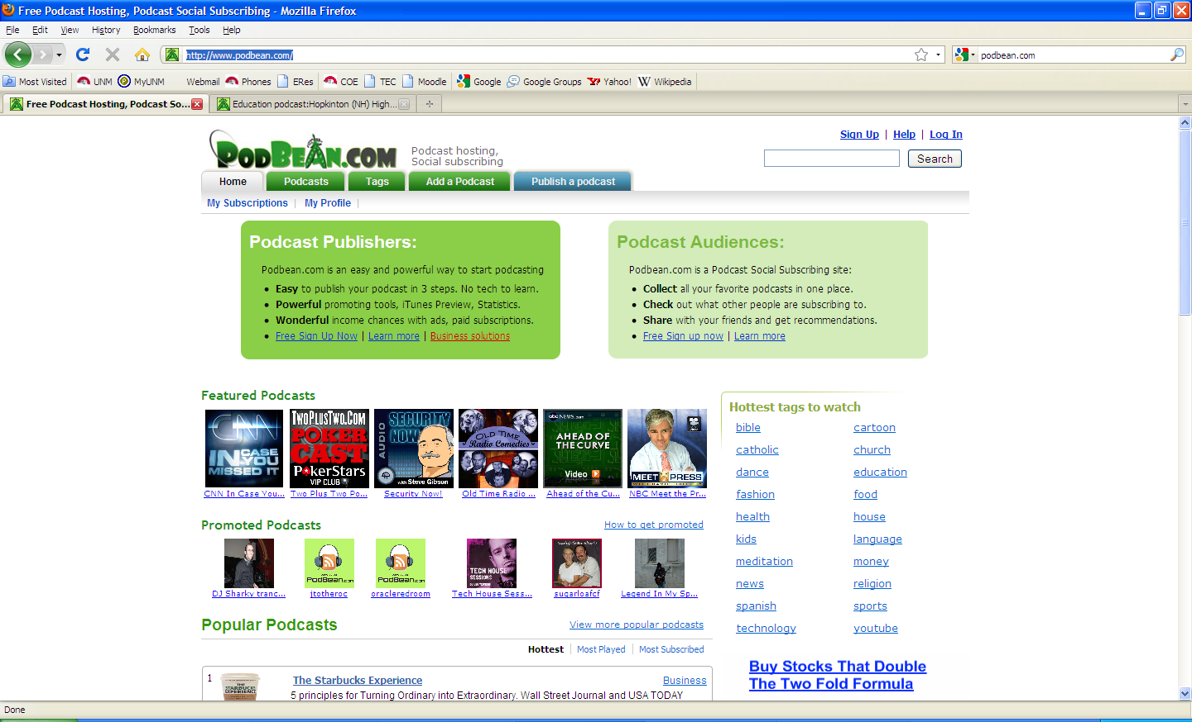  Figure 1: EPN Homepage.  Figure 2: Listening to Podcasts on EPN.  Figure 3: podbean.com Homepage.

