Cell Padding within a Word Table

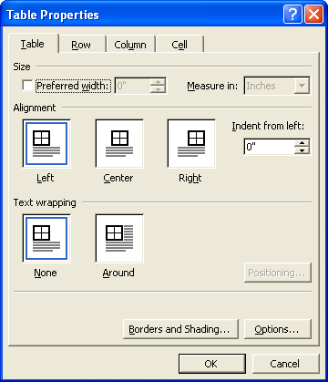
Change Cell Margins in a Table
Figure 1: Table Properties Dialog Box
One way to adjust how much space appears between the cell boundaries and the text inside the cell is to adjust the table’s cell margins. To do this, follow the steps below:

- Open the Table Properties dialog box by right clicking on the table, then selecting Table Properties (Figure 1).
- On the Table tab, Click Options to open the Table Options dialog box (Figure 2).
- Under Default cell margins, enter the new values you want. Note that the values are in inches, not points.
- Click OK.

OR
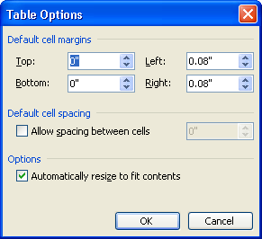
Figure 2: Table Options Dialog Box
- Open the Table Options dialog box by clicking within the table to make the Design and Layout tabs appear. Then select the Layout tab and in the alignment section, select Cell Margins.
- Complete steps 3 and 4 above.

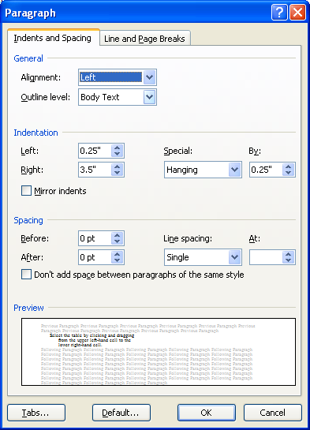
Change Paragraph Spacing within a Table
Figure 3: Paragraph Dialog Box
Another way to add cell padding is to adjust the paragraph spacing within a table. To do this, follow the steps below.

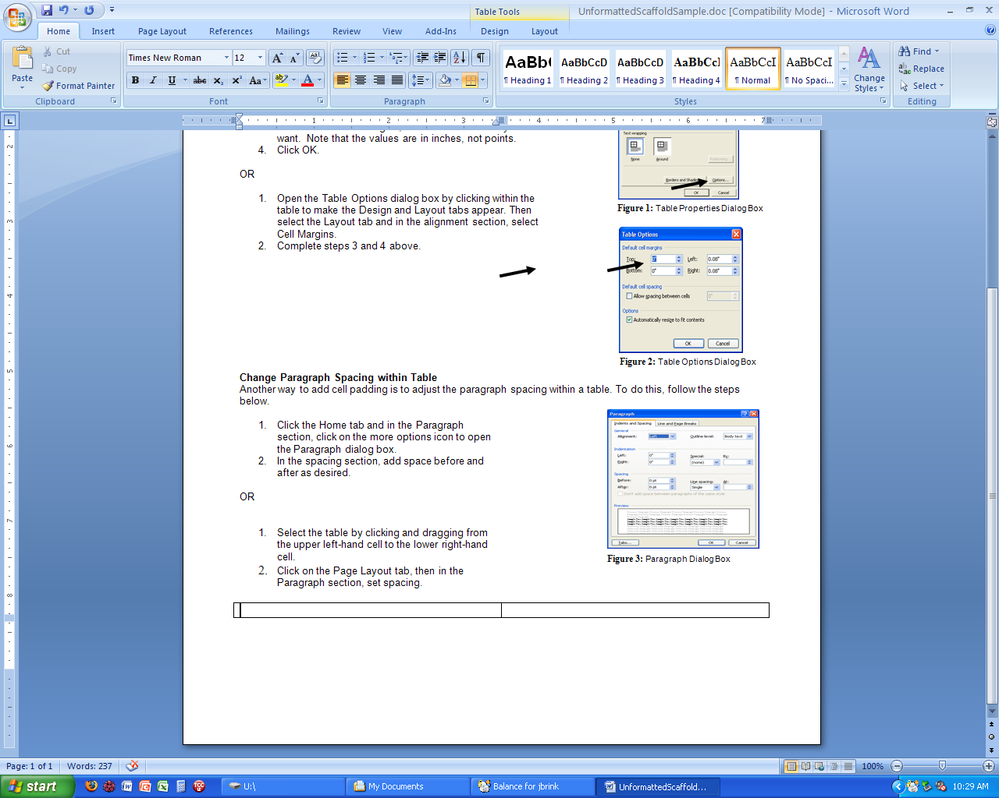
- Click the Home tab and in the Paragraph section, click on the more options icon to open the Paragraph dialog box.
- In the spacing section, add space before and after as desired (Figure 3).

OR

- Select the table by clicking and dragging from the upper left-hand cell to the lower right-hand cell.
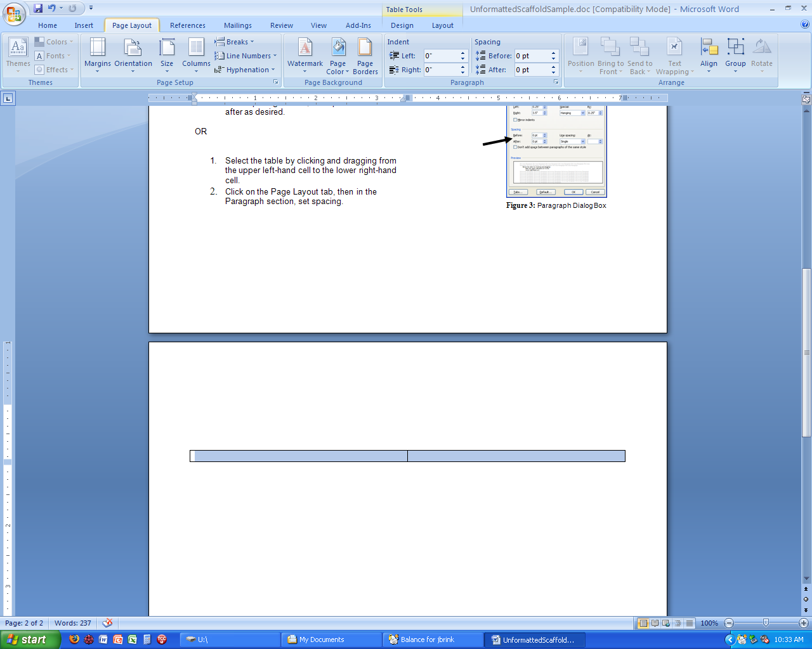
- Click on the Page Layout tab, then in the Paragraph section, set spacing (Figure 4)..
Figure 4: Set Spacing

