Constructivist PowerPoint | Is It An Insect, Yes or No?
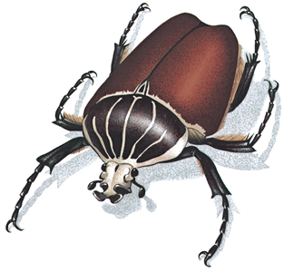
You will create a constructivist PowerPoint to support students in building an understanding of the defining criteria of insects. Begin by clarifying the content for yourself, i.e. what are the criteria that define an insect. Remember, you can’t teach what you don’t know.

Each box marked yes earns 3 points; no earns 0. The two reflection questions are worth 2.5 points each.

Required Criteria |  | Yes | No
Follows the lesson design for having prior knowledge shown below:
 | Slide 1: Title / author slide
 | Slide 2: Statement of problem / learning expectations slide
 | Slide 3: Determine prior knowledge (teacher action in Notes)
 | Slide 4: Question slide for first criteria of an insect (use a non-insect)
 | Slide 5: Answer / information slide (teacher actions in Notes)
 | Slide 6: Question slide for second criteria of an insect (use another non-insect)
 | Slide 7: Answer / information slide (teacher actions in Notes)
 | 1 Guided practice slide (teacher modeling in Notes)
 | 2 – 3 Guided practice slides (students describe thinking aloud in Notes)
 | ≈ 6 slides Guided practice slides (students provide answer only in Notes)
 | Review / summary slide (information coming from students)
 | Image credits slide (image name and URL of source for each image)
Consistent image style: all images of creatures are photograph
Images are clear and sharp with no pixilation
Correct spelling and grammar

Explain why you feel your PowerPoint lesson would or would not be an effective learning experience for students. Refer specifically to the learning theories presented in class in your answer.

Explain why you feel creating the Is It An Insect, Yes or No? PowerPoint was or was not an effective learning experience for you. Again, refer to learning theories presented in class in your answer.

