Creating a Multiple Series Scatter Plot – Inclined Plane

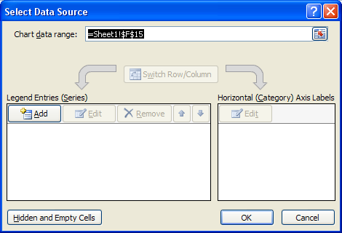
On the Insert tab:
- Charts section, select Scatter – No line option
- Data section, select Select Data. The Select Data Source dialog box will appear (Figure 1).

Adding data for 10 degrees
- Click the Add button. The Edit Series dialog box will appear (Figure 2).
Figure 1
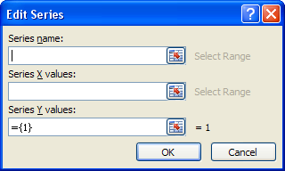
- In the Series name space, type 10 Degrees
- Click in the Series X values space, then select the X values for 10 degrees
- Click in the Series Y values space, delete the inserted text, then select the Y values for 10 Degrees
- Click OK
Figure 2
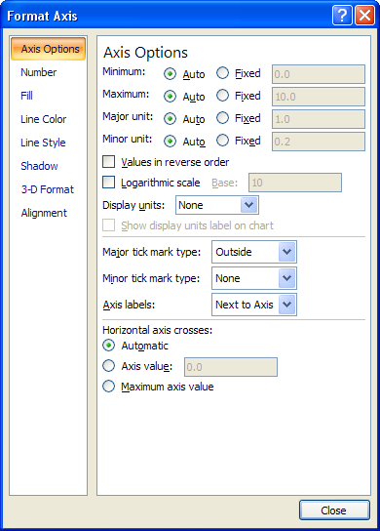
- To add the data for 20 and 30 degrees, repeat the steps for 10 degrees.
- When the data for all three series have been entered, click OK on the Select Data Source dialog box.

If your graph shows lines connecting the data points, set the scatterplot to no lines
- With the graph selected, on the Insert tab in the Charts section, select Scatter and click the no line option.

To change the scales
- Click on the scale within the graph.
- On the Format tab in the current Selection section, click on Format Selection. The Format Axis dialog box will appear (Figure 3).
- Click the desired fixed radio button and enter desired value.
Figure 3

To add chart titles and labels
- On the Layout tab, Labels section, click on Chart Title
- Select the desired chart title style and type chart title, then click outside the text box.
- Click on Axis Titles, select horizontal or vertical, type the axis title and click outside the text box.

