Creating A Scaffold

Creating a Title and Horizontal Line

- Type a title.

- Activate the drawing toolbar by right clicking in any part of the current toolbar, then left clicking on Drawing in the menu. Or, go to View - Toolbars and select Drawing from the drop down menu.
(Figure 1).

- 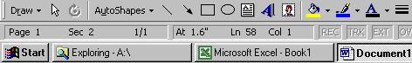Add a horizontal line under the title by clicking the line button on the Drawing toolbar. Then, left click the mouse button at the place you want the line to start and, holding down the mouse button, drag the mouse to the place you want the line to stop before releasing the mouse button. (Holding down the shift key while creating the line will automatically keep the line straight.)

- Change the line thickness by clicking the line style button on the Drawing toolbar and choosing the desired thickness.

- Type in appropriate text describing the task.

Creating Screen Shots

- Effective scaffolds include lots of images! There are two types of screenshots: whole screen and active window.

- Figure 2 shows a whole screen screenshot which included everything visible on the computer’s monitor. Press “Print Scrn” on the keyboard to create a screenshot of the whole screen.

- Note that superimposed on top of the PowerPoint screen shown in Figure 2 is an active window titled Desktop. A window is active if it has a blue title bar as indicated by the arrow.

- Figure 3 shows an active window screenshot of the monitor from Figure 2. Pressing “Alt+Print Scrn” on the keyboard created a screenshot showing only the active window labeled Desktop.

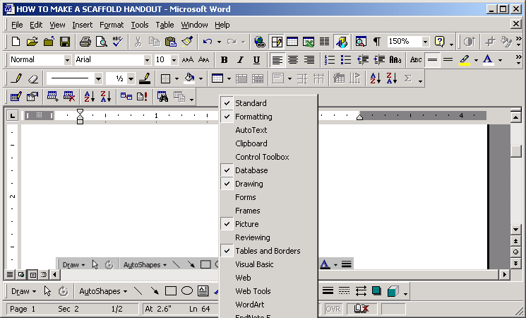
Figure 1: Activate the Drawing Toolbar

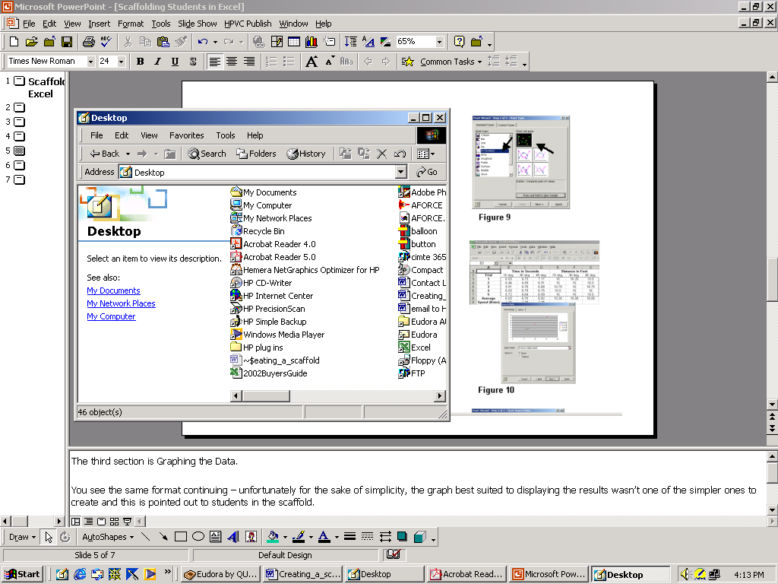
Figure 2: Whole Screen Screenshot

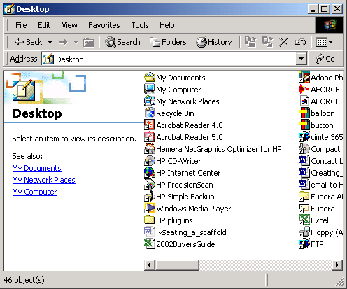
Figure 3: Active Window Screenshot

Inserting Screenshots

- Insert the screenshot by placing the cursor where you want the picture to appear and going to Edit - Paste (or pressing Ctrl+V).

- Note: When first pasted into Word, the screenshot will have black boxes inside the edge of the image (Figure 4). Images in this form can’t be manipulated (moved, resized or cropped). In order to manipulate the image you must change the image layout.

- Change the image layout by first double clicking the image to activate the Format Object dialog box, then clicking the Layout tab. Select a Wrapping Style and click OK (Figure 5).

- Selecting a wrapping style will change the handles on the image from black boxes, as in Figure 4, to white boxes, as in Figure 6. It’s now possible to manipulate the image.

Resizing and Cropping Screenshots

- Activate the picture toolbar by right clicking in any part of the current toolbar, then left clicking on Picture in the menu. Or, go to View - Toolbars and select Picture from the drop down menu.

- Resize the image proportionately by moving the cursor over one of the corner boxes. When the cursor turns into a two-headed arrow, click and hold the left mouse button and drag the picture to the desired size before releasing the mouse button (Figure 7).

Resizing the image proportionally will ensure that the proportion of length to width is maintained and the image doesn’t look squeezed.

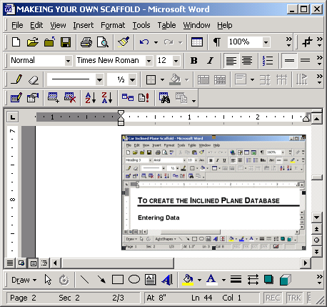
Figure 4: Nonformattable Image

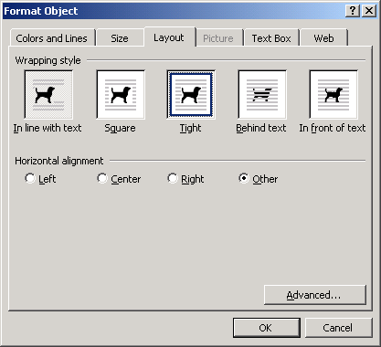
Figure 5: Format Object Dialog Box

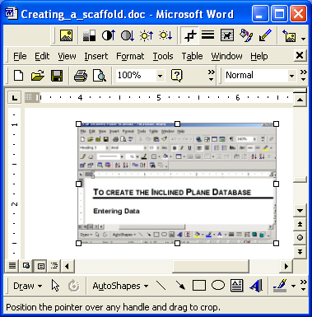

Figure 6: Formattable Image

Figure 7: Proportional Cropping

- Resizing an image from one of the boxes located in the middle of the sides will alter the proportions of the image, compressing it in that dimension. (Figure 8).

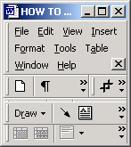
- Crop an image by first clicking on it to make the white boxes appear, then clicking on the crop button on the Picture toolbar. Next, move the crop icon over one of the white boxes, click and hold the left mouse button, then drag the mouse to the desired location before releasing the mouse button.

Simply cropping and resizing was all that was used to create the images in this scaffold including the images of single buttons such as this .

Creating Image Labels

- Label your figures using text boxes. Click on the Text Box button on the Drawing toolbar, then place the cursor where you’d like the text box to appear. Next, hold down the left mouse button and drag the mouse to create the text box.

A cursor will appear in the text box. Type the image label. You can use all the regular text editing tools to format your text.

As you enter text, notice the boundary around the text box is composed of diagonal lines. When this boundary appears you can enter or edit text.

If the text box isn’t large enough, resize it in the same way as you would an image. Notice when you resize the text box the boundary changes from diagonal lines to dots. When this boundary appears you can resize or move the text box.

Clicking outside the text box will unselect it. Notice that the text box has a line around it.

- Remove the line around the text box by going to Format - Format Text Box or by right clicking the boarder of the text box and selecting Format Text Box from the pop-up menu (Figure 11). Select the Colors and Lines tab and click No Line from the Line drop-down menu.

Figure 8: Nonproportional Cropping

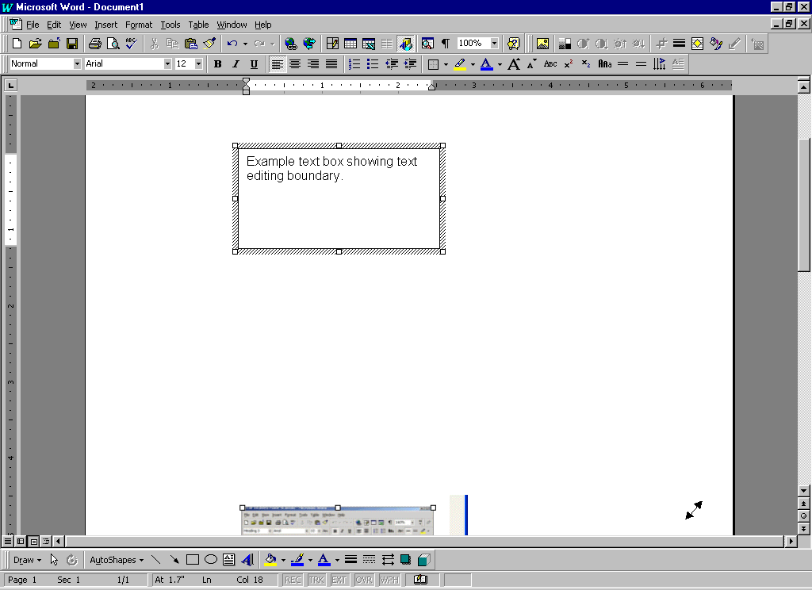
Figure 9: Text Editing Boundary

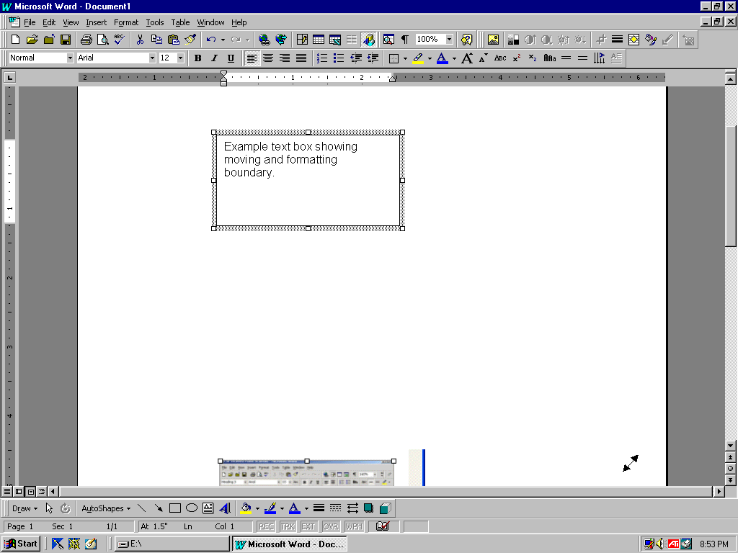
Figure 10: Formatting Boundary

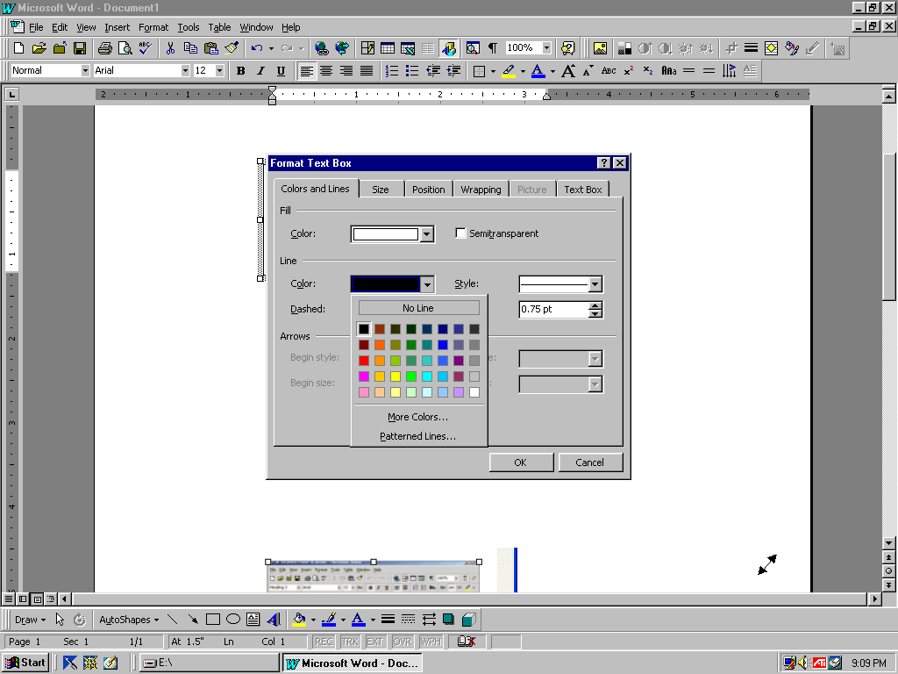
Figure 11: Text Box Formatting

- Notice that you can select a background color in the Fill section. By default, text boxes include white fill. If you want to place the text box over another object and still see the object underneath, select No Fill.
Figure 12: Example Arrows

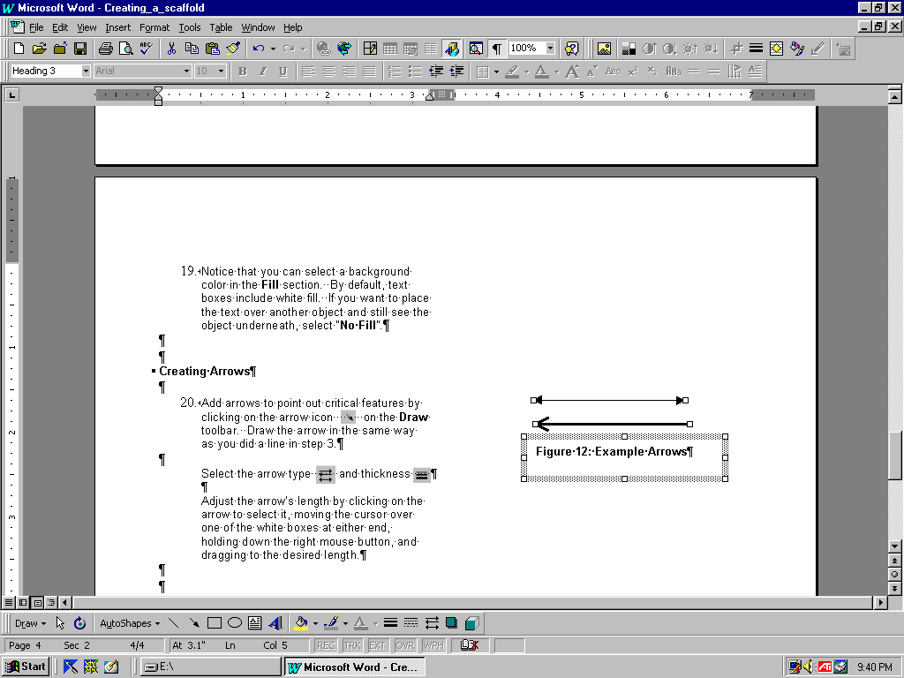
Creating Arrows
Figure 13: Ungrouped Items

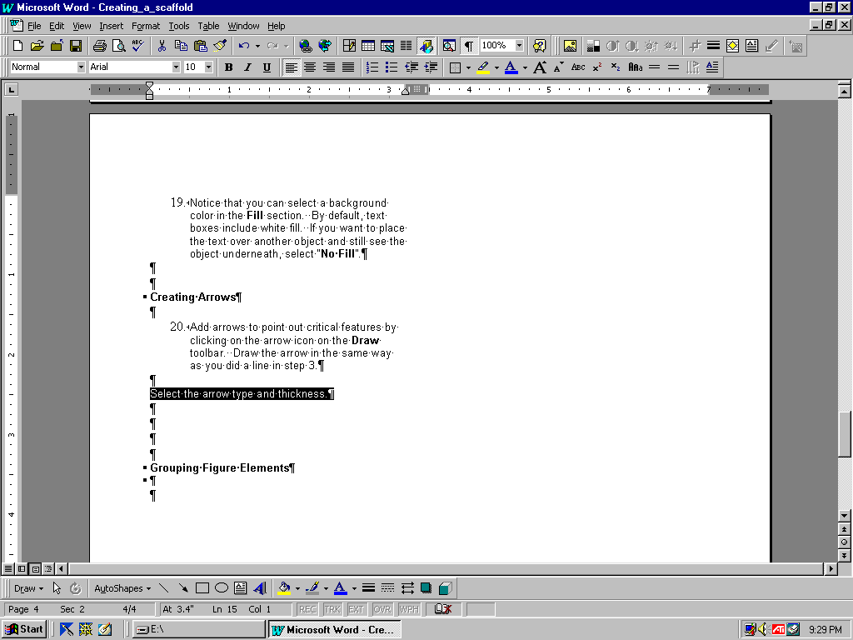
- Add arrows to point out critical features by clicking on the arrow icon on the Drawing toolbar. Draw the arrow in the same way you did a line in step 3.
Select the arrow type and thickness .

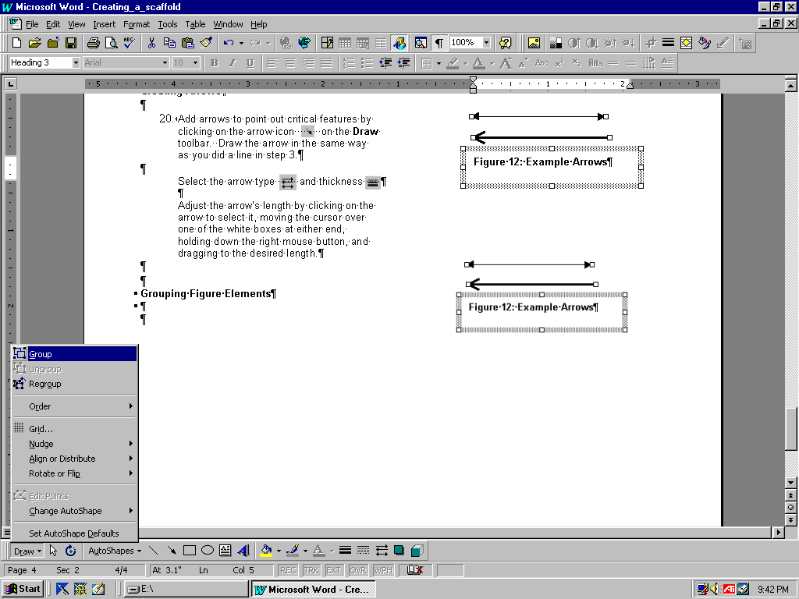
Adjust the arrow’s length by clicking on the arrow to select it, moving the cursor over one of the white boxes at either end, holding down the right mouse button, and dragging to the desired length.
Figure 14: Group Option

Grouping Figure Elements

Figure 12 is composed of three items: two arrows and a text box. Moving the figure is tedious as it entails moving each of the three items individually. Grouping the three items combines them into a single element that is easy to move.

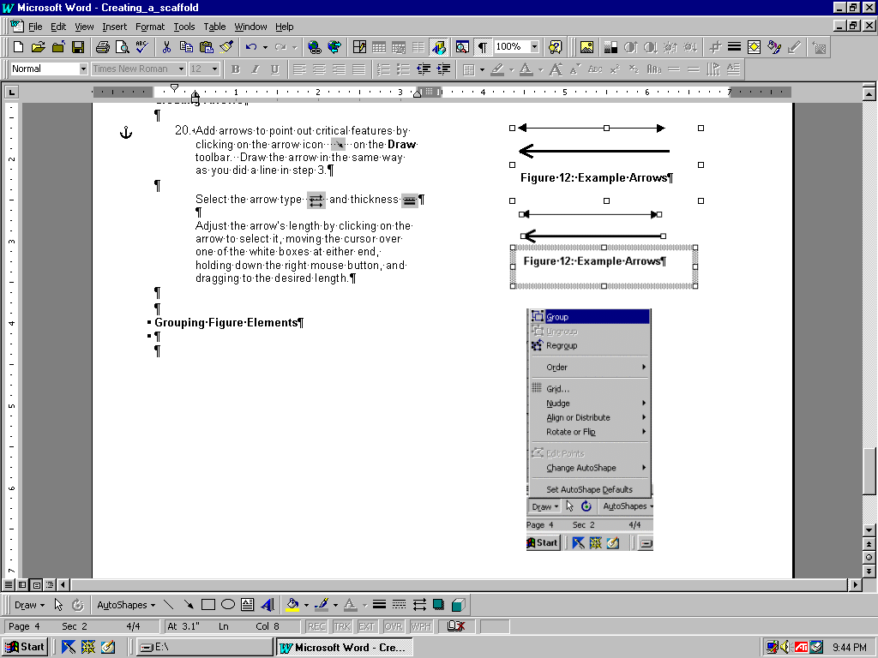
- Group items by first simultaneously selecting all items to be grouped. Do this by holding down the “Shift” key and clicking on all the items. Figure 13 shows the three items comprising Figure 12 simultaneously selected. Note that each item has white boxes indicating it’s been selected.
Figure 15: Grouped Items

Next, go to Draw – Group on the Drawing toolbar (Figure 14). Figure 15 shows the same items after they’ve been grouped. Note that the white boxes now surround all three combined items indicating that they’ve been grouped. Now when the items are moved, they will move as a single unit.

