Creating A Scaffold: Word 2007

Creating a Title and Horizontal Line
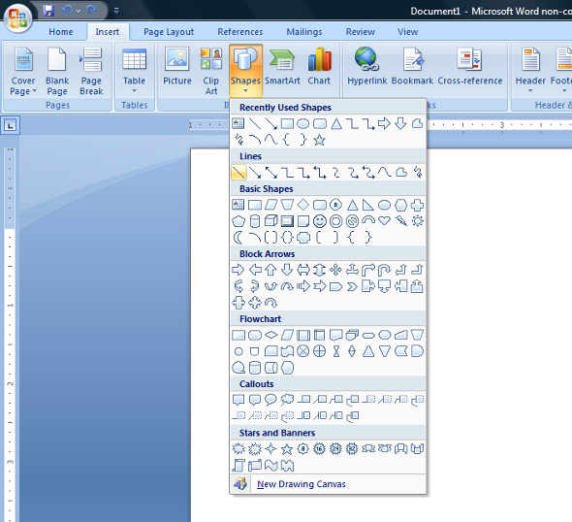
Figure 1: Shapes
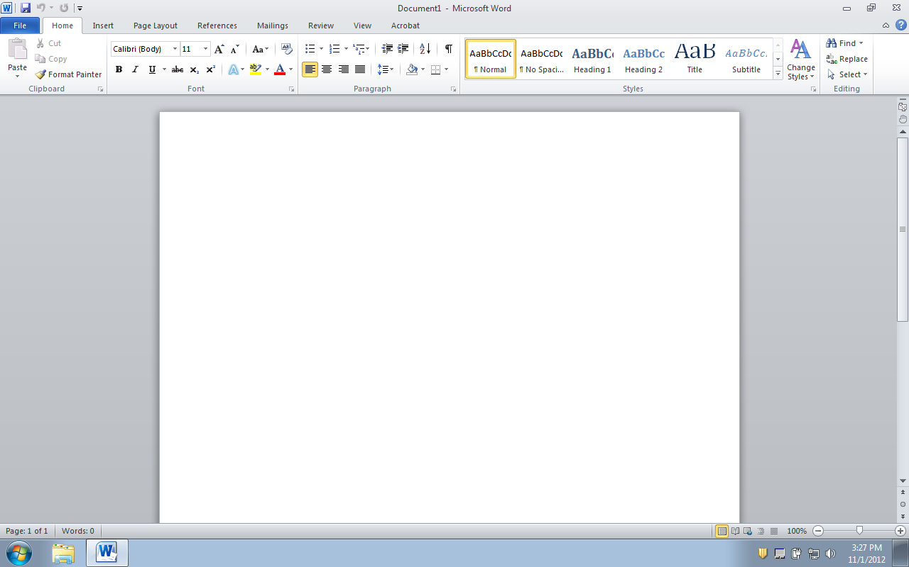
- Type a title, then highlight it. On the Home tab - Font section click the icon to open the Font dialog box. In the Effects section select Small Caps.
- On the Insert tab - Illustrations section click Shapes (Figure 1). Click on Shapes.
- 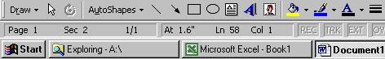Add a horizontal line under the title by picking the line button . Then, left click the mouse button at the place you want the line to start and, holding down the mouse button, drag the mouse to the place you want the line to stop before releasing the mouse button. (Holding down the shift key while creating the line will automatically keep the line straight.)
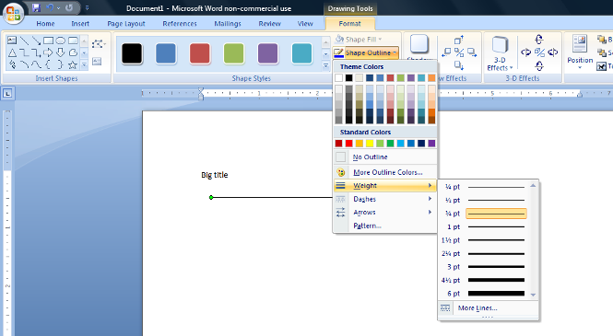
- After you finish drawing the line, an additional Drawing Tools Format Tab will appear (Figure 2).
Figure 2: Drawing Tools Format Tab
- Change the line thickness by clicking Shape Outline button in Drawing Tools Format Tab and picking the Weight option . Then, choose the desired thickness.
- Type in appropriate text describing the task.

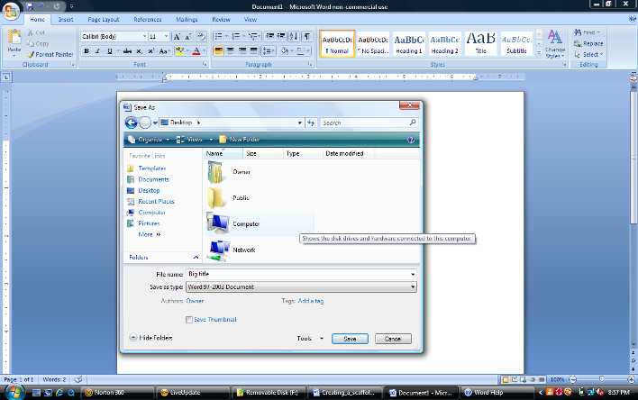
Creating Screen Shots
Figure 3: Whole Screen Screenshot

- Effective scaffolds include lots of images! There are two types of screenshots: whole screen and active window.
- Figure 3 shows a whole screen screenshot which included everything visible on the computer’s monitor. Press “Print Scrn” on the keyboard to create a screenshot of the whole screen.
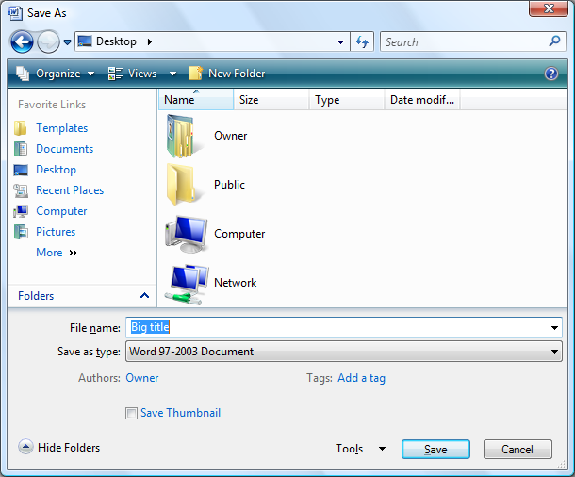
- Note that superimposed on top of the MS Word screen shown in Figure 3 is an active window titled Desktop. A window is active if it has a blue document bar as indicated by the arrow.
Figure 4: Active Window Screenshot
- Figure 4 shows an active window screenshot of the monitor from Figure 3. Pressing “Alt+Print Scrn” on the keyboard created a screenshot showing only the active window labeled Desktop.

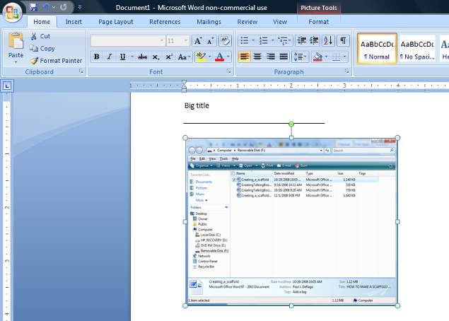
Inserting Screenshots
Figure 5: Formattable Image and Picture Tools Tab

- Insert the screenshot by placing the cursor where you want the picture to appear and going to Edit - Paste (or pressing Ctrl+V).
- When pasted into Word, the screenshot will have white circles outside the edge of the image (Figure 5) after you have clicked inside the screenshot to select it. Images in this form can be manipulated (moved, resized or cropped) using the Picture Tools Format Tab.

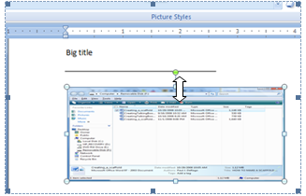
When pasting an image into Word under certain conditions, rather than seeing white circles outside the border of the image and the green circle to rotate it as seen in Figure 5, you'll instead see black squares at each corner inside the border of the image (Figure 6).
Figure 6: Image Treated As Text by Word

The black boxes indicate Word is treating the image as though it were a large letter of text rather than as an image. Accordingly, you will have trouble formatting it the way you normally would if Word were treating it at an image. For example, Word will not allow you to group and image showing black boxes to a text box. That makes sense; you can't group a letter to a graphic of any sort.

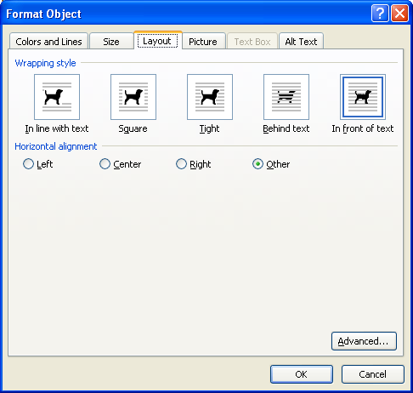
Before continuing you need to tell Word that it's an image. With the image selected and the black boxes showing, right-click on top of the image to open a menu of options and select Format Object to open the Format Object dialog box (Figure 7).
Figure 7: Format Object Dialog Box

Next, select the Layout tab. The wrapping style options In-line with text, Square, and Tight will automatically move text around the the image. Because we’ve used the margin settings to create blank space with no text, we don't want the images influencing the displayed text. Therefore, the most appropriate layout for our purposes is In front of text.

After selecting In front of text, click the OK button. When you do, you'll see the black squares inside the margin of the image change to white circles outside the margin of the image indicating Word is now treating the image as an image. This will allow you to manipulate the image more easily.

Resizing and Cropping Screenshots

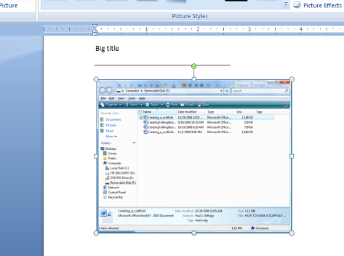
- Activate the Picture Tools Format Tab by double-clicking the inserted screenshot. Or, just select the Format Tab.
Figure 8: Proportional Cropping
- Resize the image proportionately by moving the cursor over one of the corner boxes. When the cursor turns into a white two-headed arrow, click and hold the left mouse button and drag the picture to the desired size before releasing the mouse button (Figure 8).
- Resizing the image proportionally will ensure that the proportion of length to width is maintained and the image doesn’t look squeezed.
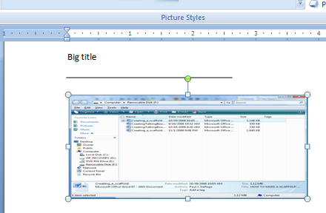
- Resizing an image from one of the boxes located in the middle of the sides will alter the proportions of the image, compressing it in that dimension (Figure 9).
Figure 9: Nonproportional Cropping
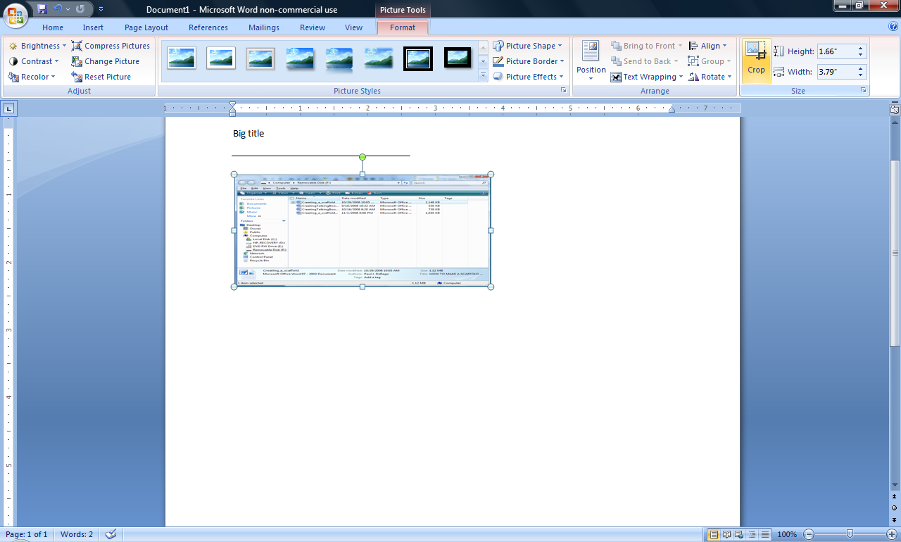
17. Crop an image by clicking on it to make the white boxes appear, then clicking on the Crop button in the Picture Tools Tab that will appear when you select the image. Next, move the crop icon over one of the white boxes, click and hold the left mouse button, then drag the mouse to the desired location before releasing the mouse button.
Simply cropping and resizing was all that was used to create the images in this scaffold including the images of single buttons such as this

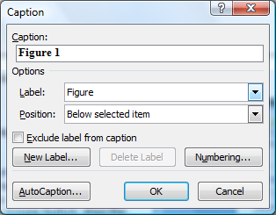
Creating Image Labels
Figure 10: Caption Window

- Label your figures using the Insert Caption button on References Tab. (NOTE: this button creates a text box for you. You could also draw your own text box but using this button automatically removes the text box line and fill color which saves some work.)
- First, click on the picture, then, on Insert Caption.
- In the Caption window (Figure 10) select the label (figure, label, equation) and the position (below or above selected item). If you don’t specify the numbering, Word will number the figures automatically in descending order. You can use all the regular text editing tools to format your text.

Creating Arrows

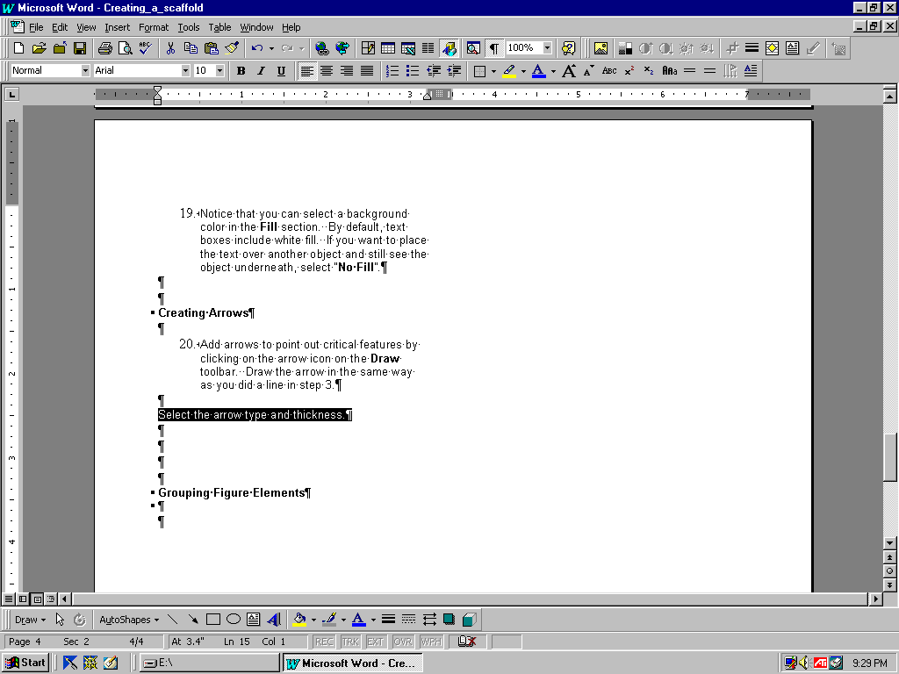
- Add arrows to point out critical features by clicking on the Insert tab, then Shapes. Select the arrow icon and draw the arrow in the same way you did a line in step 3 (Figure 11).
Figure 11: Arrow Examples
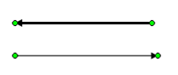
After you draw an arrow, the Drawing Tools Format Tab will appear. Change the arrow type and thickness the same way you did in step 5 - by clicking Shape Outline button in Drawing Tools Format Tab and selecting Weight and Arrows buttons.
Figure 12: Selected Arrows Ready to be Resized

Adjust the arrow’s length by clicking on the arrow to select it, moving the cursor over one of the green circles at either end (Figure 10), holding down the right mouse button, and dragging to the desired length.

Grouping Figure Elements
Figure 13: Ungrouped Items
- If the figure consists of several elements, they should be grouped first in order to add an image label or captioning as discussed above.

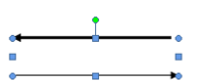
- Group items by first simultaneously selecting all items to be grouped. Do this by holding down the “Shift” key and clicking on all the items. Figure 13 shows the two items comprising Figure 12 simultaneously selected. Note that each item has green circles indicating it’s been selected.
Figure 14: Grouped Items

Next, go to the Page Layout Tab and select the Group button. Note that the blue boxes now surround combined items indicating that they’ve been grouped. Now you can create a caption for the image as described above.

