Educational Website Checklist

This assignment will be completed in two parts, the website shell which is due first, and the completed website due at the end of the semester. Website shell components appear below in black text. Website components in blue text should be added before turning in the final version later in the semester.

Directions: Use the checklist to ensure you include all required components in your educational website. Next, create a hot link to your educational website below the table, then save the file as LastName_FirstInitial_Educational_Website and submit it through the Educational Website Final Assignment Submission link in the Table of Contents.

Criteria | Yes | No
Home page includes the class name and / or subject
Home page includes a welcome statement describing what parents and students can find on the site
Home page includes a statement describing your thoughts on the role of technology in supporting effective instruction and learning
Home page includes an active email link (the link automatically opens an email program)
Home page includes education-related image with attribution if you didn't take the picture yourself
Home page includes navigation bar to access the Assignments, Instructional Resources and Exemplary Work pages
Website includes an Assignments page with space to add links
Assignments page includes links to your three lesson plans and all associated scaffolds
Website includes a Resources page with space to add links
Resources page includes annotated links to educational websites
Website includes an Exemplary Work page with space to post student work
Website uses consistent layout
Website uses consistent color scheme
Website uses consistent text formatting
Website is free of spelling and grammatical errors

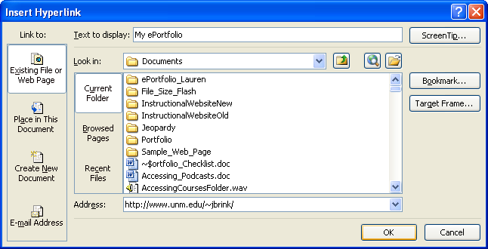
There a multiple ways to create a hot link within a Word document. You can simply copy the URL from your Google site and paste it into the document, but readers see all the gobbledygook that is part of a web address.

Here’s a better way: on the Insert tab in the Links section, click on Hyperlink. In the Insert Hyperlink dialog box, type the words you want to turn into a link in the Text to display line, then paste your URL into the address line.

