Linking to a Document in your Google Site
First, create a new page and make it a File Cabinet page. Name it something like “Files.” Place it at the top level. Click the button “Create Page.” | 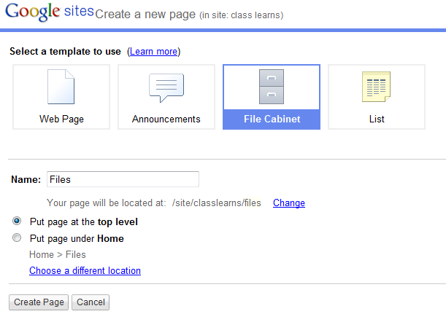
Upload the documents you want to use in your website by clicking the Add file button. | 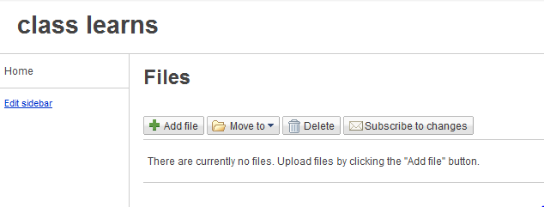
Click the browse button and navigate to the file you wish to add. When the file name appears in the space under “your computer” click the upload button. | 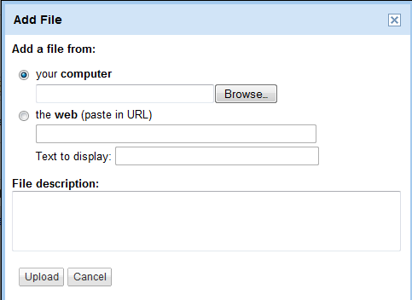
You will now see your file in the file cabinet. | 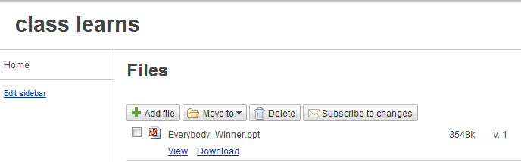
Navigate to the page you want your document to link to. | 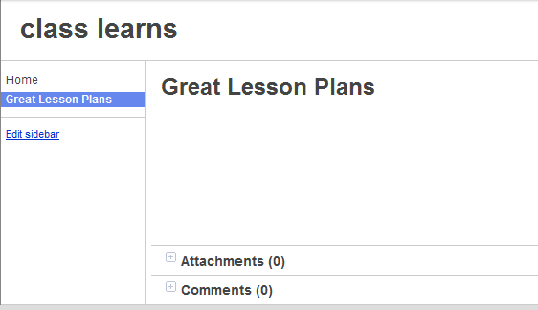
Click edit page and create the text you will use as your link. Highlight the text, then click the blue “link” button. | 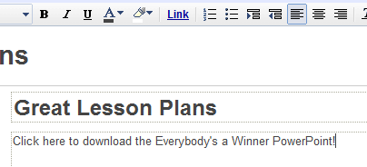
On the window that pops up, click existing page, then type the name of the file (or a portion of the name of the file). Click search pages. | 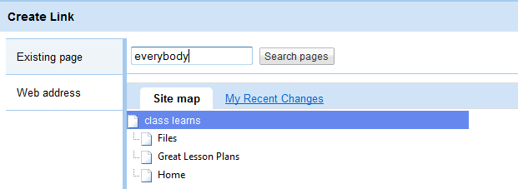
The file you placed in the file cabinet will show up. Click it so it has a check mark next to it, decide whether you want it to open in its own window, then click ok. | 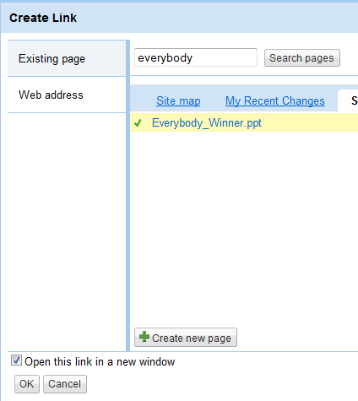
The file link will appear on your website. Just click the save button and your file is linked. | 