Your name & page number in header
Word Art.

Make all headings bold 14.
Problem:

Does the angle of the incline a model car is rolled down affect the average distance traveled and maximum speed attained?

Hypothesis:

The greater the angle of the incline, the greater the distance traveled and speed attained.
I predict the car will travel farther and faster when rolled down a steeper incline. The average distance traveled and speed attained will be greatest using the 45 degree incline, followed by the 30 degree incline, followed by the 15 degree incline.

Procedure:

- Using a protractor, set the ramp to an incline of 45 degrees. (See Figure 1).
- Place the car at the top of the ramp.
- Zero the stop watch.
Numbered list with 1.5 spacing.
- Let the car go.
- Record the time the car was in motion in seconds.
- Record the distance the car traveled in feet.
- Repeat steps 2 – 6 for 5 trials.
- Repeat steps 1 – 6 for ramp angles of 30 degrees and 15 degrees.
- Calculate the average distance and speed for each of the three ramp angles.

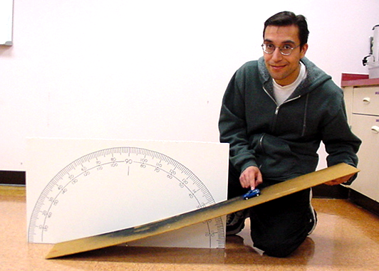

Insert image and adjust size.

Figure 1: Set Ramp
Add text box with no line or fill, bold 9 point text, and group with image.

Centered practicum name in footer.
Results:
Delete spaces as needed so Results heading starts on first line of page.

At 15 degrees the car traveled an average distance of 10.25 feet, in an average time of 6.03 seconds. This results in an average speed of 1.70 feet/sec. (See Table 1.)
At 30 degrees the car traveled an average distance of 16.05 feet, in an average time of 6.746 seconds. This results in an average speed of 2.38 feet/sec.
At 45 degrees the car traveled an average distance of 16.05 feet, in an average time of 6.82 seconds. This results in an average speed of 2.35 feet/sec.
Bold and center all titles.
Center all data in cells.
Merge cells and add gray fill.
Entire row 10 pt. font.

Trial | Time in Seconds |  |  | Distance in Feet
 | 15 degrees | 30 degrees | 45 degrees | 15 degrees | 30 degrees | 45 degrees
1 | 6.03 | 6.73 | 7.17 | 10 | 16.25 | 15.5
2 | 6.46 | 6.59 | 6.91 | 10 | 16 | 16.5
3 | 5.91 | 6.78 | 6.68 | 10.75 | 16 | 16.75
4 | 6.03 | 6.79 | 6.75 | 10.5 | 16 | 16
5 | 5.72 | 6.84 | 6.59 | 10 | 16 | 15.5
Average | 6.XX | 6.XXX | 6.XX | 10.XX | 16.XX | 16.XX
Speed (Ft/sec)  Table 1: Average Speed Results | 1.XX | 2.XX | 2.XX
Add text box with no line, no fill and bold 9 point type.
Resize cell widths to match example. Data cells should all be the same width.

Analysis:

As the ramp angle increased, the height the car began its descent from also increased. As a result, the car’s potential energy was greatest when the ramp was set at a 45 degree angle. This greater potential energy translated into correspondingly greater kinetic energy, causing the car to travel the farthest and fastest when rolled down the steepest incline.

