Designing Effective Peer Teaching (Jigsaw)
Activities for Teaching Structural Geology
Barbara Tewksbury
Hamilton College
btewksbu@hamilton.edu

The general technique
In this technique, teams of students are assigned to investigate different aspects of the same problem/issue. Once teams have completed their assignments, members of each team then disperse during class among mixed groups and teach group members from other teams about what they have learned. The group then completes a task that ties all of the pieces together to reveal the “picture”. Each person makes up part of the “jigsaw puzzle”, hence the commonly-used nickname for the technique. This technique can be used equally well for assignments involving data analysis or field work and in assignments involving reading. A detailed outline of steps to follow for constructing a jigsaw activity appears on page 4, but a short outline follows:
• Prepare several different assignments for the class. For the sake of example, suppose you devise 4 assignments. Divide the class into four teams, and have each team prepare one of the assignments.
• Once each team is prepared, divide the class up into new groups. Each group will have one team member from each of the teams. Each member of the group is responsible for teaching the rest of the group what he/she has learned from his/her team assignment.
• The group then puts all of the pieces together and addresses a question that can be answered once all of the team pieces are together.

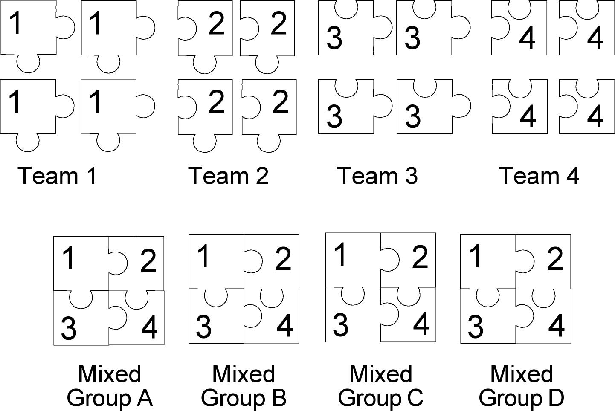

Short examples:

Introduction to classification of igneous rocks: As students enter a large introductory class, they each pick up one rock from a box of samples by the classroom door. The box contains samples of gabbro, granite, and basalt. Before beginning igneous rock classification, the instructor asks each student to study his/her rock sample and write down all the observations he/she can make about it. After giving the students several minutes to study their rocks, the instructor asks the students to make groups of three so that each group has three different rock types. Each group then compares rocks, noting similarities and differences. The instructor then asks groups what they have noted in their rocks and writes down responses on an overhead transparency. Students make all of the observations that one might expect them to make about color, grain size, and texture, providing an engaging base for the instructor to then introduce igneous rock classification. (Jeff Niemitz).

In the field: While on a field trip, students are divided into teams of 3-4. At each outcrop, each team is assigned a portion of an outcrop to examine closely and given an assignment pertinent to the character of the field trip (e.g., based on what you can see in your section of the outcrop, what is the structural history of these rocks? the depositional environment? the intrusive relationships? the rock types?). After each team has examined its section, mixed groups rotate through the sections of the outcrops, with each team member sharing what he/she discovered and discussing what the group can determine overall from the outcrop. This technique encourages students to look closely at an outcrop, rather than wandering around and looking only casually, and also drives home the point that what you conclude depends upon the outcrop exposure. (Barbara Tewksbury)

In the lab: Students are divided into teams of 3-4 and look at a particular group of thin sections or samples. Once each team is done with its study, mixed groups form, and team members share what they have learned about their samples/sections. Groups then consider the implications of similarities and/or differences. The advantages of this strategy are two-fold: 1) few of us have enough multiple thin sections for all students to easily look at identical thin sections and 2) looking in detail at a few thin sections/samples and in general at a number of others gives students both the practice in detailed analysis and the experience of seeing the variability between thin sections/samples without requiring them to see all of in excruciating detail. (Barbara Tewksbury)

Reading assignments with overlapping but different topics. After having learned several techniques for measuring strain in real rocks in a structural geology course, the instructor assigns a different research article from the published literature to each of four teams. Before class, each student reads his/her article and prepares written answers to a set of questions, which the instructor collects in class. The instructor meets briefly with each team to make sure that no important points have been missed. In mixed groups, each person teaches the rest of the group about his/her article, and the group has a discussion on which articles show the best examples of 1) establishing volume loss during deformation, 2) establishing whether deformation involved pure shear, simple shear, or compound strain, 3) establishing the orientation of foliation with respect to the principal directions of the strain ellipsoid, and 4) establishing what variables appear to govern foliation development in rocks. Each person is responsible for learning enough from the other group members to then write an individual summary explaining two examples for each of the four points. (Barbara Tewksbury)

Benefits of the technique
Repeated use of the technique accomplishes the following:
• Students have the opportunity to teach themselves, instead of having material presented to them. The technique fosters depth of understanding.
• Each student has practice in self-teaching, which is the most valuable of all the skills we can help them learn.
• Students have practice in peer teaching, which requires that they understand the material at a deeper level than students typically do when simply asked to produce on an exam.
• Students “talk geology” and become more fluent in use of geological terminology.
• Each student has a chance to contribute meaningfully to a discussion, something that is difficult to achieve in large-group discussion. Each student develops an expertise and has something important to contribute.
• Asking each group to discuss a follow-up question after individual presentations fosters real discussion.

Critical aspects for success
• Team assignments must be carefully crafted.
– The best team assignments are overlapping ones. If no common elements exist among the team assignments, group discussion degenerates into a series of mini-lectures given by unskilled lecturers. If, on the other hand, assignments overlap in some way, each person can be engaged in comparison and extension of his/her assignment while other students are presenting their team assignments.
– Be sure that each team assignment is valuable in its own right, because teams will learn their own assignments well and those of other teams considerably less well. If each student must learn the topic of each team assignment equally well, this is not the strategy to use to have them learn it.
– Choose team assignments that lend themselves well to comparison among teams, which fosters discussion and engagement during group sessions. You might, for example, assign each team a different set of samples, field sites, thin sections, different aspects of the same topic, different viewpoints, and so forth.
– Choose team assignments that students can successfully reason out or teach themselves. Items that students don’t get easily on their own don’t lend themselves well to the jigsaw technique.
• Students must come prepared. If they are not prepared, discussion will not work. Having students prepare individual written responses to carefully selected questions (a work sheet or a list of questions) forces students to think in ways that will prepare them adequately for discussion. Collecting and grading the written preparation is an option that serves as a stick. Giving a short quiz before discussion starts is effective but is less in keeping with the spirit of discussion and the notion of making students more responsible for their own learning.
• The aims of in-class group work cannot be met if students do not come to class and participate. If students at your school tend to be casual about class attendance, you will probably need to establish some kind of “stick” to make sure that students come to class. Students also need to understand that a stiff attendance policy is not merely a whim but arises from the fact that in-class learning is vital in a non-lecture-based course.
• Meet in a room where students can move chairs into small clusters. If your classroom has fixed chairs that cannot be moved, find a different room. The setting is, in fact, very important.
• Be absolutely sure that you touch base with each team before teams split up to teach in the mixed groups. Be sure that each team member understands the main points and how to teach them so that he/she won’t pass wrong-headed notions along to other students.
• Be sure to build individual accountability into the group work. Tell students that, when another student is talking, each person in the group is personally responsible for learning what that person is talking about. Tell them that, if a member of the group is muddling along and not teaching clearly, it is up to the other members of the group to prod and question until they have learned enough to do the written assignment. If prodding doesn’t illuminate the issue, tell them that it is their responsibility to call an instructor over to clarify things.
• Don’t just stop at the end of the individual presentations. Be sure to have each group discuss a summary question or a related issue based on what they have learned from each team member. Not only does this engage students at another intellectual level in the issues, but it also provides an incentive for students to learn enough from each other that they can successfully address the new issue.
• Assign each student to prepare an individual written summary assignment based on what he/she has learned in the group. This provides an incentive for students to be responsible in their groups.
– An upcoming written assignment places the focus on teaching and learning during group discussion, rather than on simple presentation. The prospect of a written assignment forces students to pay attention to other students and places the responsibility of learning on each student. A student cannot be disengaged while another student is talking if he/she knows a written assignment depends on the information.
– An individual summary assignment forces a student to process the information learned in the group so that he/she really learns the material.
– An individual assignment also allows the instructor to evaluate what each student has learned, something that can be difficult in a class that revolves around group work.
• Be sure that students clearly understand what the advantages are of approaching learning in this fashion. Convince them that they will learn more this way than by listening to you lecture.
• Don’t be tentative, and don’t give the impression that you’re experimenting on students with this technique. Be confident and committed, rather than negative, tentative, and apologetic.

Detailed steps for using the jigsaw technique

Step 1: Divide the class into teams of three to five people.
Step 2: Devise two to five different team assignments. The number of different assignments depends on how many teams you want to have, because each team will receive a different assignment. You might give teams different reading, different data sets, samples, maps or problems, different issues for discussion, different field sites, and so on.
Step 3: With a small class, give a different assignment to each team. If there are four different assignments, there will be four teams. For a larger class, create several #1 teams, several #2 teams, and so on. Give all the #1 teams the same assignment, etc.
Step 4: Unless you plan to give teams time to work during class, ask each student to prepare individually before class. One effective way to prepare students is to give them focus questions to accompany the assignment and require that students prepare written responses to those questions. If you don’t do something like this, some students won’t come prepared to class. Rather than asking students to prepare ahead of time, you can set aside time during class for students to work in teams to do the reading/analysis (this works if the reading/analysis is short or involves equipment that is not accessible to students outside of class and does guarantee that all students do the reading or analyze the data). If there are several teams of the same number (e.g., four #1 teams), each team should meet separately, not as a large group.
Step 5: Give each team time in class to discuss the preparation and to develop a strategy for teaching the material to members of other teams. It is the responsibility of each team to make sure that all of its members understand the material thoroughly and are prepared to teach it. It helps to provide guidelines for what you mean by “teach“.
Step 7: Don’t assume that individual teams will head in the right direction without some guidance. You need to make sure that each team is prepared to teach a mixed group and that students will make the points that you want them to make. You or an assistant needs to check in with each team at least once during the discussion session to make sure that the team has not missed the boat. Be gentle and listen – nudge, don’t pontificate. Resist the temptation to direct too strongly. As long as the team is on the right track and is prepared to address the main issue adequately, let them digress and explore. What strikes them as significant might open your eyes to something you have missed.
Step 8: When all teams are ready, reassemble the class in groups. There should be enough groups so that each group has one member from each team. Odd numbers may mean that a few groups have one extra member. In a class of 64 with four different assignments, for example, there might have been four team #1’s each with four people, four team #2’s each with four people, and so on. Each mixed group would have a #1, a #2, a #3, and a #4, for a total of four people. There would be 16 mixed groups in such a class.
Step 9: Each member of the group will then teach the rest of the group whatever was discussed or prepared by his/her team. The rationale, of course, is that a person only really learns something well when he/she has to teach it to someone else. Each person in the group is responsible for learning from the others in the group.
Step 10: Some type of written assignment should result from the peer teaching effort, and students should have that assignment in mind as they work in their groups. A written assignment might involve comparing work done by a student’s own team with that done by a different team. Alternatively, an assignment might ask a student to take all of the information presented by each team and use it to address a new/different/summary issue.
Step 11: If the size of the class permits, evaluate students in the group setting. Sit in on a group session, and evaluate each person’s ability to teach the rest of the group. Fill out the evaluation form during the session so that students can have feedback immediately after class. This is a very useful tool for helping students improve, particularly if you outline clearly what your criteria are for assigning each level in your grading scale. Knowing that they could be evaluated at any time gives students a real incentive to come prepared, and a carefully done evaluation gives them suggestions on how to improve. It helps if you and several student assistants can simultaneously evaluate several groups in order to evaluate as many students as possible during a single session, but you can evaluate one group at each session by yourself. In a larger class, you simply won’t evaluate any individual as often. If you can work out a way to evaluate everyone at every session early in the course, however, you will see faster progress in students’ abilities to teach one another.
Step 12: Have each group complete a task that requires the group to bring all of the pieces together to form the “picture”. This might be a comparison of information from each team or it might be an entirely new task that requires information from each of the teams to solve. This is a crucial aspect of the jigsaw. Without a culminating group task, the exercise is little more than four mini-presentations by individual students without incentive for students to teach or learn from each other.
Step 13: Bring everyone back together toward the end of the class, and ask each group for its most important point. Make a list of main points on the board, going around a second time to each group if people still have points to make. Use the time to elaborate (a little! don’t turn it into a lecture!) or to emphasize important issues. You can be sure this way that you drive home the most important points. This also serves to confirm for the students that they have done a good job in recognizing the important points. If you have student assistants, ask them for additional points. This is a way to give your student assistants credibility and also to have a “plant” in the audience in case (and it does happen) one of the important points is not raised by one of the groups. As an aside, keep careful track of those points, because, for one reason or another, students have missed them and will need different reading or direction the next time in order to catch the point, if it is indeed as important as you had originally thought.

The term “team” throughout means a number of students working on the same thing. “Group” means a mixed group of members from various teams.

