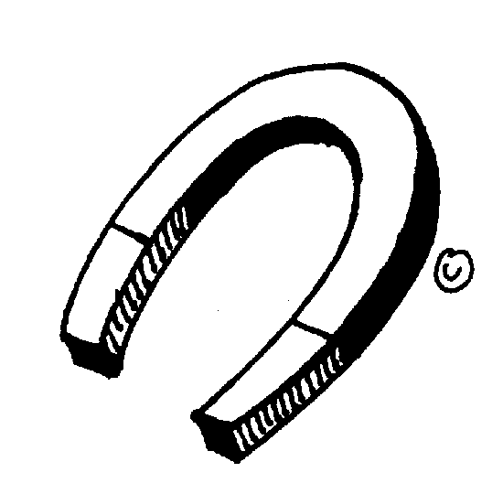
Data Collector:
Materials Manager:

Question: What is attracted to a magnet?

My Guess (Hypothesis):

Experiment

- First, write your prediction for each object in the Prediction column. Write Yes if you think the magnet will be attracted to the object. Write No if you think the magnet won’t be attracted to the object.

- Second, test your prediction with the magnet and record your results in the Results column. Write Yes if the magnet attracted the object. Write No if the magnet didn’t attract the object.

- Third, indicate whether your prediction was correct or not by writing Yes or No in the Correct column.

Object | Prediction | Results | Correct
Plastic tubing
Ceramic tile
Cardboard
Nickel coin
Lead fishing weight
Wood dowel
Copper penny
Steel washer
Rubber
Brass
Aluminum

Think About It

Was your hypothesis correct?

How can you explain your results?

What question(s) does this raise in your mind?

What experiment could you design to answer your question(s)?

