Four NETS for Better Searching
Scaffold and Worksheet

This worksheet is designed to help you record your answers as you explore advanced Internet searching techniques and think about why the number of hits came out as they did. Before getting started, make sure your advanced search options are completely visible.

Go to http://www.google.com/advanced_search | This link will take you directly to Google Advanced Search.  When searching on your own, you can type “advanced search” into the search bar of any browser and the first link will be to Google Advanced Search.  Another option when using Google is to conduct a search then scroll to the bottom of the first search results screen where you’ll find a link to Advanced Search.
This window opens, but does not include all the options available for advanced searching.  To access the other options, see below. | 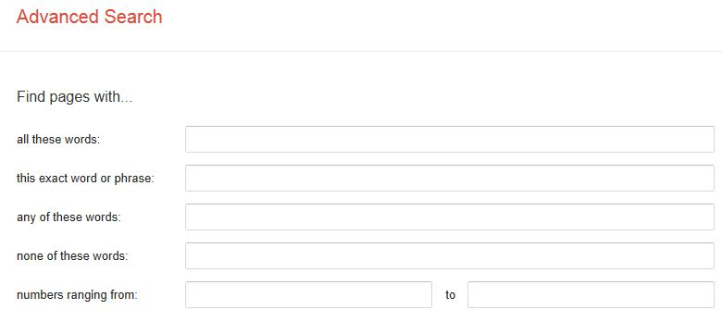
If you scroll down the page, you’ll see a set of links under the heading You can also…  Follow the link titled Find pages that are similar to or link to a URL.  Now you’re ready to refine your search. | 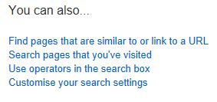

Directions: The column on the left tells what to search for and how to search for it. Record the number of hits you get in the Matches column. Explain what contributed to the number of hits in the Reasons column. The space in the column will expand as you type.

Query | # Matches | Reasons
Find web pages that have...  all these words: Atlantis continent  But don't show pages that have...any of these unwanted words: shuttle film movie |  | The first search shows only what? And excludes what?
Find web pages that have...  all these words: Atlantis |  | The second one has more hits because…
Find web pages that have...  all these words: Waterbury  one or more of these words: Vermont VT  But don't show pages that have...  any of these unwanted words: Connecticut CT |  | The first search shows only what? And excludes what?
Find web pages that have...  all these words: Waterbury |  | The second one has more hits because…
this exact wording or phrase: San Diego State University |  | The second one has more hits because…
Find web pages that have...  all these words: San Diego State University |  | The second one has more hits because…
this exact wording or phrase: Bill 602P |  | What do these searches show?
this exact wording or phrase: We know he has weapons of mass destruction |  | What do these searches show?
this exact wording or phrase: demonstrating genuine leadership |  | What do these searches show?
this exact wording or phrase: Jenny kissed me when we met |  | What do these searches show?
Page-specific tools:  Find pages similar to the page:  www.tappedin.org |  | These are different because...
Find pages that link to the page: www.tappedin.org |  | These are different because...
Find pages similar to the page: kids.msfc.nasa.gov |  | These are different because...
Find pages that link to the page: kids.msfc.nasa.gov |  | These are different because...

Reflection: Please reflect on what you learned while completing this assignment.
Why are these advanced, Internet searching techniques important to you as a future classroom teacher? Support your ideas with specific examples.

