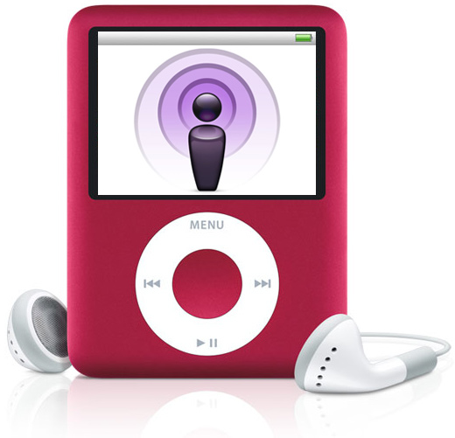
Podcast
Assignment &
Checklist

You will create a podcast individually or in a group of up to three. The podcast may be instructional, or it may represent an example student product which you could use as a model for your students.

Mac users will use GarageBand while PC users will use Audacity. Audacity is available as a free download, however, to save it as an MP3 file requires an plug-in. You can download the plug-in and save your podcast as an MP3 on your own computer, or you can download only Audacity, create your podcast and save it as an Audacity file, then bring the Audacity file to the TEC, open it using Audacity, then resave it as an MP3.

Fill out this paper and turn it in with your podcast.

Name(s):

Podcast Planning Sheet
Grade Level / Subject
NM Standard(s)
Describe how you see your podcast being used

Criteria | 2.5 | 1 | 0
Length between 2 and 5 minutes. | Yes |  | No
Includes written script (attached to this document). | Yes |  | No
Script uses correct grammar. | Yes |  | No
Includes an introduction, content, and summary. Be sure to identify all speakers. | Yes |  | No
Clarity of material: straightforward and easy to understand. | Yes |  | No
Follows copyright guidelines: attributions within the podcast. | Yes |  | No
Sound quality (volume; breath; balance of volume between voices and music) | Good | Adequate | Poor
Voice quality / expression. | Good | Adequate | Poor

