Taking Whole Screen and Active Window Screen Shots on a PC

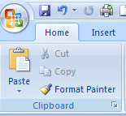
To take a picture of the whole monitor screen:
- Press the PRINT SCREEN button. This will place a screen shot of the entire monitor’s screen on the clipboard. The clipboard is a place the computer uses to temporary store stuff such as text or images.
- Click in a Word document so you see the flashing cursor.
Figure 1: Home Tab Paste Option
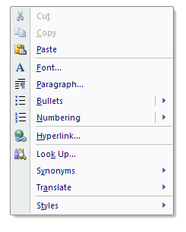
- Paste the image into the Word document one of these three ways:
  - On the Home Tab, click Paste (Figure 1).
  - Right click to open a list of options and select Paste (Figure 2).
  - Use shortcut keys by pressing CTRL + V simultaneously.

Figure 2: Right Click Paste Option

Figures 1 and 2 were created by taking a whole screen shot, pasting the image into the document, setting text wrapping to In Front of Text. Next, the image was selected to make the Picture Tools tab appear before using the crop tool to cut off irrelevant parts of the images. Finally, the images were enlarged proportionately by dragging from the corner to make the Paste options easy to see.

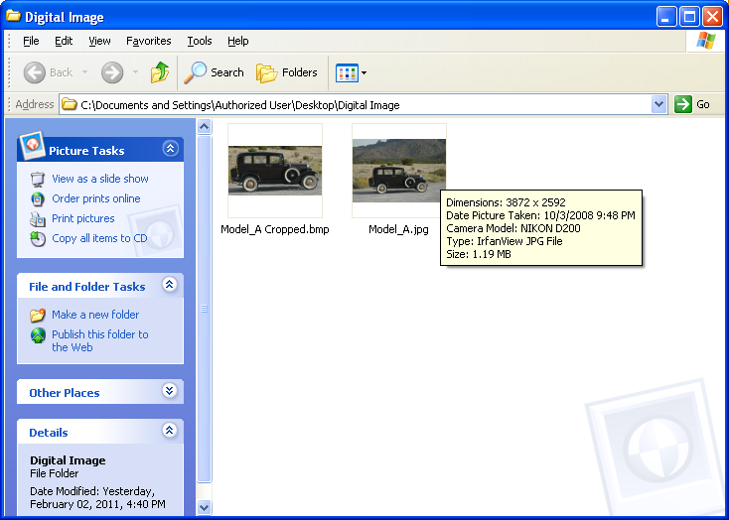
This required a lot of cropping. Sometimes, what you want to show is found in an active window such as a dialog box or folder. You can tell what part of the screen is active by the color of the blue bar; the window with the dark blue bar is the active one. Figure 3 shows the active window for a folder named Digital Image.

To take a screen shot of an active window only, rather than the entire monitor screen, Press ALT – PRINT SCREEN. Then paste the image into Word as described above.
Figure 3: An Active Window for a Folder Named Digital Image

Taking Whole Screen and Active Window Screen Shots on a Mac

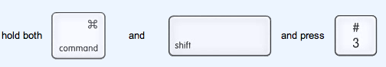
To take a picture of the whole screen:
Press and hold down the COMMMAND, SHIFT, and 3 keys, in that order. This will place a screen shot of the entire monitor’s screen on the desktop (Figure 4).
Figure 4: Whole screen on a Mac

To take a picture of exactly what you want to capture:

Press and hold down the COMMAND, SHIFT, and 4 keys, in that order. You will see a cross hairs tool that you can use to draw a rectangle around what you want to capture. This will place a screen shot of what you selected on the desktop (Figure 5).
Figure 5: Partial screen on a Mac
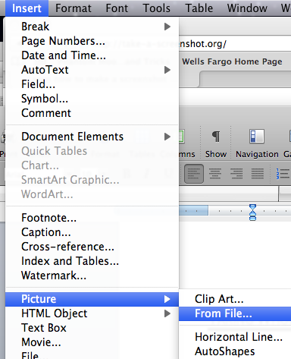

To insert the screen shot into a Word document:
- Click in a Word document so you see the flashing cursor. Then either:
  - Go to Insert, Picture, From file, and navigate to your desktop. Select the image and click the Insert Button (Figure 7).
  - Drag the image from you desktop to the Word document. You can then double click on the image and select your Layout wrapping style.
Figure 7: Insert Picture


To take a screen shot of either the entire or partial screen and place the image in the clipboard so that you can paste the image into your document, hold down CONTROL in addition to either combination shown in Figure 4 and Figure 5 (Figure 8).
Figure 8: Place screenshot on Clipboard

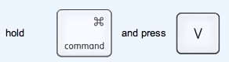
To paste the screen shot into a Word document:
- Click in a Word document so you see the flashing cursor. Then either:
  - Use shortcut keys by pressing CTRL + V simultaneously (Figure 9).
Figure 9: Keyboard Shortcut to Paste
  - Click on Edit, and then Paste.

