Visualization Tools

A word cloud can be used to show the most commonly used words in a text passage. Here’s Obama’s inaugural speech (NY Times) http://www.nytimes.com/2009/01/20/us/politics/20text-obama.html?_r=1&pagewanted=print

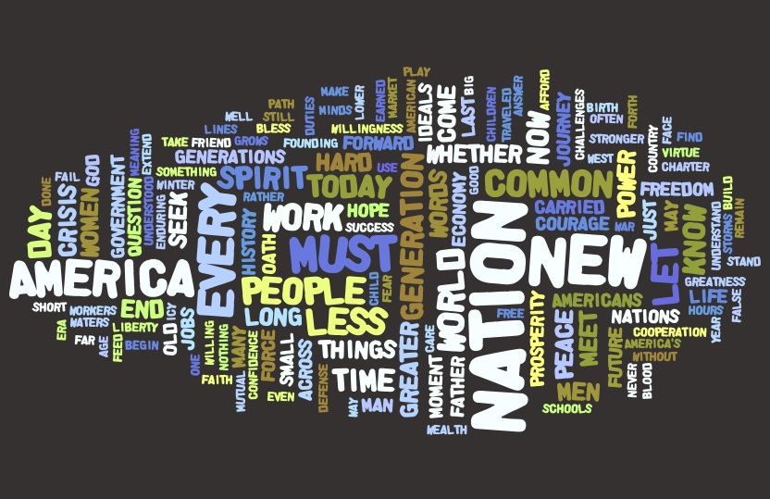

Here it is again using a horizontal format.

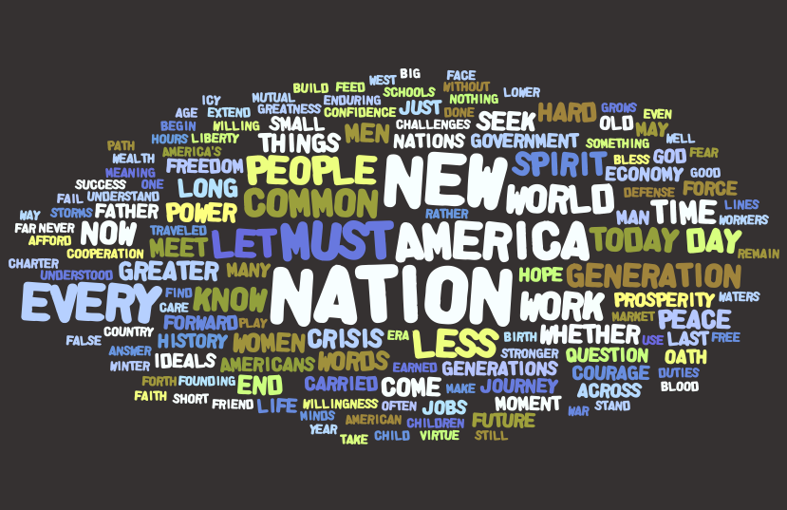
Here’s Bush’s (NY Times) http://www.nytimes.com/2005/01/20/politics/20BUSH-TEXT.html

